“OLD REBELS AT OLD SALEM”
By Hu Daughtry copyright 2007
Used with permission

James Elerbee was “A Man Of God.” During the days of most of his adult life, he was called “A Missionary Baptist Minister Of The Gospel.” Hence, he was probably “A Biblical-Scholar-Of –Sorts.” Having said this, it stands to reason that he was more than familiar with people and places of The Bible. Perhaps this is largely why he chose to attach the name of “Salem” to his new site of worship.
According to several oral and written accounts, worship at Old Salem commenced during the final year or so of Reconstruction. In the beginning, there was no physical edifice. Monthly services were conducted on the dam of a mill pond. This mill pond was owned by a Mr. G. W. Lee, Sr. Lee, although he never actually fought in the Army Of Northern Virginia (with the forces who served proudly under his partial namesake), was a former Confederate soldier.
Services were also (sometimes) held on the bank of a nearby-segment of Fifteen Mile Creek. However, at some point prior to the advent of the decade of the 1880’s, a sanctuary was constructed.

As aforementioned, Old Salem was a place in the Bible. It first appears in the fourteenth chapter of Genesis. Some believe that it may have been the precursor of Jerusalem.
In any event, most etymologists/word scholars agree that Salem means “Place Of Peace,” or “City Of Peace.” Perhaps Elerbee and his followers (most came with him from Poplar Springs, although a few “defected” from That Anti-Missionary Baptist Church located where Fifteen Mile Creek Makes a Lake) did, indeed, find much peace, tranquility, and solace at their newly-found place of worship.

Approximately thirteen decades have come and gone since Reverend Elerbee and his small group of Baptists met at Lee’s Mill Pond. However, even after nearly two life-spans, Old Salem can still be accurately described as “A Place Of Peace.” I know, because I was actually there – not so long ago. It was on a late winter day; the sun was just before “setting in the west.” It seemed to remind me of a great ball of fire, as it headed along its westward trail. In fact, it almost seemed as if it had been fired or launched from some type of supernatural source; not at all unlike one of Mother Nature’s Exploding Cannon Balls!

As I stood out there, shivering in those rapidly-decreasing temperatures which often accompany winter-time darkness, I realized that I was standing near a triad of “Southern Crosses.” Once upon a time, they had belonged to me. Now, they belonged (posthumously) to someone who deserved them much more than myself; someone who had actually earned them. This old soldier had fired and seen more exploding cannon balls than I could possibly imagine. He had spent some 47 months in That Gallant Army Of The Southland. When The Army of Northern Virginia “came to be in the late spring/early summer of 1862,” he was there. Likewise, he was at Appomattox when the bitter end presented itself. In spite of the cold and darkness, I stood out there -- alone with Private Henry Ellis Thain. How many times, during his not-quite four score of years on earth, had he seen the sun explode and race across the sky? I pondered this – and many other things about him -- as I lingered in his company for just a few more moments.

Although he lived nearly a decade beyond his allotted three score and ten years on earth, he never managed to recapture the glory which he attained on July 3, 1863. During those first three days of July, nearly 52,000 American men and boys joined the ranks of “the casualties of war.” Most, if not all, unwillingly joined this unfortunate, but select group. If not for Private Thain, there could very well have been more. Some say this number could have been as high as 87! Private Julius Morgan, a boyhood friend and fellow-cannoneer of Henry’s, remembered it well. He even went so far as to pencil it in on Old Henry’s Application for a Confederate Pension. Even nearly forty years later, this old Rebel had not forgotten. Brief descriptions of his heroic deed(s) at Gettysburg have also appeared in print in several other publications. In other words, they actually happened!

During the trio of early summer days which will go down in history as the most sanguinary encounter of “Our American Civil War,” the temperatures exceeded double-digits. Some accounts mention that the heat may have pushed the mercury up as high as 105! During the final two days at Gettysburg, the four guns of Company A of The First North Carolina Light Artillery fired 1146 rounds towards “Those Hated Forces Of Northern Aggression!” At the age of 25, Private Henry Thain of Johnston County, North Carolina was a viable part of it all. Hence, much American History lies buried in the ground of Old Salem Cemetery. On the last day of the hostilities, Thain would perform his famous life-saving feat.
As the story goes, someone had inadvertently and carelessly lit the fuse of an artillery shell. Private Henry E. Thain, with no regard for his personal safety, exhibited superhuman courage and alacrity, with respect to this potentially-lethal situation. He grabbed the live shell, tucked it beneath his arm, and sprinted away from the other men in his company. As soon as humanly possible, he rendered this “bomb-of -sorts,” inert. For this, he was recognized by the men in his company as “A True Hero Of The Bloodiest Battle In The War For Southern Independence!” For service above and beyond the call of duty, he received a 30 day furlough, a commendation, and perhaps even some type of medal. As I stand near his headstone, watching the sun disappear into the westward darkness, I try to picture all of this in my mind. Somehow, I am able to do so.

But Private Thain and I are not alone in the darkness of Old Salem Cemetery. There are others who have stories which are worth telling. Just a few yards away rests one Frank Tillery. Young Tillery was not a soldier in the struggle against Northern Subjugation; however, he came from Confederate stock. As a very young boy, I’m sure that he heard many stories about “That Revolution Of 1861.” Before the advent of television and computers, youngsters were often entertained by stories of feats of those who lived before them. As Frank began his journey in life in 1908, there were still quite a few old, Gray Warriors around who had actively participated in “That Confederate War.” Unfortunately, Frank died in his youth. He was a few days shy of his fifteenth birthday. In early 1923, antibiotics did not exist. Had he been a resident of a future generation, he may well have conquered these horrific and lethal colonies of Staph which robbed him of his future on earth. Quite recently, I learned that Frank was very athletic and an excellent Boy Scout. He was also quite popular, as is evidenced by his obituary –which appeared on the front page of “The Metter Advertiser.” A native of Southeastern Alabama, young Frank had moved to Candler County circa 1918. His father, James Crawford Tillery, was “a foreman with the railroad.” Young Tillery had at least eight paternal antecedents who fought for The Southland. They served in units endemic to Texas and Alabama. Several who served in The Third Alabama Infantry held the unique distinction of having fought in the first Alabama Regiment to arrive in Virginia. They were a vital part of The Army Of Northern Virginia. Therefore, it was appropriate that he engage in eternal slumber among “Confederate Warriors.” Without a doubt, it was meant to be.

On the other side of the youth who never made it to adulthood, lies another brave Spartan who served beneath that banner known as The Confederate Battle Flag. His marker reads “Nick B. Johnson.” Johnson lived in Oglethorpe County, Georgia when his native state elected to secede from The Union and become a part of The Confederate States Of America.

Nicholas B. Johnson was also present at Gettysburg. He served in Company E of the 38th Georgia Infantry Regiment. This was an integral part of The Lawton/Gordon/Evans Brigade – of The Army Of Northern Virginia. Johnson and several of his brothers/cousins fought in Company E. Most of the soldiers in this unit were from Oglethorpe County.

Not unlike Private Henry Thain, Nick enlisted in the armies of Jefferson Davis long before conscription (the draft) was invoked by The Confederate Government. Johnson was single and employed as a farm laborer when he “joined up.” He owned neither slaves, nor a foot of real estate. He fought exclusively “For Southern Rights.” Nick became Sergeant Johnson in February of 1863. Shortly before The Long, Gray Lines began their march towards that never-to-be forgotten battlefield in The Keystone State, Nick was hospitalized. Perhaps it was “a touch of Camp Fever (a lay-term for the dreaded and often terminal malady known as Typhoid),” but that cannot be known for sure. In any event, he was well-enough to make the march through Maryland and up into Pennsylvania. This is known because he was wounded in the left leg on the very first day of the fighting. It was broken, rendering him “permanently disabled.” However, he did not seek a discharge from “The Armies Of The Southland.” He continued “to fight on in that heroic struggle against The Lincolnites!”

On July 12, he was admitted to one of The C. S. A. General Hospitals in Charlottesville, Virginia. In addition to at least one of the bones below his left knee having been shattered, he was also plagued with fever of unknown origin(s). In early October, he would return to duty. On May 12, 1864, he would be captured by the enemy at a place called Mine Run, Virginia. This was during The Battle Of Spotsylvania Courthouse. For a time, his compiled service records indicate that he was believed to have been killed. At Spotsylvania, one of his younger brothers was killed in action. However, William Johnson was not the first of his junior, male siblings to perish in Those Hostilities Of The 1860’s. Young Woodson Johnson had met and joined Death in an Augusta, Georgia Hospital in late May of 1862. Perhaps the cause was disease, but that cannot be known for sure.

Following over five months in that Yankee-version of Hades called Fort Delaware, he was exchanged. The date was October 31st. It was his birthday. It was a present which he would never forget!

Available records point out that Sergeant Johnson was paroled near Salisbury, North Carolina in early May of 1865. Perhaps he may have been en route to rejoin his unit when the end finally came for those once-indomitable Gray Armies. For the most part, the nature of his presence in Salisbury remains unknown.

The Johnson family probably moved from Oglethorpe to Bulloch at some point shortly after the turn of the century. The Old Rebel first became a Bulloch-County Pensioner in 1904. His widow’s obituary, which appeared in “The Metter Advertiser” shortly before The Christmas of 1916, tells us that all nine of their surviving children resided in the Bulloch/Candler area. Francis Johnson outlived the old Rebel Sergeant with the lame leg by not-quite a year. Needless to say, both are interred in that quiet yard of Old Salem.

There are others (resting in peace at Old Salem) who waged some degree of war against their former countrymen in “That War Between The States. Joshua Ellis, son of Benjamin Ellis, a wealthy planter and slave-holder (by Bulloch County Standards), was also a member of The Lawton/Gordon/Evans Brigade. He served in one of the Bulloch Companies of The 61st Georgia. Having been wounded at Second Manassas, he may have missed “that bloodbath called Gettysburg.” Ellis was also a prisoner of The Forces Of The North. He was captured during the final days of Petersburg – less than a month before Appomattox. He would live until 1913 and was also a deserving recipient of “An Old Soldier’s Pension.”

The twin brothers, George and Henry Lee, both served for a short time in the 47th Georgia. During the final months of the war, at least one of them would fight (unwillingly) in one of Governor Joe Brown’s State Militia (Home Guard) units. Bulloch County Court Records tell us so. As the Lee brothers came from a somewhat-opulent family, both were more than capable of “purchasing themselves substitutes.”

Lastly, there is Clemmons Mercer. Mercer served as a lieutenant in an Emanuel County Militia Unit. Captain Moring’s Company fought valiantly against those battle-hardened veterans of General William T. Sherman during The Atlanta Campaign. Mercer survived the war, but died before he reached the age of fifty. Having contracted malaria during the Third and Final Seminole Indian War (down in Florida), he never quite recovered from those poisonous mosquito bites of 1856.

Of course, Reverend James Elerbee is there – as well. He lies quietly beside his long-time partner-in-marriage, Polly. It seems that the Elerbees had no children, but were certainly not unaffected by “That War Against Yankee Oppression and Imperialism.” In addition to being “an ordained speaker of The Bible,” Elerbee was also a small planter and an owner of bondservants. Although too aged for service in The Southern Armies, he, no doubt, suffered and sacrificed – in other ways. As his small plantation was located in present-day Candler (less than a mile from the intersection of The Metter-Portal Road and Rosemary Church Road), there were surely enemy foragers and peripheral scavengers from those haughty and vaunted forces of William Tecumseh Sherman who “came his way.” Until his death in 1893 (during his 85th year), I’m certain that he was never quite able to forget “Our Second American Revolution.”

Furthermore, how many funerals were preached by Elerbee during that heroic struggle which lasted for four, long years? How many of these could be labeled as “corpseless services?” How many were directly related to “Our Fight For Southern Rights?” The answers to these, and many more questions of long ago, lie buried with the old preacher and those around him who lived through perhaps the most turbulent and definitive four years in American History. Unfortunately, there will never be a history book written which will reveal “the real truths of our Ante-Bellum South” and the actual causes of “Our American Civil War.”

By now, my hands are numb from the cold. However, I have much to think about. I also have a story to write. As I leave Private Henry Thain, Sergeant Nick Johnson, Lieutenant Clemmons Mercer, Sergeant Joshua Ellis, Reverend Elerbee, and the rest of those who played roles in American History, I suddenly feel quite warm – inside. Perhaps I have somehow connected myself with the past. More importantly, I have “hooked-up with history!”

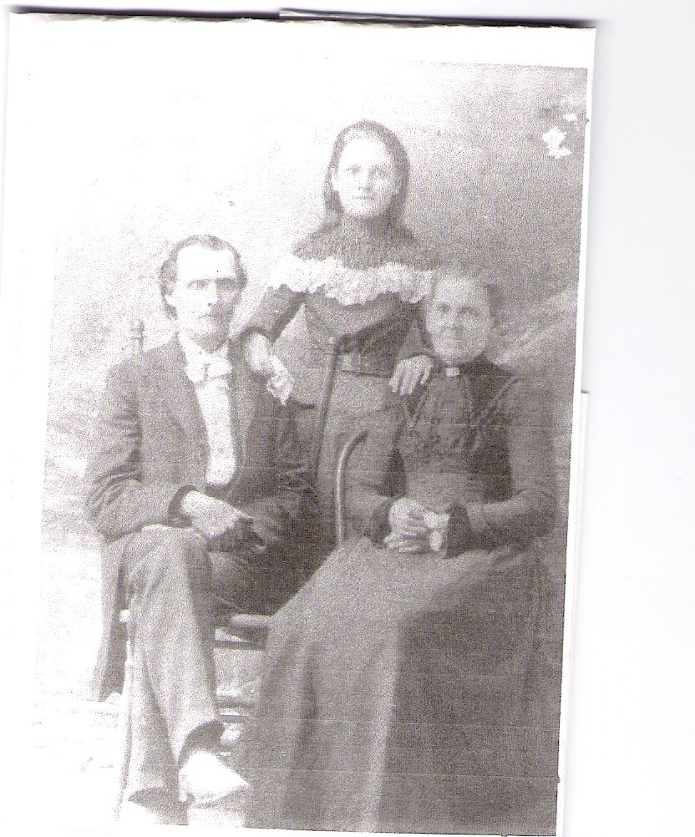

Henry Ellis Thain, Delia Susan Thain, Bertha Thain; Bulloch County, Georgia; Circa 1898

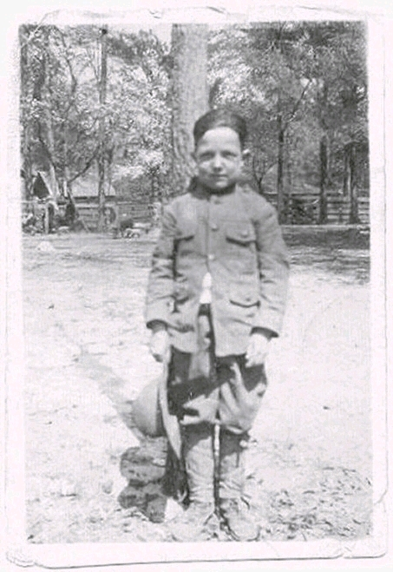

Little Frank Tillery in his Boy Scout Uniform

POST SCRIPT: Much more can be learned of the lives and times of Private Henry Thain, Reverend James Elerbee, and many others who are buried at Old Salem Cemetery by consulting the recently-published book: “CONFEDERATE TALES OF CANDLER AND CONNECTED COUNTIES.”

Hu Daughtry

March 15, 2007

