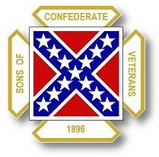
The Dispatch
The Official Publication of The Dixie Guards Camp # 1942
Sons of Confederate Veterans
Metter, Georgia

September 2007 Edition

Next Meeting – Thursday, September 6th

Dixie Guards Camp # 1942
Sons of Confederate Veterans
P.O. Box 761
Metter, Georgia 30439

Postmaster Please Deliver To:

Visit Us Online at:
www.dixieguards.org

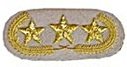Commander’s Comments
September is a very important month in American History. On September 17, 1862, the Battle of Sharpsburg, also known as the Battle of Antietam is remembered as America’s Bloodiest Day. Over 4000 Americans lost their lives that day and another nearly 20,000 battlefield casualties makes the battle the single bloodiest day in American History. Just six years ago, evil America-haters made September 11, 2001 America’s second bloodiest day. The difference in the two days in actual loss of life is actually not much. The most recent accounts of actual loss of life on September 11th are near or over 3000. The biggest difference is of course, Sharpsburg was actual combat. Federal forces were fighting to preserve the federal union of states. Confederate forces were trying to win independence. The resulting 4000 fatalities were a result of their battle confrontation.
September 11th is very, very different. Terrorism is an act committed by desperate or sick individuals that don’t have the regular means to enter warfare or they are simply to cowardice to do so. In the case of September 11th, cowardice has to be the reason. Al Qaeda and their ilk are disgusting. They have no comprehension of the value of life. A careful study of their guide, the Koran and its teaching clearly illustrates why they choose to act as they do. Of course, Al Qaeda is of the more extreme members of Islam – but the Koran is the Koran. In the Koran, Islamic followers are taught that non-Islamic are of no value and should be treated in only 3 ways. They should be enslaved – or, they should be forced to pay for their survival…in other words, they pay a tribute to be allowed to live – OR, they should be killed. According to Islamic teaching in the Koran, there is to be no peace with non-Islamic, only death or slavery. So much for a peaceful religion!
In the American Revolution against the British, not all American colonists were in favor of the War. In fact, Georgia was chocked full of Loyalist. Some so adamant that they fought against their neighbors to preserve British rule. To say that all Georgians and Americans were “united” in their thoughts and beliefs would be far from the truth. In the War Between the States, things were remarkably similar, especially at first. Georgia was far from unanimous in its support for secession. Georgia had entire regions that remained loyal to the Federal government and actually supplied troops to the Federals.
Why do I discuss the wars of the late 1700s and mid 1800s along with the current wars in Afghanistan and Iraq? Because, America is far from united in its feelings related to the war. In fact, the only thing that remains ghastly similar from one American war to the next is the divisive public sentiment towards it. Believe it or not, there were Americans that protested against WWII. It is not likely that the folks here in Metter heard much about them, but they protested and complained just the same.
One thing that has remained constant with all of our American wars – when the soldiers came back home, somehow we all reunited again. We need to remember that now! Robert E. Lee asked his men to return home and reunite and to become model citizens. They did that. The South donated more citizen soldiers that any other section of our country since the War Between the States. They led the way against our enemies in both World Wars, against Korea, against Vietnam and now in the Middle East. Right now, there are Georgia SCV members in Iraq. Some of them are from near or neighboring camps. We have had some of our very own there. We cannot forget them and we cannot forget September 11th. Whatever heartfelt belief you have related to the war – why we are there or whether or not we should be there, remember this. They are there – our brothers and they deserve our support. We owe it to them and we owe it to their legacy. They’ve marched off to war just as their ancestors did. Remember, not all of our ancestors volunteered, some were drafted. These guys have all volunteered and most of them are citizen soldiers of the National Guard.
I would like to challenge our Camp to rally to their support. I am currently gathering material for a care-package of a couple of our own. One is in Afghanistan – the other is in Iraq. Let’s let them know that we believe in them and we honor their service. Let us also not forget September 11th - the Trade Center, Pentagon and Flight 94. Let us not forget September 17th and Sharpsburg. All of these people who lost their lives would much rather have been at home with loved ones. Sadly, they never returned home. We should never forget their loss or sacrifice and we should always honor their memory.
God Bless You and Your Family,
Randy

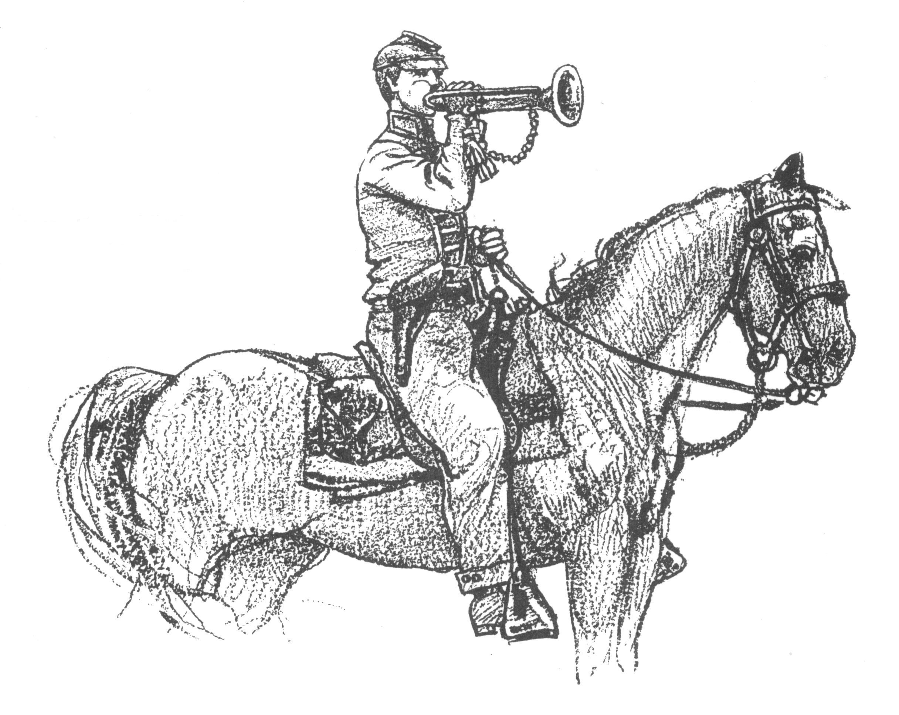 Call to Duty – Camp Calendar
Thursday, September 6th – Regular Monthly Meeting Thursday, October 4th – Regular Monthly Meeting
Western Steer Western Steer
7 PM – Meal 7:30 Meeting 7 PM – Meal 7:30 Meeting
Program: GA Division Chaplain, Jim Cavanah Program: TBA

It is Dues Renewal Time

Because of the pro-rated dues system, members who have joined within the last year may not be required to renew. All others are due now. Please contact Tony with any questions about your dues.

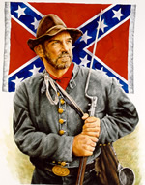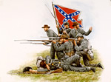
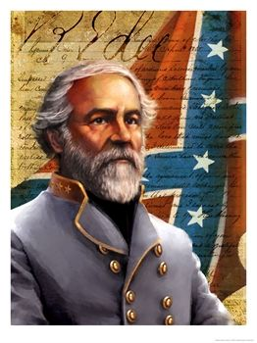
"Everyone should do all in his power to collect
and disseminate the truth, in the hope that it may
find a place in history and descend to posterity.
[Southern]History is not the relation of campaigns and battles
and generals or other individuals, but that which
shows the principles for which the South contended
and which justified her struggle for those principles."
--Robert E. Lee

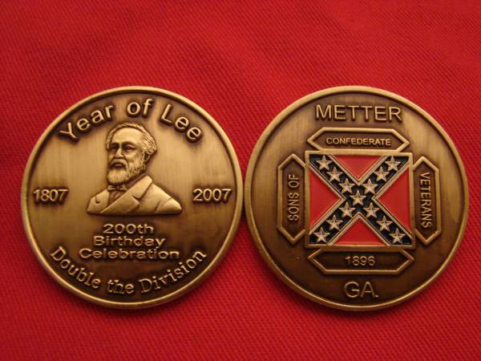
Extra Commemorative Reunion Medals
*While Supplies Last – Contact Tony or Randy for details

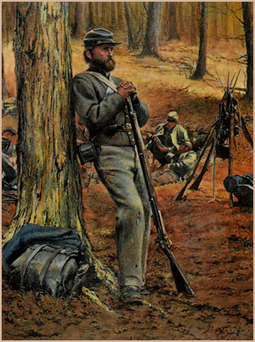Feature Article: The Battle of Sharpsburg
At around daybreak on September 17, 1862, Union Major General Joseph Hooker opened the battle with an artillery barrage on the units of Confederate Major General Stonewall Jackson. Initially, the Federals seemed destined to control the field. But, the Confederates held their ground. The Miller Cornfield and the area around the Dunker Church were destined to become famous landmarks. Gallant troops from both sides paid the ultimate sacrifice.
Further down the line, were christened other famous sites. The Sunken Road, where John B. Gordon nearly drowned in his own blood while trying to hold precious ground. Gordon and his Georgians gallantly anchored the Confederate center and prevented the Federal troops from dissecting the Confederate lines and overrunning Lee’s army. The Rohrback Bridge, now known as Burnsides Bridge. At the bridge, another group of Georgians held solidly for hours. There, roughly 400 Georgians under Brigadier General Robert Toombs held back the entire Union Corps of Major General Ambrose Burnside for most of the day. The solid fighting of these two sections of Georgia men allowed General Lee to reposition troops time and again in the face of the Federals.
Of course, the Georgians weren’t the only units in desperate fights. The concerted effort of all the Confederates saved Lee’s army. Earlier in the week, Confederate paperwork was discovered by Union troops in an area where a portion of Lee’s army had camped. In the paperwork were orders and description of virtually all of Lee’s army. The Federals had all the intelligence necessary to annihilate Lee’s army. Major General George McClellan’s Federal army outnumbered General Lee’s Confederates by more than two to one. The intelligence should have sealed the fate of the Confederates. Instead, McClellan misused his troops.
General Lee and his subordinates, Major General Stonewall Jackson and Major General James Longstreet fought tenaciously and stymied the bungling Federals. Federal Major General Joseph Hooker fought mostly unsupported against Jackson and suffered for it. Longstreet’s men, though scattered across several miles of territory, with their flanks in the air, fought a battle of the ages. Attack and counterattack ensued.
At the end of the day, Lee and his men held off McClellan and his Federals. Modern historians claim that the battle was a Federal victory because General Lee is alleged to have abandoned the field in defeat. The truth is that General Lee, in contempt of the poor generalship of McClellan held his men in place, as if to dare McClellan to attack on the 18th. The Confederates had secured a defeat of the Federal garrison of Harper’s Ferry earlier in the week and were maneuvering back towards Virginia anyway. They did not turn and run as modern historians claim. Far from it, they mocked McClellan and his army. They fought like cornered animals.
Truthfully, McClellan should have totally destroyed Lee’s army. The Federals had over twice as many men. They had over twice as much ammunition and artillery. They had over twice as much cavalry. They had General Lee penned against the Potomac and with his troops scattered across the countryside. Capping it off, they had a copy of Lee’s paperwork that provided more than enough information to enable them to defeat Lee, even if the numbers of troops were closer. But, they didn’t have General Lee, Jackson, or Longstreet. In fact, McClellan turned out to be his own worse enemy. After the battle, McClellan bragged of victory, but his own men knew better and so did Lincoln. Soon, Lincoln fired him and replaced him with Burnside – who was the only Federal General that performed anywhere near the level he should have during the battle.
Historians may call Sharpsburg or Antietam a Federal victory, but they weren’t there. James Longstreet recalled that Sharpsburg was Lee’s finest hour and proved that he was the best general in the field. Lee too must have been proud of his two subordinate generals. It was at Sharpsburg that Lee coined the Longstreet’s nickname – Old Warhorse. And, immediately after Sharpsburg General Lee requested that Longstreet and Jackson be promoted to Lt. General. The request would take a special act of the Confederate Congress because the rank did not exist at that time. Lee’s request was granted – first for Longstreet and then, for Jackson. Lee reorganized his army into two Corps. Longstreet, the senior Lt. General was given the 1st Corps and Jackson became the commander of the famous 2nd Corps.
Remember September 11th
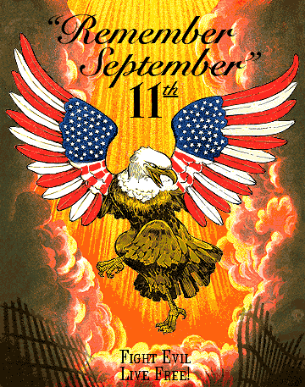
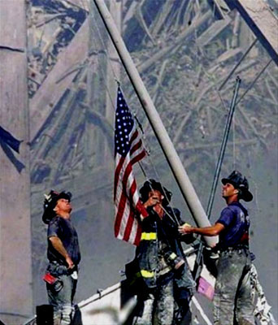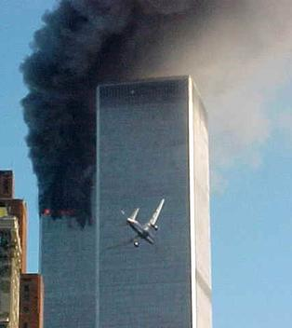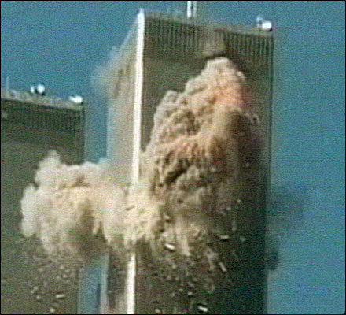Never Forget

Upon taking his army into Maryland, General Lee thought it prudent to declare his purposes to the citizens of the state of Maryland. This is the official letter that General Lee penned and published through the local presses of Maryland.
To the People of Maryland:
Headquarters Army N. Virginia
Near Fredericktown, 8th September, 1862
It is right that you should know the purpose that brought the Army under my command within the limits of your State, so far as that purpose concerns yourselves.
The People of the Confederate States have long watched with the deepest sympathy the wrongs and outrages that have been inflicted upon the citizens of a Commonwealth, allied to the States of the South by the strongest social, political and commercial ties.
They have seen with profound indignation their sister State deprived of every right, and reduced to the condition of a conquered Province.
Under the pretense of supporting the Constitution, but in violation of its most valuable provisions, your citizens have been arrested and imprisoned upon no charge, and contrary to all forms of law; the faithful and manly protest against this outrage made by the venerable and illustrious Marylanders to whom in better days, no citizens appealed for right in vain, was treated with scorn and contempt; the government of your chief city has been usurped by armed strangers; your legislature has been dissolved by the unlawful arrest of its members; freedom of the press and of speech, of the Federal Executive, and citizens ordered to be tried by a military commission for what they may dare to speak.
Believing that the People of Maryland possessed a spirit too lofty to submit to such a government, the people of the south have long wished to aid you in throwing off this foreign yoke, to enable you to again enjoy the inalienable rights of free men, and restore independence and sovereignty to your State.
In obedience to this wish, our Army has come among you, and is prepared to assist you with the power of its arms in regaining the rights of which you have been despoiled.
This, Citizens of Maryland, is our mission, so far as you are concerned.
No constraint upon your free will is intended, no intimidation is allowed.
Within the limits of this Army, at least, Marylanders shall once more enjoy their ancient freedom of thought and speech.
We know no enemies among you, and will protect all of every opinion.
I is for you to decide your destiny, freely and without constraint.
This army will respect your choice whatever it may be, and while the Southern people will rejoice to welcome you to your natural position among them, they will only welcome you when you come of your own free will.

R. E. Lee, General Commanding.

