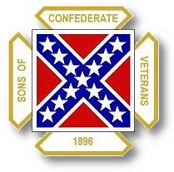
The Dispatch
The Official Publication of The Dixie Guards Camp # 1942
Sons of Confederate Veterans
Metter, Georgia

September 2006

Dixie Guards Camp # 1942
Sons of Confederate Veterans
P.O. Box 761
Metter, Georgia 30439

Postmaster Please Deliver To:

Visit Us Online at:
www.dixieguards.org
 Commander’s Comments
September is here and the fiscal year is already in full swing. Renewals are coming in and I applaud those who have gotten theirs in early. If you received your Georgia Confederate, you’ll see that our brand new Division Commander is fully behind our belief that we can Double the Division. I know that we can do it! You may think that I’m crazy, but I really do believe that we can. I know that we should. Not to sound like a doomsday forecaster, but the very future of anything Southern in Georgia depends on Us doing all that we can to preserve our Ancestors place in History. Without the membership numbers that will potentially scare Politicians, we simply won’t have the majority of their votes when issues come up. That is certain at the Federal level. It is certain at the State level. More and more, it will become the issue in our Area, County and Town too in the future. Our enemies have revisionist historians on their side and they are chocked full of propaganda.
On September 13th, Georgia Southern will be hosting a visit from James Loewen. In case you’ve never heard of him, he is a Sociology Professor. He is famous for the book Lies My Teacher Told Me. In the book, Professor Loewen revises history. In fact, he is famous for trying to revise history. For years, he has bragged about revising history and U.S. Federal Courts have upheld his battle to infiltrate schools of higher learning with his textbooks that offer revisionist history. Because of him and his famous court cases, all American textbooks are subjected to making sure that no one is possibly offended by history books. It makes no difference if it is history, if it offends someone, then it is removed. Just prior to coming to GSU, he’ll be speaking and teaching the NAACP Legal Defense Group. Then he’s coming to Our midst and will be giving a seminar for teachers and the general public.
We already struggle to get any sort of message that the Confederate Soldier is not the evil, boogey man. Imagine how hard it will become if our local teachers begin to accept the doctrines of such revisionists. It won’t be hard, they’ve been hearing these revisionist stories for years and they’ve been teaching the stuff to your kids. Men like Robert E. Lee are bad, haven’t you heard. They were Anti-Americans and Extremists. They were enemies of the U.S. Constitution. If you don’t believe me, just read the books of authors like Loewen. You’ll see. Now more than ever, our Ancestors and their History need Us!
I remember in school there was a sentence that we used to have to type in typing class to make us use most of the keys when typing. The sentence that we typed really applies to Our situation. It goes like this: “Now is the time for all good men to come to the aid of their country!” How true. Add to that the words of the great American Patriot, Thomas Paine, “These are the times that try men’s souls.” And from James Madison, “If men were angels, no government would be necessary.”
Our Ancestors need us now, more than ever. The SCV needs us now more than ever. The Dixie Guards Camp 1942 needs you now more than ever. So far, our Camp has escaped the heritage violation issues that many other Camps struggle with daily. We have a good working relationship with our local officials. But, we should never let our guard down. As long as men like James Loewen are invited to come and share his message, then our kid’s education is at risk and our Ancestor’s place in history is even more at risk. How long will it be before our local teachers and government officials begin to listen to these revisionist stories and forget the stories handed down from their long deceased family members. I ask you, who do you choose to believe Professor James Loewen or your Grandparents or Great-Grandparents?
I look at history with and open mind, but I choose to believe the stories that my Grandma told me about her Grandpa. She knew him, she was proud of him. She remembered his stories about his service in the Confederate Army and his imprisonment at Elmira. She remembered his stories of his long walk home to Georgia from New York and how if it wasn’t for Blue Lodge Masons, he may have starved along his way. From her stories, I felt that I came to know my Great-Great Grandpa. If I’m wrong about him, then I will always be and won’t apologize for it either. My Great-Great Grandpa was a good man, just as I’m sure that yours was too. He was a Confederate Soldier who went off in service of his country. He followed men like Robert E. Lee and Stonewall Jackson. He prayed and a faith in a Loving God. He believed that his mission was true. Just as any other government, his might not have been perfect, but it was his. It was the Confederate States of America. It was Georgia. And, he was a Confederate Soldier, fighting for his homeland. Professor James Loewen can get over it. I don’t care for his message and I’m gonna recruit every man I can to help spread mine. My message is clear: My Ancestor was a Confederate Veteran. I am a Son of a Confederate Veteran. My Ancestor was an honorable man and so am I. I am an American and a Patriotic one! So were my Great- Great Grandpa and his compatriots.
Will you help me spread Our message? Let’s Double our Division. Let’s Double OUR Camp. Let’s preserve our Ancestors!
God Bless You and Your Family,
Randy

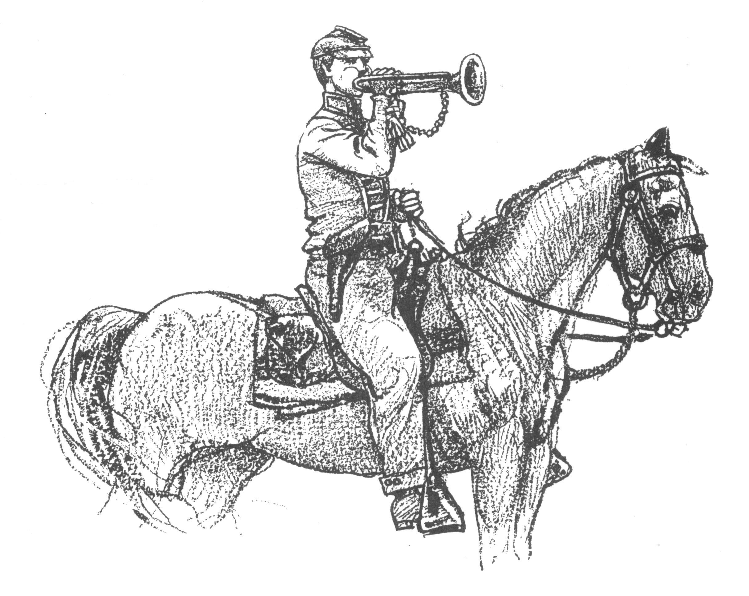 Call to Duty – Camp Calendar
Thursday, September 7th – Regular Monthly Meeting Thursday, October 5th – Regular Monthly Meeting
7 PM – Meal / 7:30 PM Meeting 7 PM – Meal / 7:30 PM Meeting
Western Steer - Metter Western Steer - Metter
Program/Speaker – Tony Thompson Program/Speaker – TBA



"All that was, or is now, desired is that the error and injustice be excluded from the textbooks of our schools and from literature brought into our homes; that the truth be told, without exaggeration and without omission; truth for its own sake and for the sake of honest history, and that the generations to come after us not be left to bear the burden of shame and dishonor unrighteously laid upon the name of their noble sires."
- Rev. James Power Smith, Last survivor of the staff of General Stonewall Jackson
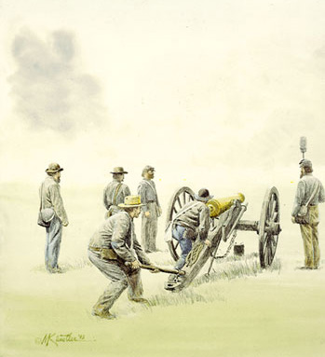 Feature Article: The U.S. Supreme Court Case – Ex parte McCardle (1869)
In his 2nd Inaugural Address, President Lincoln promised that if the US government was successful, then the old States of the Confederacy would be welcomed back into the US fold with open arms. Of course, with his assassination his promise died with him. We’ll never know if his words would have been true. One thing that we do know is that after he was killed, the Radical Republicans took over control of the US government and they put harsh Reconstruction rules on the South. Confederates were denied the pledges of the Constitution. For example, duly elected Congressmen were denied their seats in Congress which was a direct violation of the Constitution. They were not criminals, yet they were denied their seats. In the 1960s, Representative Clayton Powell of New York was a known criminal and yet, he had to be seated because he was elected. But that is another story. Here is the story of how the Radical Republicans simply would not allow anyone to support the South during Reconstruction. There laws were unconstitutional and they knew it. But, it didn’t matter. They were in charge and since they had won their power by the overwhelming of our Confederate Armies, they had the might of the US Army’s sword to make their case. They didn’t need or want the US Supreme Court. And, as history shows us, when President Andrew Johnson disagreed with them, they tried to impeach him.
After the war, the Radical Republican Congress passed the Reconstruction Acts, which made the South a military controlled territory. Not everyone in the North agreed with their policy of breaking the Constitution and mistreating the Southern people. Journalist William McCardle opposed them and wrote editorials urging resistance and rebuke by honest Americans. He urged the Americans to remember the words of Lincoln and invite the impoverished, battle-worn and starving Southerners back into the Union. He urged unity and forgiveness on the part of everyone for the benefit of all.
The Radical Congress claimed his editorials were inflammatory. And, just as President Adams had done in the 1790s with the Sedition Acts, they had him arrested for publishing “incendiary and libelous articles” – a direct attack on the Freedom of Speech and Freedom of the Press. He was held for trial before a military tribunal established under the newly created Reconstruction Acts.
But, McCardle was a civilian. Even with the bogus charges, his trial should not have been in military courts. Knowing this, he petitioned for a Writ of Habeas Corpus under an 1867 Act that stipulated that Federal Courts had the power to grant them Writs of Habeas Corpus in all cases where any person may be restrained of his or her liberty in violation of the Constitution, laws, or treaties of the United States. His efforts failed. So, he petitioned an appeal to the US Supreme Court which under the 1867 law would have jurisdiction in such cases.
According to a Constitutional Law textbook, “In early March 1868 McCardle ‘was very thoroughly and ably [presented] upon the merits’ to the U.S. Supreme Court…the Court’s sympathies as was widely known, lay with McCardle. “ So, the Radical Republican Congress usurped the power to rule away from the US Supreme Court. Again, the textbook says, “Congress, on March 27, 2868, enacted a law repealing the 1867 Habeas Corpus Act and removing the Supreme Court’s authority to hear appeals emanating from it. The move was meant to punish the Court or, at the very least, to send it a strong message.” The Court had rebuked Lincoln when he had misused military tribunals and the Radical Congress was not going to let them do it to them.
By changing the law, Congress took away the grounds for the Supreme Court to hear the case and so the Court had to dismiss it without a ruling. No law, no violation of law…no ruling. Since, McCardle’s whole case stemmed from the 1867 Law, his case was now moot and lacked justiciability before the Court. The Radical Congress had removed the Supreme Court’s Appellate Authority to hear the case, thereby successfully making an example of McCardle, frightened the news media, suppressed the Court, and enabled the continued policies of Reconstruction towards the South.

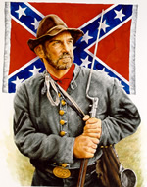 "I must not forget our old flag — though torn & tattered & faded. In the three days of fighting, although about 18 inches was torn off the end & lost — there is fifteen bullet holes through the flag & three through the staff — & besides there is a large rip made by a piece of a bomb. Three color bearers were shot down & the fourth now carries it. If I should live through the war I would want no brighter monument than this faded flag to decorate my parlor walls — (Provided I ever have a parlor)." … James C. Bates CSA

Can You Help Us Remember Men Like James C. Bates…Men Like Your Ancestor?
Please help us by sharing the names & information of 4 potential members – if you can’t contact them, we’ll contact them for you. We’ll still honor you as the recruiting member if they join! Just fill this out & bring it to the next meeting.

Name_____________________________ Name_____________________________
Address___________________________ Address___________________________
___________________________________ ___________________________________
Phone_____________________________ Phone_____________________________
Recruiting Member_______________________________ Recruiting Member_______________________________

Name_____________________________ Name_____________________________
Address___________________________ Address___________________________
___________________________________ ___________________________________
Phone_____________________________ Phone_____________________________
Recruiting Member_______________________________ Recruiting Member_______________________________

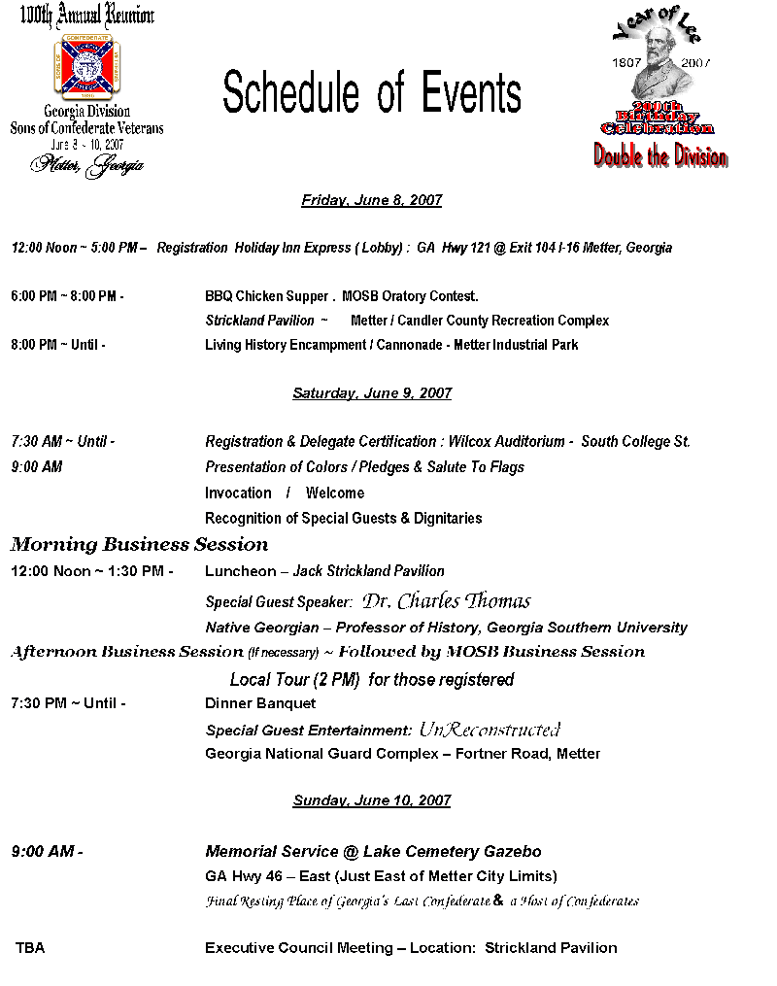
Reunion Planning Information & Help Requests
1. Local History & Sites Tour - Concept: Our current plans are to host a tour for the ladies and any members who would like to attend on Saturday beginning @ 2 PM. We want to start from our host hotel (Holiday Inn Express). Take bus to sites:
Stop 1 Welcome Center Stop 2 Cedar Plantation Stop 3 Guido Gardens & Guido Evangelistic Association
Stop 4 Metter Depot
Points of Interest - We are looking for either a tour size bus at low cost or church buses to borrow for tour - Anyone attending the tour will have to sign a waiver - Tour price dependent on costs - We’ll be having a Power Point Presentation at the Depot – There will be refreshments and door prizes. Anyone who can help with the planning of the Tour please let us know.

2. Commemorative Program Ad Sales – Carlton Clifton has the local lead on Program Ad sales – Wayne Lesesne is in charge in Bulloch County. Carlton has already made head way and is planning to add a color section to the Program. Anyone wishing to help Carlton locally, Wayne in Bulloch-Statesboro, in neighboring communities let us know. We’re hoping for quite a lot of support from our local businesses. Anyone who can help Carlton & Wayne please let us know.

3. Living History Encampment - On Friday, July 8th we will host a Confederate Living History Encampment at the Metter Industrial Park. This has been tentatively approved by City Mgr, Joseph Mosley. A firm commitment to follow. The public is invited. At "Dark 30" we will have a cannonade demonstration across the lake that will rival a fireworks display. **Reenactors are ready and just about all confirmed. We are pledging 1 – 2 hotel rooms for the reenactors to make sure they have bathroom facilities & dry sleep areas in the event of rainy weather. We’re looking to get the rooms @ American Inn & Suites or Scottish Inn & Suites.

4. Friday, BBQ Chicken “Que” – Opening meeting of convention for members, guests and general public interested in meeting conventioneers. ½ Chicken – plus fixins’. Strickland Pavilion is the site and is already booked and confirmed. . **Jason has the lead – volunteers needed

5. Thursday, July 7th 4 Man or 3 Man Lauderdale Golf Tournament– Plans are underway to host a Benefit Golf Tournament @ Willow Lake. Profits will go to Monument Foundation. The idea is to draw golfers and members to Metter earlier in the week to generate extra monies for local businesses. Any business or member who purchases an Ad in the Commemorative Program will get special advertising rates for the golf tournament. Volunteers will be needed the day of the tournament. Carlton / Wayne will head up T-Box Ad Sales beginning early 2007. The Actual Golf will be a break even event – The profits are generated by T-Box Advertisements & Mulligan Sales. We will begin to plan the Golf Tournament in depth in December.

6. Banquet & Period Dance – We are looking at the possibility of hosting the Banquet & Dance at the High School Commons Area or one of the local gyms. The National Guard Armory does not have Air Conditioning and is in need of serious cleaning and some repairs.

7. Public Relations – We have supplied pamphlets and information handouts to our local businesses and the Chamber of Commerce. These are the only “Official” announcements that have been made available. If you attend any outside meetings and the Reunion / Convention topic comes up, please ask that any questions be addressed towards the Camp and not in an open forum of another organization’s meeting without us having “Official” Representation there. This will ensure that correct information is provided. Recently, in a Chamber meeting discussion came up relating to the Reunion and erroneous information was shared with the Chamber meeting. We cannot afford anyone to give out wrong information. Rules of the Governing Body of International Headquarters of the SCV restrict who can speak on behalf of a Camp and in relation to things such as this.

These rules must always apply and cannot be deviated from or we can get into trouble:
1. Anyone speaking or giving information in any type of “Official” Capacity must be a SCV member – the recent discussion in the Chamber meeting deviated from this most basic principle. We can’t allow this to happen. Anyone who speaks in honor of the Reunion / Convention must be a Dixie Guard Member (or) someone designated to speak on our behalf at the particular meeting. The Camp has not awarded any such speaking arrangement to anyone – but if we do it will be a member of the Planning Committee of Volunteers. This had been made clear to the Chairman of the Chamber of Commerce and she has been provided the most up to date information.
2. Advise anyone wishing information related to the Reunion / Convention for which you cannot provide absolute answers for to contact the Camp either by writing or in person.

In writing at: Dixie Guards Camp 1942 PO Box 761 Metter, Georgia 30439
In person at our Regular Meetings – 1st Thursday of Each Month – Western Steer (or) at one of our Regularly Held Planning Meetings

BEGIN The Membership Drive NOW! - We need to set the pace for other Camps to follow towards the Division Goal. We need new members each and every month. Please get your Renewals in as soon as possible. Please help us try to re-activate lost members.


Is Membership Important?
Is Recruiting Important?
Is Retention Important?

You Decide For Yourself!
“All that is needed for evil to flourish is for good men to do nothing. Or remain silent.”
- an American Patriot

