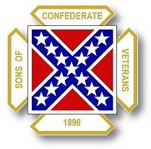
The Dispatch
The Official Publication of The Dixie Guards Camp # 1942
Sons of Confederate Veterans
Metter, Georgia

October 2007 Edition

Next Meeting – Thursday, October 4th

Dixie Guards Camp # 1942
Sons of Confederate Veterans
P.O. Box 761
Metter, Georgia 30439

Postmaster Please Deliver To:

Visit Us Online at:
www.dixieguards.org

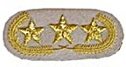Commander’s Comments
Gentlemen, I want to apologize to everyone for my recent absence. Many of you have not seen me at all since the Reunion. I have been very busy with work and home and simply have been unable to attend our meetings. As I expected, the camp has faired just fine without me and I have missed y’all far more than you probably have missed me.
If I had been able to be around, you would have certainly heard one central theme from me - RENEWALS. I am sorry gentlemen, but it is recommitment time. I know that you are always hearing it, but we only have the month of October left to renew virtually our entire membership. Thus far, we only have about 20 renewals submitted. Of course, not everyone is due to be renewed, but when you have a membership of 100 and you find out only 20 renewals have been submitted a terrible image comes to mind. It causes me to ask one simple question. Have we forgotten why we joined in the first place?
I won’t try to put words into anyone’s mouth, but I know why I joined. I first joined to pay tribute to my Great-Great Grandpa. He joined the 14th Georgia Volunteers. He went off to war in Virginia for a belief instilled in him by his father. I know this because his father was one of the original members of Company F of the 14th. My Great-Great Grandpa was captured at the Battle of the Wilderness and thrown into Elmira Prison Camp in rural New York. He was fortunate. He survived Elmira. Many did not. In fact, Elmira had roughly the same mortality statistics as Andersonville. The Confederates did not have food for the Federal prisoners at Andersonville – so, yes many starved. At Elmira, the Confederate prisoners were starved on purpose. Their captors took their coats and shoes from them. The reason they were given was that if they were cold, they couldn’t run away or escape. In January and February of 1865, many simply froze to death. As I said, my Great-Great Grandpa was fortunate. Somehow, he lived through the intentional attempt to starve and freeze him to death. To me, he deserves remembrance and it is my task to remember him. Since I initially joined, I have found many more Confederate soldiers in my families – both my father’s side and my mother’s. Each time I find another soldier, I am grateful that I joined. Now, another soldier won’t be forgotten.
Who are you honoring? Exactly how much does he mean to you? Is there anyone else better suited to honor his legacy than you are? Were you proud when you discovered you had a Confederate ancestor? Do you still have the same pride today and when you first discovered him? Do you think he would be happy to know that you have not forgotten his sacrifices? Do you think that he deserves the reputation that Flag-haters and the media are trying to force upon him? Or, do you think he deserves to be remembered as merely a soldier doing his duty?
I think I know your answers already. What I don’t know is why men of honor have to be reminded to rekindle their pledge to their own family members. Some people simply aren’t the “going to a meeting kind” but that doesn’t stop you from being an SCV member and honoring your ancestor. The very first member I ever recruited has never – and I mean never -been to a meeting, a banquet or anything. But, he is always among the very first in his camp to renew his membership every year. He simply doesn’t like meetings. He joined in the name of his ancestor. His only question every year is whether the dues the same price as last time he paid them. He doesn’t follow the business of his camp, the division or the organization as a whole. He honors his ancestor.
If you are that kind of member, that is just fine. If you are the “want to be a part of everything you can” type member, that is fine too! It takes all kinds of members to make any type of club successful. It even takes the cynics and negative-type folks that say that things cannot be done. Everyone plays a valuable part – everyone. We need you all and we want you all.
For those of you that are tired of me and my ranting, don’t worry about it. We will be nominating and electing new officers in the next couple of months and I am stepping down. We need new leadership to re-kindle our spirit of commitment and a new commander can help with that. So, if I’m your problem for renewing, give the next commander a chance – even before you know who it is. Maybe you should run for the job yourself!
I do want to thank everyone for their calls and prayers for my wife and new baby. It meant a lot to me. Please continue to keep the Charles Beasley family in your thoughts and prayers. Also, keep Tony’s father there too. He is fighting to tough fight to get better. Please renew you membership – for you ancestor’s sake, not mine. And, recruit a new member along the way. That way another soldier won’t be forgotten.
God Bless You and Your Family,
Randy
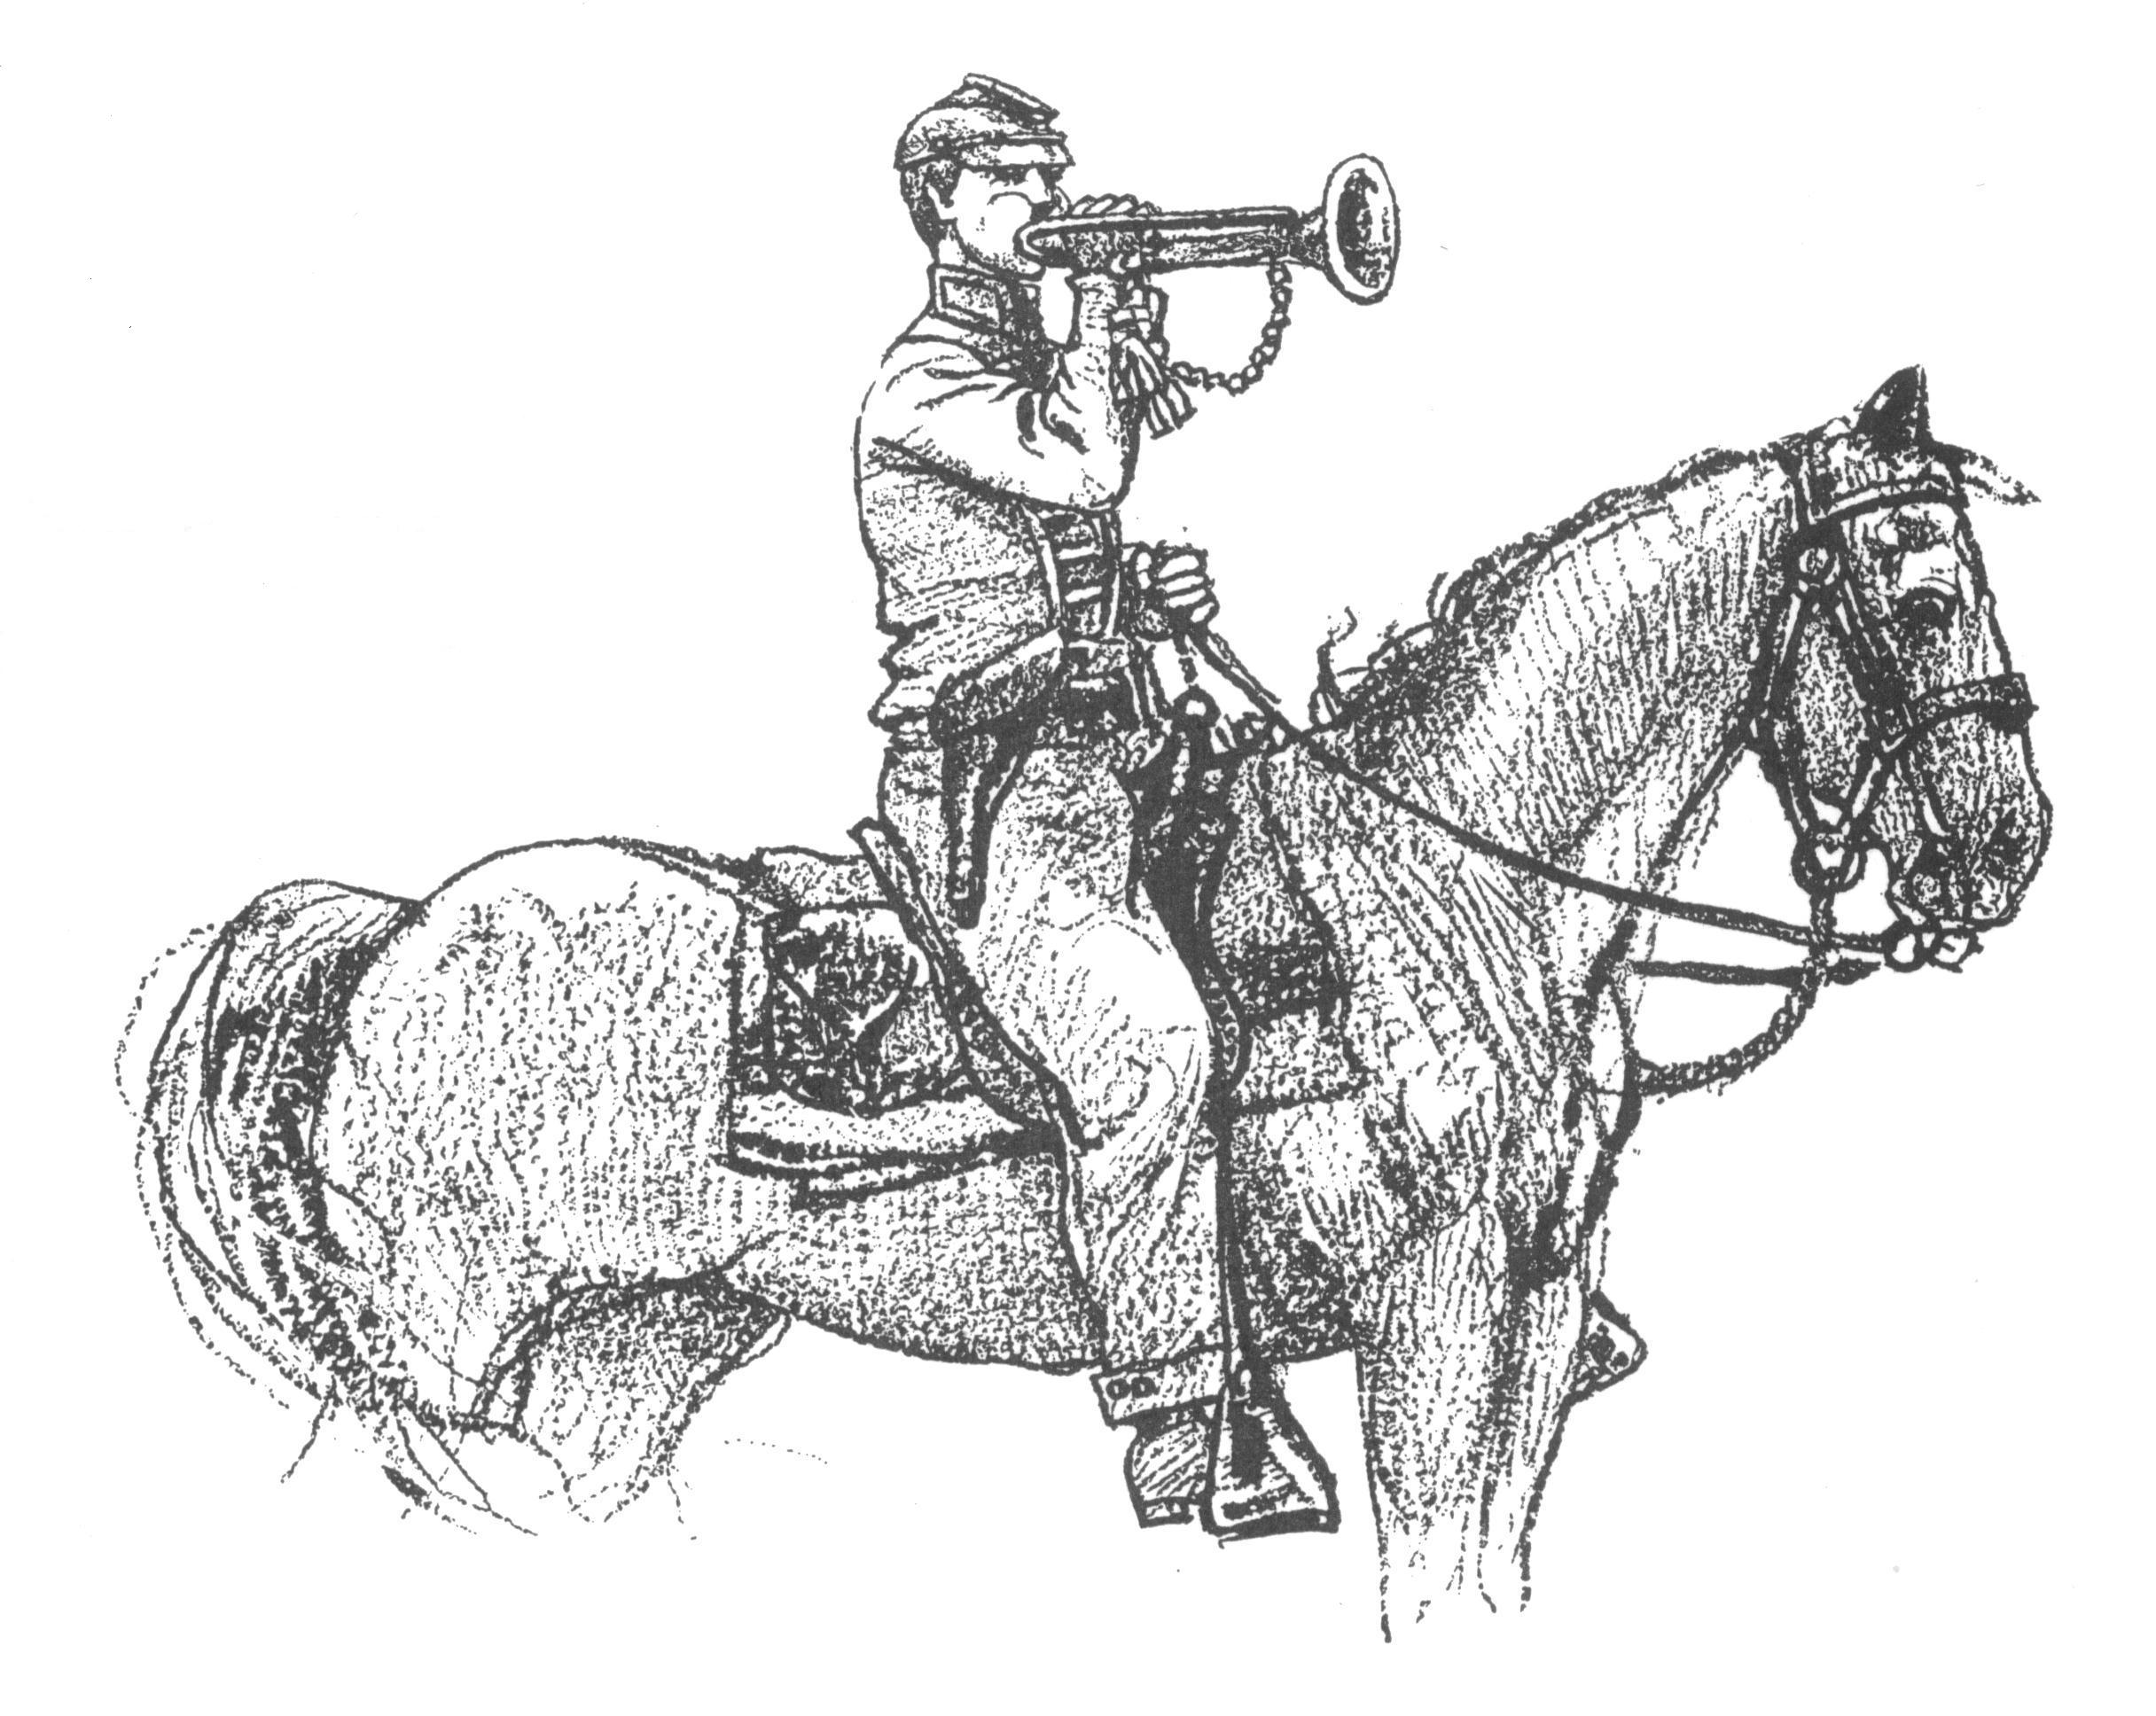 Call to Duty – Camp Calendar
Thursday, October 4th – Regular Monthly Meeting Thursday, November 2nd – Regular Monthly Meeting
Western Steer Western Steer
7 PM – Meal 7:30 Meeting 7 PM – Meal 7:30 Meeting
Program: Mike Mull Program: TBA - Officer Nominations

It is Dues Renewal Time

Because of the pro-rated dues system, members who have joined within the last year may not be required to renew. All others are due now. Please contact Tony with any questions about your dues.

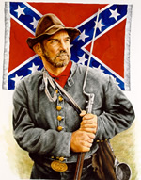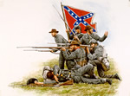
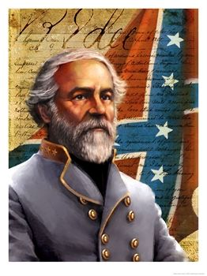
"Everyone should do all in his power to collect
and disseminate the truth, in the hope that it may
find a place in history and descend to posterity.
[Southern]History is not the relation of campaigns and battles
and generals or other individuals, but that which
shows the principles for which the South contended
and which justified her struggle for those principles."
--Robert E. Lee

Commemorative Medals
We still have some General Lee Commemorative Medals from the Reunion. If you would like one or know anyone who does, let Randy or Tony know.
These medals are truly a lasting tribute to the hard work the Camp put forth to put on the Georgia Division Reunion. Many members from across the state said this was the best reunion they had ever attended and the medals were the nicest Commemorative Relic from any Reunion. WE made the YEAR of LEE special.
These medals make great heirlooms because they are One of a Kind. When they are gone, there won’t be anymore like them. We have gotten requests from all across the South and the supply is shrinking. Get yours today!
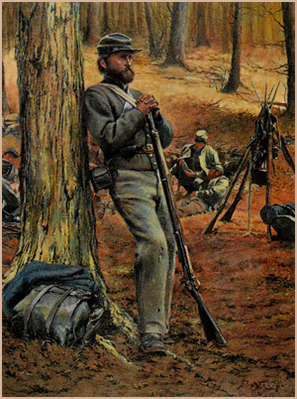Feature Article: Tales from Elmira - Thomas A. Botts: An American Civil War Confederate Prisoner
Confederates who survived the harsh conditions of Elmira Prison looked back fondly on one fellow inmate who did not: a good-natured man with an odd sense of style and a nickname to match. By Hudson Alexander
A thick, gray sky hung over south-central New York State this dead winter's day in early 1864. Against the darkness and the season's barren landscape, Elmira Prison looked particularly gloomy. Indeed, Confederate prisoners there were freezing, starving, and sick, clinging desperately to their lives.
On the surface, the widespread suffering seemed to have little effect on one of the prisoners. An icy wind blowing through his long, dark beard, he strolled nonchalantly about the compound alone. Snowflakes frosted the shoulders of his coat, a strange garment that said more about him than any words ever could.
"He was a large fine specimen of a man and wore a long-tailed coat of brown jeans," wrote fellow prisoner John Williamson Alexander of the 5th Virginia Cavalry. "He had a mania for buttons -- sewn on every available spot of his coat -- hundreds of buttons from every state in the union. You could not put down the point of your finger without touching a button."
Prisoners and guards alike wondered aloud about the unusual coat. "The Yanks plied him with questions," Alexander wrote. "He hesitated and did not want to hurt any feelings. After being hard-pressed, he told them that every time he killed a Yank, he sewed on a button -- and this was his second coat!"
Identified simply as "Buttons," the mysterious eccentric turned up over the years in diary after diary and memoir after memoir. Alexander remembered him as "playful as a kitten." One writer recalled a "strange character" who "fairly glistened" in the sunshine.
A true testament to Buttons's legendary status was the number of apocryphal stories that featured him as protagonist. One of these fabricated accounts, published in Confederate Veteran magazine in 1926, described how he had escaped Elmira by feigning death. According to that article, Buttons lay in a coffin that was en route to the cemetery beyond the prison grounds for interment. Suddenly, he popped open the casket lid, frightening the burial party off into the adjacent woods. He then climbed out and ran away to reunite with the Confederate army.
Despite all the references to Buttons, his true identity remained a mystery. Fellow Elmira prisoners had given him the nickname almost immediately upon his arrival, and for obvious reasons, they remembered it long after they had forgotten his given name. The phenomenon was common among former prisoners trying to record their prison experiences for posterity, according to Berry Benson, a South Carolinian who escaped from Elmira with 10 other inmates in October 1864. "It was generally true that whenever soldiers could hit upon a nickname which was in any way characteristic, that name would take preference over the legitimate one," he wrote. After a while, the real name was gone, if anyone had ever known it. Such was Benson's experience with Buttons: "I never heard him called by any other name than Buttons."
The truth behind the legend of Buttons might have been lost forever if not for a woman named Annie Alexander Johnson. A member of the United Daughters of the Confederacy, she urged her brother to record his memories of his days as a Confederate soldier and prisoner of war. To please his sister, Alexander sketched out the story of his Civil War experience. Once completed, the document lay forgotten in old family files until a descendant in Matthews, North Carolina, discovered it.
In his manuscript, Alexander states that he left his father's farm in Pond Field, just outside Gaffney, South Carolina, and enlisted in the Confederate army at Orangeburg on June 4, 1861. After serving as a private in Company G of the 5th South Carolina Infantry for 10 months, which included the war's opening campaign at Manassas, Virginia, he transferred to Company G of the 5th Virginia Cavalry. During the Battle of Yellow Tavern on May 11, 1864, Alexander was captured. Sent to prison at Point Lookout, Maryland, he remained there for three months before being moved north to Elmira.
It was at Point Lookout that Alexander met Buttons. Fortunately for us, Alexander remembered more than his comrade's nickname, and in the latter pages of his manuscript, he provided the key to the Buttons mystery. Describing the death and disease so prevalent at Elmira, he wrote, "among those who died now of the writer's acquaintance was: that gentle soul, Botts, familiarly called Buttons...."
Feature Article: Tales from Elmira – continued… Further research revealed that "Botts" was Thomas A. Botts, born in 1817 at Abbeville District in South Carolina. He was one of eleven children born to Thomas Cromer Botts and Nancy Moore Botts. No other details have surfaced about his early life.
Information about his adult years is hardly more enlightening. At one point, he was listed as an "overseer" of a farm. On Christmas Eve 1848, he married Matilda Wright at Abbeville. The couple had five children: James (1849), John (1851), Nancy (1857), Asa N. (1859), and E.G., whose exact year of birth is unknown.
As the clouds of war darkened over the North and South, Botts decided to join the Confederate army. On December 28, 1861, he enlisted in South Carolina's Holcombe Legion Infantry Battalion at Camp Hamilton. The 44-year-old private was assigned to the regiment's Company F. The following March, he reenlisted for two more years. The last time Botts saw his family and home was during a brief period between March 6 and April 31, 1862, when military records listed him as "home on leave of absence." Several Botts family descendants speculate that he may have fathered the last of his five children during this furlough.
Later in the war, when Confederate troops were entrenched in defense of Petersburg, Virginia, Botts was captured at Jarrett's Station on May 8, 1864. His first place of confinement is unknown, but many prisoners captured in Virginia about the same time were briefly held at Fortress Monroe, at the tip of the Virginia Peninsula. Before long, Botts was at Point Lookout and on August 17, 1864, was moved to Elmira. He died there on May 14, 1865, less than two weeks before President Andrew Johnson ordered prisoners released. The official cause of death was listed as "rhuematism." Alexander's memoir recalls some of the burial ritual performed for Botts and the nearly three thousand others who died at Elmira:
...I went to the Dead House often, and his [a Reverend Eddy, chaplain of a Texas regiment] was the last kindly act done for our dead. After they were placed in their coffins, it was he who regulated the wooden shavings, which served for pillows for their last long sleep. This done, those rough grizzled carpenters, who were so familiar with death, formed a line with hats off while this good man repeated short burial services -- the last and only service I ever heard while there. This done, the carpenters again got busy and the lids of the coffins were speedily nailed down.
The caskets were then interred at Woodlawn Cemetery, adjacent to the prison compound. That 2.5-acre piece of land was the final resting place for most of the 2,917 who did not survive the rigors of Elmira. In plot No. 2801 lies Thomas A. Botts -- Buttons, to those who knew him.

Check this out !
In an article, which appeared in the New York Tribune, during the War Between the States, a correspondent wrote:
"A people separated from their heritage are easily persuaded,"… This particular correspondent zealously supported the Northern side in the bitter conflict. He went on to say: "If you erase the symbols of a people's heritage, you erase their public identity and memory, and then you can "persuade" them in whatever you want."
The newspaper man was none other than Karl Marx, the Father of Communism

And this…!
The Southern Confederacy will not employ our ships or buy our goods. What is our shipping without it? Literally nothing....It is very clear that the South gains by this process, and we lose. No---we MUST NOT "let the South go." ----Union Democrat , Manchester, NH, February 19, 1861
Okay, even if Lincoln truly only wanted to “preserve the Union” –clearly Big Business, the Media, and those in power realized that if the South was not forcibly kept in the Federal Union, the rich and powerful would lose. Allowing the South the peaceably leave the Union would be like Bill Gates, The New York Stock Exchange, or The Wall Street Journal giving away all their money and not caring where their next dollar or meal came from. Yea - Right! Like that would happen! Nothing could be further from the TRUTH in either case!



Southerners saw the War Between the States more like our Patriot forefathers !
John and Samuel Adams were Northern Patriots from our Colonial Era
But - They had it RIGHT!
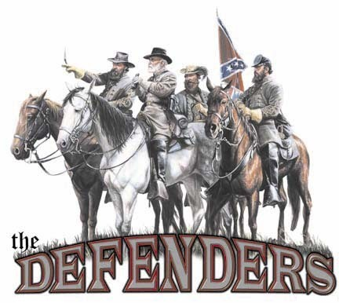
"If ye love wealth greater than liberty, the tranquility of servitude greater than the animating contest for freedom, go home from us in peace. We seek not your counsel, nor your arms. Crouch down and lick the hand that feeds you; and posterity forget that ye were our countrymen."
-Samuel Adams

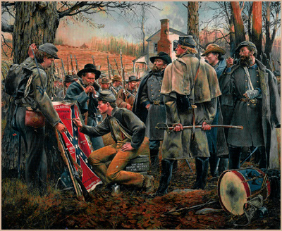
"Liberty cannot be preserved without a general knowledge among the people... Be not intimidated, therefore, by any terrors, from publishing with the utmost freedom...nor suffer yourselves to be wheedled out of your liberty by any pretenses of politeness, delicacy, or decency. These, as they are often used, are but three different names for hypocrisy, chicanery, and cowardice."
-- John Adams

"The liberties of our country, the freedom of our civil constitution, are worth defending at all hazards; and it is our duty to defend them against all attacks. We have received them as a fair inheritance from our worthy ancestors; they purchased them for us with toil and danger and expense of treasure and blood. It will bring an everlasting mark of infamy on the present generation, enlightened as it is, it we should suffer them to be wrested from us by violence without a struggle, or be cheated out of them by the artifices of false and designing men."
-- Samuel Adams

