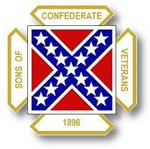
The Dispatch
The Official Publication of The Dixie Guards Camp # 1942
Sons of Confederate Veterans
Metter, Georgia

October 2006

Dixie Guards Camp # 1942
Sons of Confederate Veterans
P.O. Box 761
Metter, Georgia 30439

Postmaster Please Deliver To:

Visit Us Online at:
www.dixieguards.org
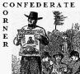 Commander’s Comments
October – Fall is in full swing. Deer season or gun season at least, will be in full swing soon. Football has been in full swing for a while now – Friday’s and Saturday’s people are cheering on the favorite teams. This is all very important to many of us – to us, our families and our community. October is also important to our Camp. October is the last month prior to the November 1st deadline for dues to be turned into International Headquarters. I cannot overemphasize how important this is. I know you probably think that I harp on it too much – but ask yourself…do I? In many ways, we are the only barrier that stands between our Ancestors place in American history and total ridicule and removal. To many, the Confederate Soldier is a blight on American History. They want this blight removed. So, they want anything that can remind someone of the Confederacy to be erased from public view and from the classrooms of our children. There thinking is…if we do away with everything Confederate, we’ll make the world a better place. We'll make the world a better place. Really, they feel this way! Our Ancestors and our Heritage are their targets and with political correctness the way it is, the target just keeps getting easier to hit. If we don’t protect our Ancestors, then we might as well accept the fact that the enemy is gonna win. If they win, the Confederate Flag will be gone. The statues honoring the Confederate Soldiers all across the Southland will be gone. The streets named for Confederate heroes will be renamed. Are you starting to see my point?
I think you’ll agree - I’m not a pessimist. This is very real. Just ask any of the big wheels of our enemies…they don’t even try to hide their ideals anymore, nor do they try to disguise them. They are very blatantly out in the open with the fact that the Confederate Flag must go and sooner than later. You may be asking yourself…how does this really have anything to do with us here in tiny little Metter, Georgia. Well, I’ll tell you. Studies are showing that Georgia is one of, if not the fastest growing states on the East Coast. The area that some researchers are now started to call the Savannah-corridor includes Metter-Candler County. In the next few years, Savannah and its area is projected to have a population boom. They can’t live in the ocean, so that means the people moving into Southeast Georgia are going to begin to migrate westward. Like I said, Metter is in the Savannah-corridor. The once very rural counties of Liberty and Effingham have been growing in astronomical numbers over the recent years. Bulloch County’s growth is unbelievable too. Little towns like Metter, Claxton, and Reidsville are going to grow, whether we want them to or not. The people are going to come. Let’s face it; most of them won’t be Georgians. How do you think they’ll play into our heritage if issues begin to come to votes or we need support? We better get ready. The battles will start small at first, but they’ll come. The blatant enemies will try to “out shout” and “out protest” us. Here in Metter and in our neighboring little towns, we simply have got to be prepared.
We have got to grow our Camp. We have got to develop a good relationship with our local populace. We have got to develop and maintain proof-positive that we are right to honor our Ancestors and anyone that portrays us as anything but honorable men are the sinners. We have got to make absolutely certain that we have the solid base of support that it will take to weather a storm that will come. It will hit our schools – it will hit our monument drive – it will hit our public image – it will hit our membership numbers. Rest assured - it is coming. The Flag fight came and went and sadly, now it is gone! You better get it in your memory, because that is where it is…memory! No politician at the State Level is going to build and maintain enough support in either of the 2 major parties in Georgia to give Our Flag a fighting chance to win. Besides, in the next few years, it might not have a chance to win anyway with all these immigrants. They don’t care and they don’t know about our heritage. All they know is a dollar bill, cheaper land, cheaper taxes and a milder climate. Think about it, who is coming….they ain’t Southerners!
So, what can we do now? Build that solid base I was talking about. That is the reason I believe with all my heart the Georgia Division must double its membership. If we don’t, we’re in trouble once all these uncaring Yankees get down here. They’ve already taken Atlanta for the most part. Savannah is beautiful and it is on the “I want to live there list”. They’re coming, let’s get ready.
At the battle of 1st Manassas, the Confederate Generals realized that we had very green troops who didn’t understand the horrors of warfare. They realized that to have any chance of victory, the Confederates had to hunker down and prepare for the invasion. Union General McDowell had the advantage and he had more troops, yet he was routed by the hunkered Confederates fighting for their homeland. Georgia belongs to US! Metter and all our neighboring communities belong to US! For the sake of our Ancestors…for the sake of our Children…for the sake of our Honor, we must hunker down and prepare for the invasion. Our first battle plan should be to recruit, retain and reactivate every possible member and to invite unqualified friends to become “associate members”. We can do it….we must do it! Otherwise, how will we ever be able to face them when our time comes?
God Bless You and Your Family,
Randy

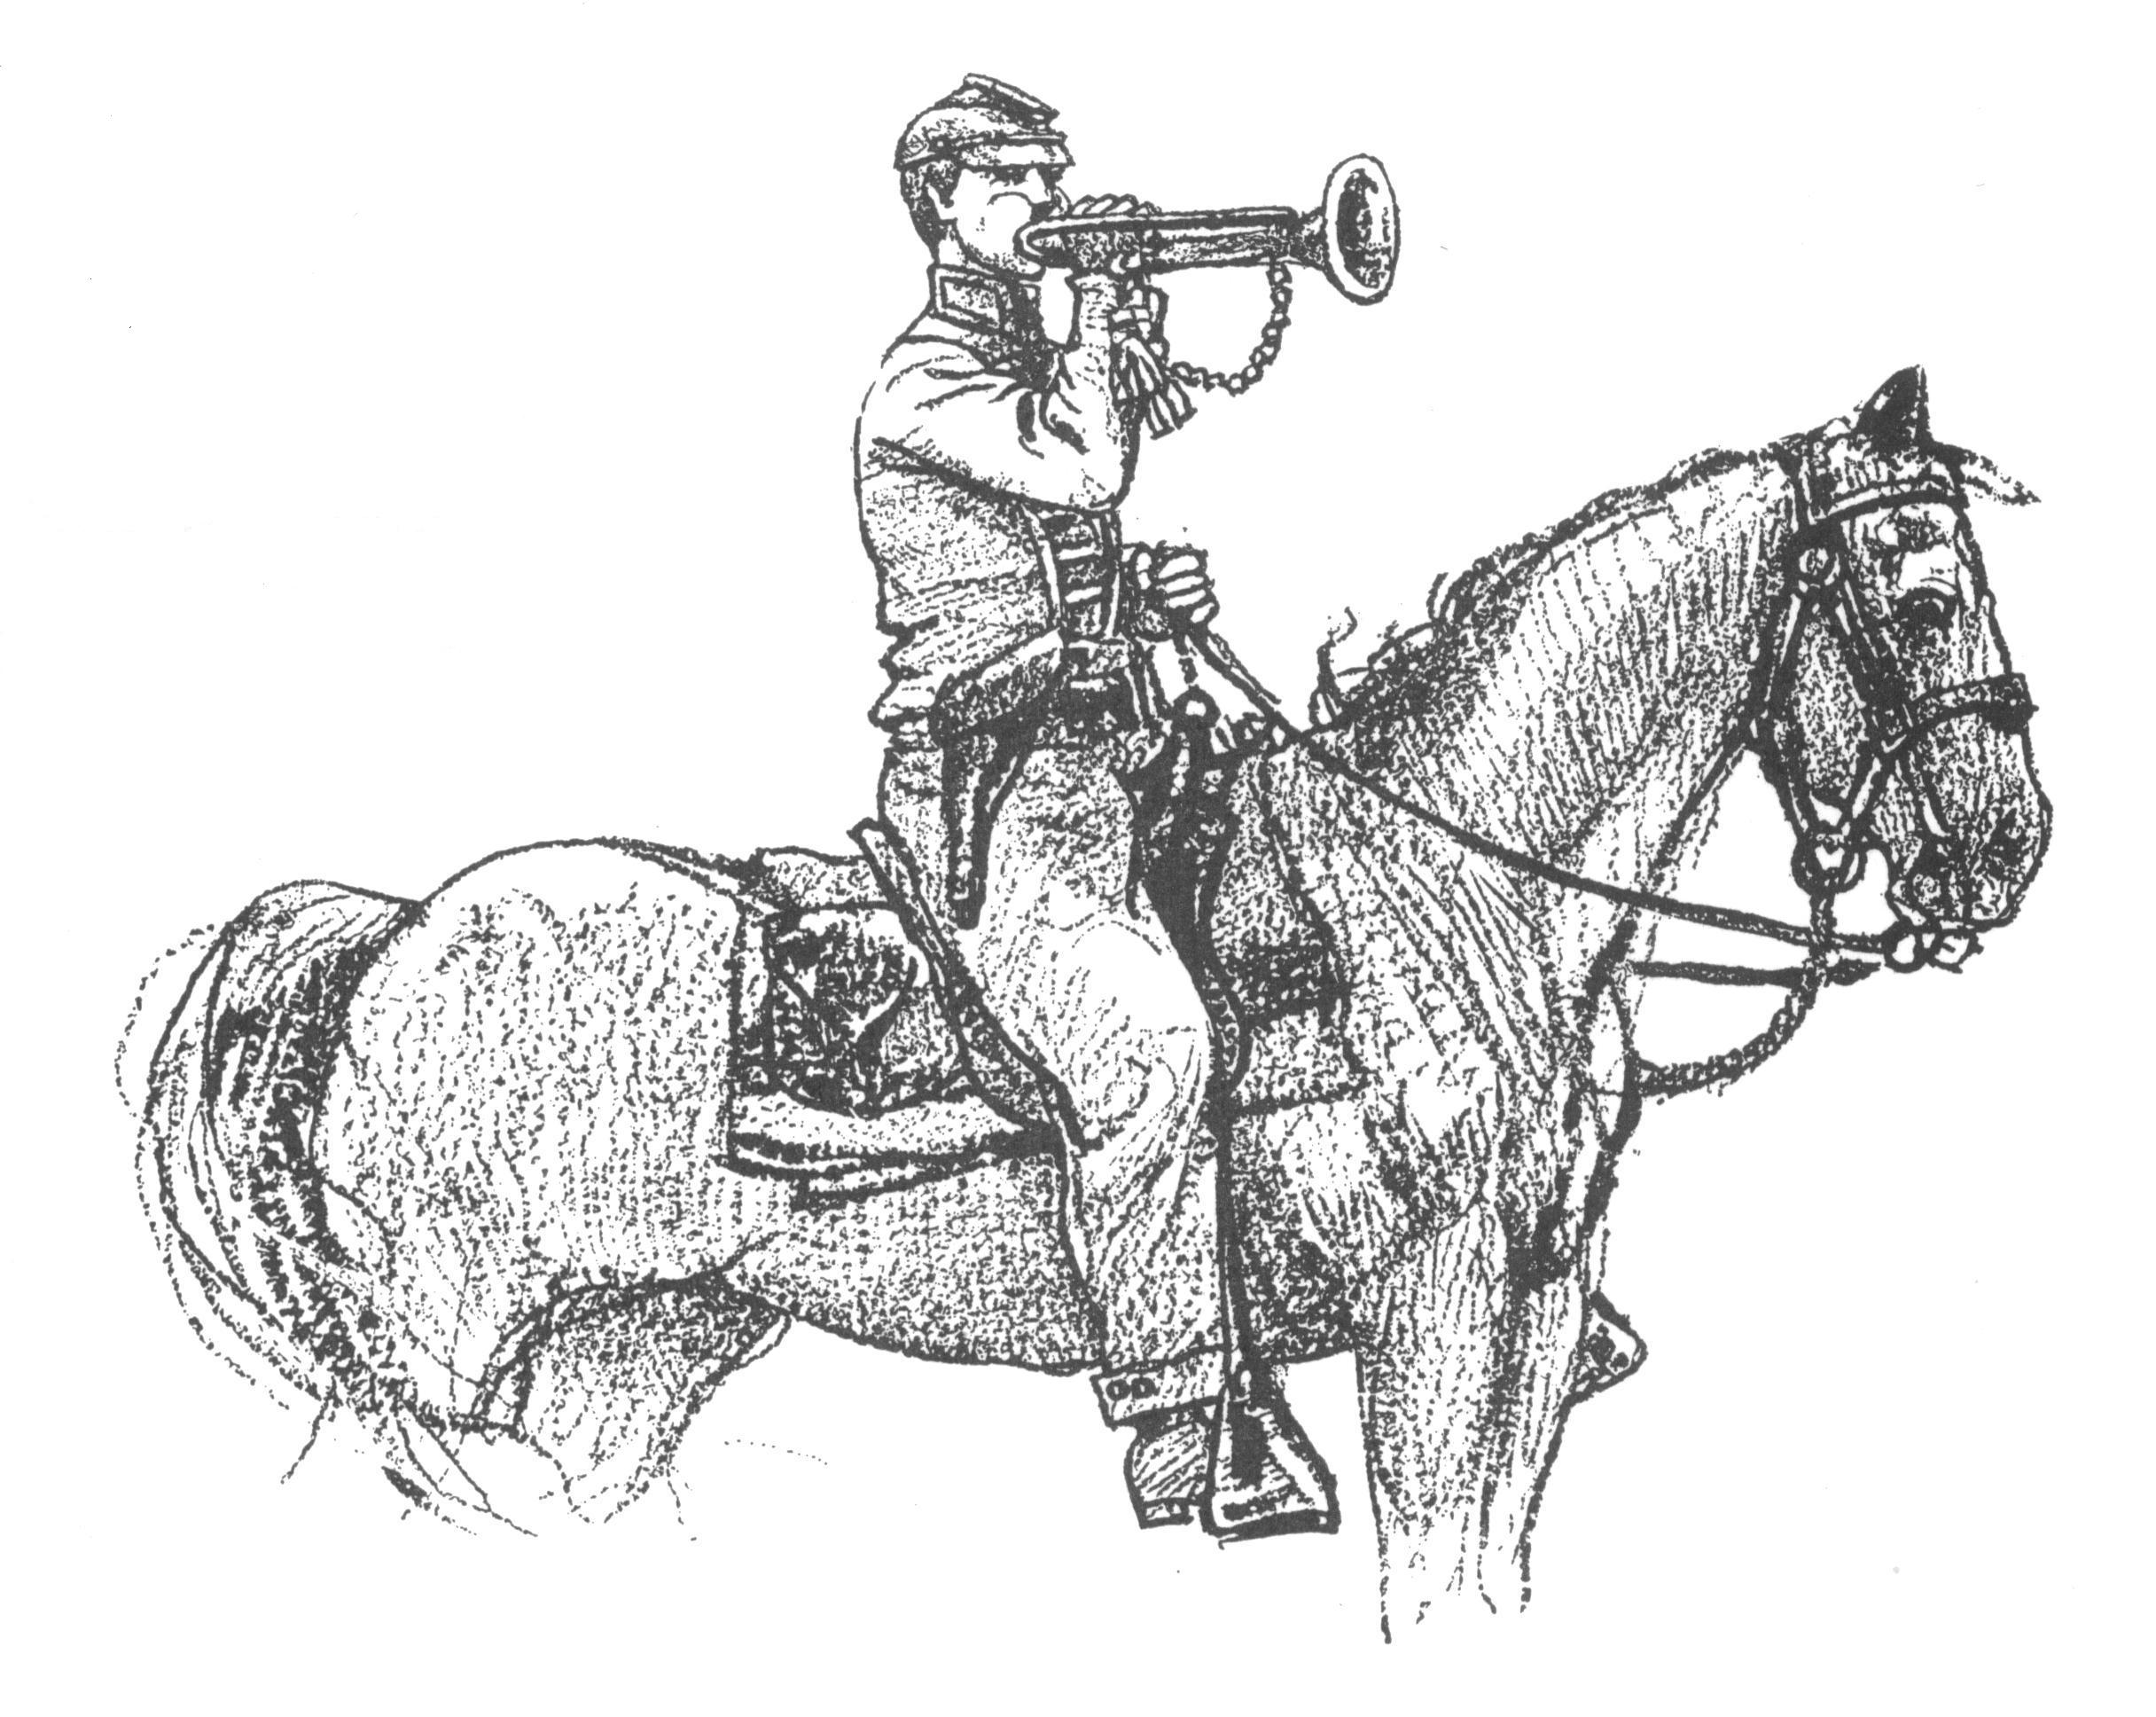 Call to Duty – Camp Calendar
Thursday, October 5th – Regular Monthly Meeting Thursday, November 2nd – Regular Monthly Meeting
7 PM – Meal / 7:30 PM Meeting 7 PM – Meal / 7:30 PM Meeting
Western Steer - Metter Western Steer - Metter
Program/Speaker – Grady Franklin Program/Speaker – TBA



"All that was, or is now, desired is that the error and injustice be excluded from the textbooks of our schools and from literature brought into our homes; that the truth be told, without exaggeration and without omission; truth for its own sake and for the sake of honest history, and that the generations to come after us not be left to bear the burden of shame and dishonor unrighteously laid upon the name of their noble sires."
- Rev. James Power Smith, Last survivor of the staff of General Stonewall Jackson
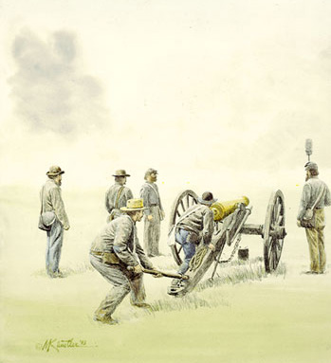
This month’s feature article is actually a copy of the report of W. P. Howard to Governor Joseph Brown relaying him information of the destruction of Atlanta. I have included it as it was written and have made no attempt to correct any misspellings, etc….

The Destruction of Atlanta
Atlanta, Ga., Dec. 7th, 1864
To His Excellency Joseph E. Brown, Governor of Georgia:
In obedience to orders of Nov. 25, to inspect the State property in Atlanta, and the city itself, and protect the same, I have the honor to make the following report. With it I beg leave to present your Excellency with a pencilled map of the city, showing the position of every house left unburned.
The property of the State was destroyed by fire, yet a vast deal of valuable material remains in the ruins. Three-fourths of the bricks are good and will be suitable for rebuilding if placed under shelter before freezing weather. There is a quantity of brass in the journals of burned cars and in the ruins of the various machinery of the extensive railroad shops; also, a valuable amount of copper from the guttering of the State depot, the flue pipes of destroyed engines, stop cocks of machinery, etc. The car wheels that were uninjured by fire were rendered useless by breaking the flanges. In short, every species of machinery that was not destroyed by fire was most ingeniously broken and made worthless in its original form -- the large steam boilers, the switches, the frogs, etc. Nothing has escaped. The fire engines, except Tallulah No. 3, were sent North. Tallulah has been overhauled and a new fire company organized. Nos. 1 and 2 fire engine houses were saved. All the city pumps were destroyed, except one on Marietta Street. The car shed, the depots, machine shops, foundries, rolling mills, merchant mills, arsenals, laboratory, armory, etc., were all burned.
In the angle between hunter Street, commencing at the City hall, running east, and McDonough Street, running southern, all houses were destroyed. The jail and calaboose were burned. All business houses, except those on Alabama Street, commencing with the Gate City Hotel, running east to Loyd Street, were burned. All the hotels, except the Gate City were burned. By referring to my map, you will find about 400 houses standing. The scale of the map is 400 feet to one inch. Taking the car-shed for the center, describe a circle, the diameter of which is twelve inches, and you will perceive that the circle contains about 300 squares. Then, at a low estimate, allow three houses to every 400 feet, and we will have 3600 houses in the circle. Subtract the number of houses indicated on the map, as standing, and you will see by this estimate, the enemy have destroyed 3200 houses. Refer to the exterior of the circle, and you will discover that it is more than half a mile to the city limits, in every direction, which was thickly populated, say nothing of the houses beyond, and you will see that the enemy have destroyed from four to five thousand houses. Two-thirds of the shade trees in the Park and city, and of the timber in the suburbs have been destroyed. The suburbs present to the eye one vast, naked, ruined, deserted camp. The Masonic Hall is not burned, though the corner-stone is badly scarred by some thief, who would have robbed it of its treasure, but for the timely interference of some mystic brother.
The City Hall is damaged but not burned. The Second Baptist, Second [Central] Presbyterian, Trinity and Catholic churches and all the residences adjacent between Mitchell and Peters streets, running south of east, and Loyd and Washington streets running south of west, are safe, all attributable to Father O'Reilly, who refused to give up his parsonage to Yankee officers, who were looking out for fine houses for quarters, and there being a large number of Catholics in the Yankee army, who volunteered to protect their Church and Parsonage, and would not allow any homes adjacent to be fired that would endanger them. As a proof of their attachment to their Church and love for Father O'Reilly, a soldier who attempted to fire Col. Calhoun's house, the burning of which would have endangered the whole block was shot and killed, and his grave is now marked. So to Father O'Reilly the country is indebted for the protection of the City Hall, Churches, etc.
Dr. Quintard's, Protestant Methodist, the Christian, and African churches were destroyed. All other churches were saved. The Medical College was saved by Dr. D'Alvigny who was left in charge of our wounded. The Female College was torn down for the purpose of obtaining the brick with which to construct winter quarters. All institutions of learning were destroyed. The African church was used as an academy for educating negroes. Roderick Badger, a negro Dentist, and his brother, Bob Badger, a train-hand on the West Point and La Grange Railroad, both well known to the citizens of Atlanta, were assistant professors to three philanthropic Northmen in this institution. Very few negroes remained in the city. Thirteen 32-pound rifle cannon, with cascabels and trunnions broken off and jammed in the muzzles, remain near the Ga. R.R. shop. One well reported to be filled with ammunition. Fragments of wagons, wheels, axles, bodies, etc., are strewn over the city. Could I have arrived ten days earlier, with a guard of 100 men, I could have saved the State and city a million dollars.
There are about 250 wagons in the city on my arrival, loading with pilfered plunder; pianoes, mirrors, furniture of all kinds, iron, hides without number, and an incalculable amount of other things, very valuable at the present time. This exportation of stolen property have been going on ever since the place had been abandoned by the enemy. Bushwhackers, robbers and deserters, and citizens from the surrounding country for a distance of fifty miles have been engaged in this dirty work.
Many of the finest houses, mysteriously left unburned, are filled with the finest furniture, carpets, pianoes, mirrors, etc., and occupied by parties who six months ago lived in humble style. About fifty families remained during the occupancy of the city by the enemy, and about the same number have returned since its abandonment. From two to three thousand dead carcasses of animals remain in the city limits.
Horses were turned loose in the cemetery to graze upon the grass and shrubbery. The ornaments of graves, such as marble lambs, miniature statuary, souvenirs of departed little ones are broke and scattered abroad. The crowning act of all their wickedness and villiany was committed by our ungodly for in removing the dead from the vaults in the cemetery, and robbing the coffins of the silver name plates and tipping, and depositing their own dead in the vaults.
I have the honor to be, Respectfully,
Your obedient Servant,
W.P. Howard

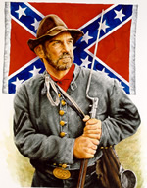 "I must not forget our old flag — though torn & tattered & faded. In the three days of fighting, although about 18 inches was torn off the end & lost — there is fifteen bullet holes through the flag & three through the staff — & besides there is a large rip made by a piece of a bomb. Three color bearers were shot down & the fourth now carries it. If I should live through the war I would want no brighter monument than this faded flag to decorate my parlor walls — (Provided I ever have a parlor)." … James C. Bates CSA

Can You Help Us Remember Men Like James C. Bates…Men Like Your Ancestor?
Please help us by sharing the names & information of 4 potential members – if you can’t contact them, we’ll contact them for you. We’ll still honor you as the recruiting member if they join! Just fill this out & bring it to the next meeting.

Name_____________________________ Name_____________________________
Address___________________________ Address___________________________
___________________________________ ___________________________________
Phone_____________________________ Phone_____________________________
Recruiting Member_______________________________ Recruiting Member_______________________________

Name_____________________________ Name_____________________________
Address___________________________ Address___________________________
___________________________________ ___________________________________
Phone_____________________________ Phone_____________________________
Recruiting Member_______________________________ Recruiting Member_______________________________

Is Membership Important?
Is Recruiting Important?
Is Retention Important?

You Decide For Yourself!
“All that is needed for evil to flourish is for good men to do nothing. Or remain silent.”
- an American Patriot
Poor is the nation who has no heroes, but BEGGARD is the nation who has and forgets them.

Here is an article that illustrates the Battle over Our Heritage – How we are portrayed by people who don’t even know us and how radicals portray our Ancestors and Emblems.

The Confederate Flag Desecration - Messing with the First Amendment has consequences.
By Jamin Raskin and Michael Anderson
When the House of Representatives passed the flag desecration constitutional amendment last week, did the Southern conservatives voting yes understand that they were taking a giant first step towards criminalizing display of the Confederate flag?
Everyone knows, of course, that the Confederate flag was the banner of secession and treason, as the Union saw it. But most people don’t know that the Confederate flag design itself was a taunting rip-off and physical desecration of the Stars-and-Stripes. It takes the physical elements of the Union flag and rearranges them in a deliberate parody: five-pointed white stars, against a blue background, against a red field suggesting blood or fire. In the first year of the Civil War, the Richmond Dispatch explained it well:
As the old flag itself was not the author of our wrongs, we tore off a piece of the dear old rag and set it up as a standard. We took it for granted a flag was a divisible thing, and proceeded to set off our proportion. So we took, at a rough calculation, our share of the stars and our fraction of the stripes, and put them together and called them the Confederate flag.
Richmond Dispatch, “The Confederate Flag,” 7 December 1861. When Confederate flag-makers used a soft pink background for the first Confederate battle-flags, General P.G.T. Beauregard demanded a more murderous theme: “dye it red sir, dye it with your blood!”
In fact, the modern-day cult of the US flag (with the rituals of correct flag display) started as a campaign to punish the South after the Civil War. The Grand Army of the Republic, a Union veteran’s organization, led the campaign to enshrine the U.S. Flag in the 1880s and 90s in reaction against reconciliation with the South. It was part and parcel of the GARs refusal to return captured Confederate flags (the emblems of treason). The Grand Army of the Republic’s demands to criminalize desecration of the US flag were tied to the campaign to make display of the Confederate flag illegal. Dearing, Veterans in Politics (LSU Press 1952) at 410-412; McConnell, Glorious Contentment: The Grand Army of the Republic (UNC Press 1992) at 192, 229-230.
If the absurd thought-control amendment to criminalize flag desecration is passed, it can and should be used to ban all display of the seditious Confederate parody of the Flag. No symbolic defacement of the U.S. Flag has been more strongly associated with violent rebellion against the United States.
Now, nervous supporters of both the flag amendment and the Confederate flag may object that flag desecration only means flag burning, as if the passive act of displaying the disrespectfully rearranged elements of the flag will still enjoy First Amendment protection.
This is, of course, completely wrong. Desecration is a metaphysical concept. The Flag is not just a particular physical flag, but a symbolic design that is protected, in the words of the (currently unconstitutional) federal flag statute, as to any part thereof, made of any substance, of any size, in a form that is commonly displayed. After the Flag Desecration Amendment, courts will not acquit people who display half-burnt or blood-spattered or spray-painted flags, just because the physical defiling happened beforehand. The display itself is a physical act. What’s more, the display would make the displayer an accessory after the fact, entitled to no more First Amendment protection than someone who buys child pornography.
Since “desecration” is a metaphysical concept that means to strip something of its sacredness or to profane a holy object, the new flag police will have to make moral judgments about whether our flag has been dishonored in a particular case. If our Constitution is going to be changed to permit this kind of thought control, let’s make one thing perfectly clear. The Confederate flag is historically the worst and clearest defacement of the U.S. Flag. Its bloody symbolic parody of the elements of the U.S. Flag was associated with the worst internal attack on the Union for which it stands. So get ready, Senator Lott: after the Flag Amendment passes, we’re coming for your desecrated flag, too.

Jamin Raskin is a professor of constitutional law at American University and author of Overruling Democracy. Michael Anderson is a union lawyer in Boston.

