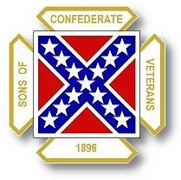
The Dispatch
The Official Publication of The Dixie Guards Camp # 1942
Sons of Confederate Veterans
Metter, Georgia

November 2006

Dixie Guards Camp # 1942
Sons of Confederate Veterans
P.O. Box 761
Metter, Georgia 30439

Postmaster Please Deliver To:

Visit Us Online at:
www.dixieguards.org
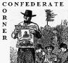 Commander’s Comments
By the time you receive this newsletter, our November 1st deadline for the Renewal of dues will have passed. I can only say that I hope that everyone has renewed. I want to thank Carlton Clifton for working so hard to contact members personally to encourage them to renew. Gentlemen, I know that I harp on membership all the time and I apologize for that. But frankly, I don’t see any alternative. Membership is the key to the survival of our organization. Numbers are what politicians recognize and the only thing that frightens our enemies.
The Holiday season is upon us. As Thanksgiving rolls around let us remind ourselves that we are blessed to live in the greatest Nation on earth and that fact that we live in the Greatest Section of that Nation. As we enter the Christmas season, you’ll certainly notice that Christmas is under attack. I don’t doubt that the effort that became famous last year will be followed up this year by those who would deny people the right to display Christmas trees in public or to celebrate the birth of Christ. These attacks are the same type that our organization and our ancestors have been going through for years. How much better would society be now if organizations like the SCV had been more active just a few years ago? The Georgia Division SCV had its first big membership expansion when Governor Zell Miller announced his Flag Change Plan. The SCV‘s membership has grown since because of the wake up call. Up until that attack to our Ancestor’s Honor the SCV had been largely a social-type club or a fraternity of brotherhood. It caused us to mobilize. In Georgia, the SCV’s membership got another big shot in the arm when Governor Barnes robbed us of Our Flag. For example, our Camp was chartered just after that; so was Kite’s just up the road. Many other small towns followed suit.
Here’s where the rubber meets the road with this story. Over the years it has taken strife to cause us to do the right thing when it comes to our Ancestors. The SCV simply didn’t get out its message well before our Flag attacks and other attacks began to surface. Now, we are behind in the race and frankly our enemies are winning. They’ve had a head start on us for years. The example of our losses should tell the Christian community and those who cherish the celebration of Christmas that just because things are “Right” and “Good” don’t make them safe from Political Correctness.
Last year, when all the Christmas Tree Attacks began I heard people all around Metter saying things like…”That will never happen here!” In 2000, did you ever think Roy Barnes would not only attack the Flag but would change it? No, you didn’t. If we are not careful, these radicals will steal Christmas from us too. Why do I say that? Because these Political Correctness People make their money from controversy and money drives people.
Go check out the archives or any area newspaper. Just a few years ago, there was never any complaint about the Flag, Dixie or anything else Southern. Do you remember that the University of Georgia Band just prior to the 1980 National Championship Season was named the “Dixie Redcoat Band” – did you hear that…Dixie Redcoat Band. And, they played it at just about every halftime show. Wow, how times have changed. You can’t even buy a Georgia Band album or CD with Dixie on it anymore. They deny that play or played it and just like Disney’s Song of the South…they’d rather you forget it ever existed. So, listen up Christmas fans…our Ancestors can vouch to the fact that the attacks won’t end unless you flat out tell the folks to shut up and get out of your life.
On to happier stuff – On Thursday, December 7th is the annual Metter Chamber of Commerce Gala. The Christmas Tree Lighting was re-scheduled to not conflict with it. We decided a couple of meetings ago that our Regular Meeting for December would be the Lighting…since then, the Gala & Lighting events have been swapped. We will still participate with the Lighting and it will be Thursday, November 30th. We’ll be taking the pictures of the kids & Santa. We get to help out and make the profits of the pictures. We have the use of a digital camera, computer and printer to create nicer pictures instead of Polaroid pictures. Why not bring your kids out to see Santa and help out the Camp by having their picture made with Santa. Wear your SCV shirt and invite people to come hear about the SCV.
On anniversary of the Attack on Pearl Harbor, our Camp will participate in the annual Chamber of Commerce Gala instead of our Regular Meeting. The Camp is donating a couple of Mrs. Katie Love’s Quilts to be auctioned off by the Chamber and they should get quite a response. Additionally, there will be some Confederate-themed packages that will be auctioned off as well, including a Robert E. Lee package. Trust me; I know that the Robert E. Lee stuff will be there! Anyway, this will be a wonderful opportunity for good Public Relations for our Camp. Come out and wear your SCV shirts. Let everyone see that you a SCV member. Make membership a topic of discussion. Just about every man there will be qualified to be a member. Many simply don’t know us or have not been asked. Many are afraid of what people might say if they join. Ask them…our efforts in Public Relations will pay off in the long run. We are very active in our community and these men simply cannot afford to overlook us any longer. Come prepared to invite them to join, bring some applications. If they are kin to you tell them they have “No Excuse Anymore”…they can join under your Ancestor. The Gala gives us the opportunity the kick off the Year of Lee with a bang…See you at the Christmas Tree Lighting and the Gala – I can’t wait!

God Bless You and Your Family,
Randy
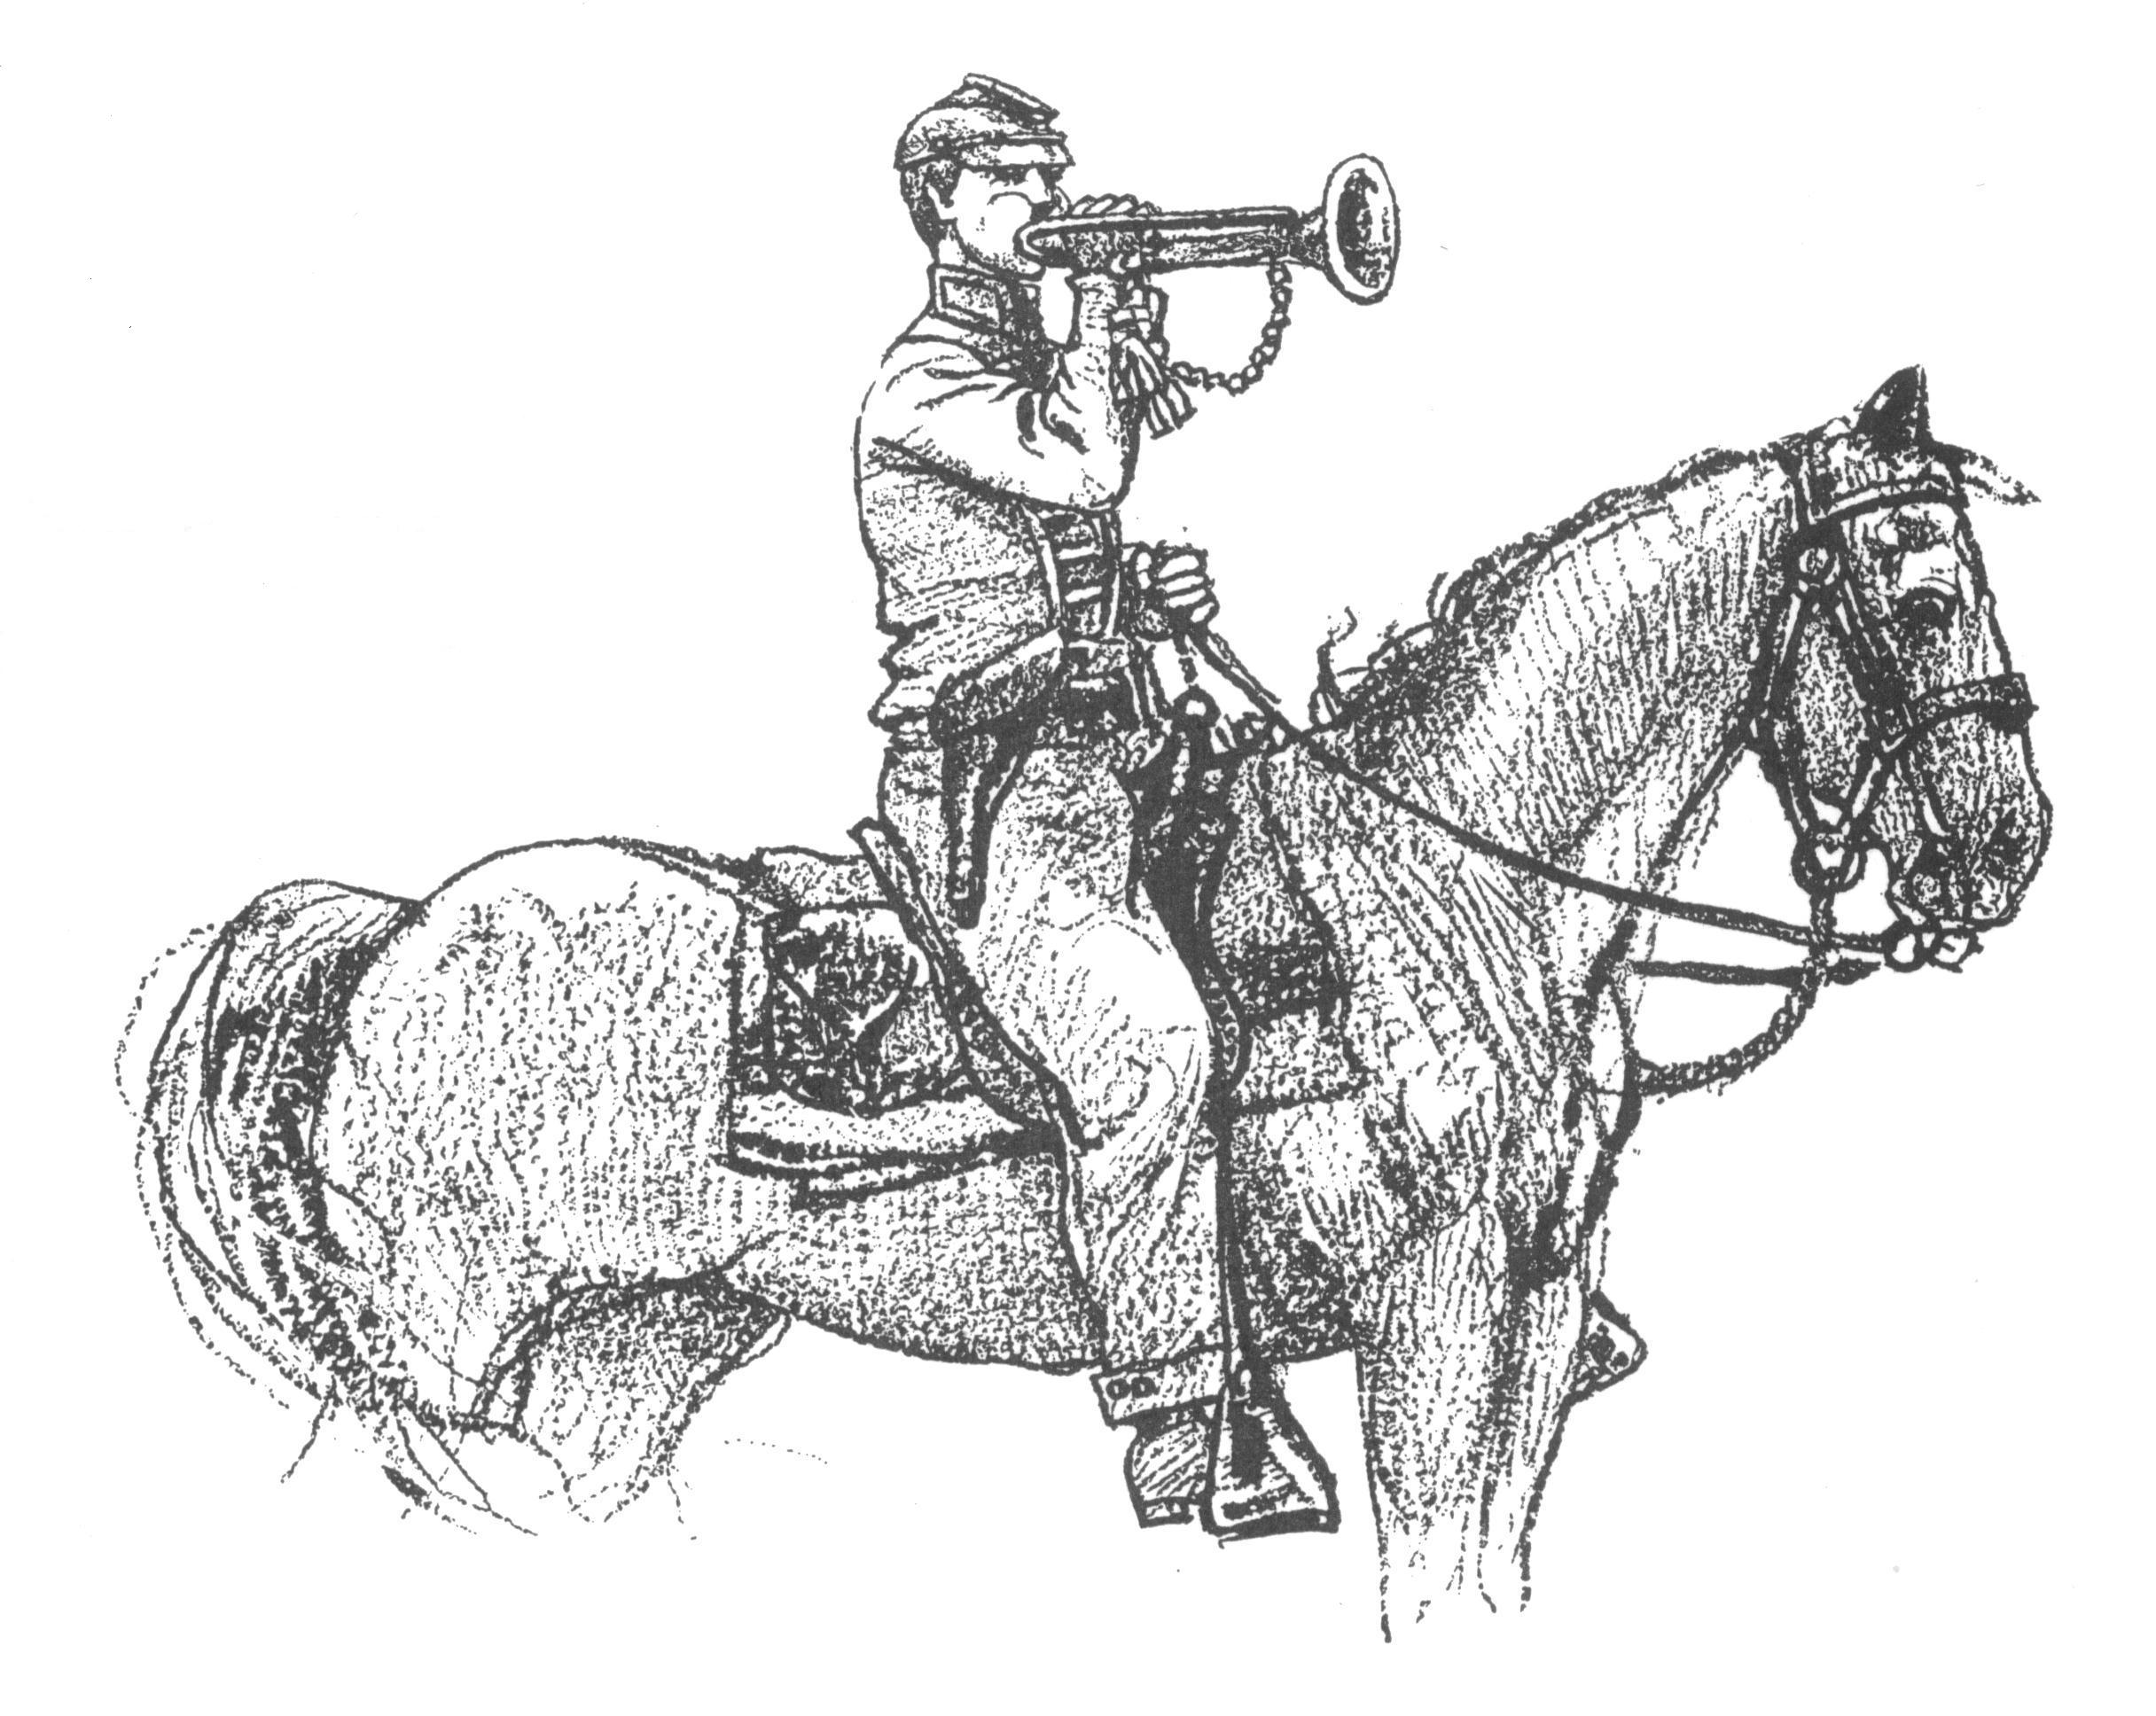 Call to Duty – Camp Calendar
Thursday, November 2nd – Regular Monthly Meeting Thursday, December 7th - Chamber of Commerce Gala
7 PM – Meal / 7:30 PM Meeting in lieu of Regular Meeting
Western Steer - Metter *Camp has donated several distinguished items for auction
Program/Speaker – TBA Time to Be Announced – Contact Randy for details



"All that was, or is now, desired is that the error and injustice be excluded from the textbooks of our schools and from literature brought into our homes; that the truth be told, without exaggeration and without omission; truth for its own sake and for the sake of honest history, and that the generations to come after us not be left to bear the burden of shame and dishonor unrighteously laid upon the name of their noble sires."
- Rev. James Power Smith, Last survivor of the staff of General Stonewall Jackson
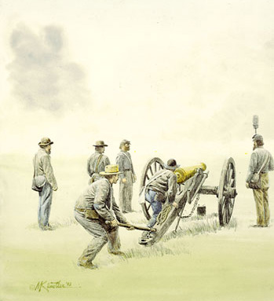 Feature Article: 2nd Manassas: Pope’s Obsession with Stonewall Nearly Destroys the US Army
When Robert E. Lee took over for the severely wounded Joseph E. Johnston, the Confederates had an unproven commander. But soon, Lee would prove to be the great general that Union General Winfield Scott claimed that he would be. In fact, a few years before the war, Scott said of Lee, “Robert E. Lee is the greatest living soldier in the world.” 2nd Manassas may have proven Scott’s claim, at least with a properly led and supplied army. Confederate General Longstreet always claimed that 2nd Manassas was Lee’s shining moment. Here is why.
After Lee drove McClellan back down the peninsula and away from Richmond in the summer of 1862, Lee and his army were still faced with terrible problems. Lee only had about 50,000 troops. McClellan was retreating with far more and to the North in Maryland was the Union Army of Virginia under Major General John Pope. The Federals wanted to try to unite and simply crush Lee’s army in a scissors move. A good plan and Lee was concerned that they might try it. So, not only was Richmond still vulnerable but Lee’s entire army was too.
So, Lee began to stir his men to eliminate the threat of Pope while McClellan was licking his wounds and before he could maneuver to unite with Pope. In Special Orders No. 185, Lee dispatched the newly christened Army of Northern Virginia to intersect Pope. In the orders, Longstreet would have the Right Wing; Jackson would have the Left Wing and Stuart would have the Cavalry. The famous Corps had not been indoctrinated yet, so we can’t use the terms 1st Corps or 2nd Corps – just Wing Commands.
Jackson move out and crossed the Rappahannock in the face of Pope and his army. Pope was cocky and looked forward to the meeting. In a note to one of his commanders Pope said, “I desire the enemy to cross as large a force as he pleases in the direction of Warrenton.” Here, he was speaking of Jackson’s Wing. Pope and his army were waiting. Not long after Jackson got across the river, a terrible rainstorm came and engulfed the area. All of the rivers and streams in the area were heavily flooded. Pope was convinced that Jackson was trapped. In fact, he bragged to that fact with several of his commanders and even to Federal Commander-in-Chief Halleck in Washington. On August 23, 1862 speaking of the condition of the rivers he wrote to Union General Sigel that the river had risen, “6 feet and is entirely impassable at any ford.” He wrote the same thing to Halleck. He bragged that Jackson was trapped on one side of the river and Longstreet the other.
Pope had not been with the Federal armies in the Eastern Theatre of Operations for very long. Lincoln had brought him east because of his success in the west. Sigel had been in the east and knew more about how Jackson and Longstreet worked that did Pope. He suspected that Jackson would not sit idly by and wait to be destroyed and he was right. Jackson was maneuvering to get into the rear of the Federals and wreak havoc. And, he did. Just prior to Jackson attacking Pope’s own headquarters camp, Sigel wrote to Pope, “There is no doubt that the enemy has outflanked us, and that his army crosses near Sulphur Springs and Fox’s or Lawson’s Ford.” In the attack on the camp, Pope’s own dress coat was lost to Jackson’s troops.
Yet, Pope was still convinced that Jackson was doomed and the continued to brag about it. He wrote to Halleck and others, “We shall bag the whole crowd.” While Pope was convinced that Jackson was doomed and that Longstreet was stuck on the other side of the river. Longstreet moved his Wing Command right up to Pope’s flank. He had crossed the river even while Pope was writing that the river had risen 6 feet and could not be crossed.
For a couple of days, Jackson and Pope’s various Corps skirmished and drove at each other. Jackson was trying to determine the locations and strengths of Pope’s army. Once he discovered that Pope far outnumbered him, we redeployed to an unfinished railroad cut in the area that he knew Longstreet would arrive and waited for Pope. All that he had to do was hold out until Longstreet arrived and he thought that he could. Jackson’s battle reports illustrate that he never was overly concerned about defeat by Pope and he never sounds distressed or disturbed. Longstreet arrived on the 29th and the Confederates were reunited in the face of Pope. In fact, Longstreet arrived on the flank of the Pope and put the Federals at a terrible disadvantage. Yet, Pope remained fixated on Jackson. On the 30th, Pope ordered an all out attack on Jackson’s Wing which was conducted by a host of Federal Corps.
Longstreet couldn’t believe it and rushed his artillery up to the front of his command. The Confederate artillery wreaked havoc on the charging Federals. In Longstreet’s report to the Confederate authorities after the battle he said, “It gave me an advantage that I had not expected to have, and I made haste to use it.” His cannons not only challenged the Federal attack on Jackson’s lines, it halted it in its tracks. Next, Longstreet rushed his whole command in a counterattack that drove the Federals completely from the field. The Confederates didn’t even require commanders to demolish the Federal forces. During the night, Pope’s army retreated and was able to get away and possibly prevented a total loss of Union forces. As it was Pope was relieved of command and cashiered from the Union army because of the fiasco.

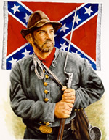 "I must not forget our old flag — though torn & tattered & faded. In the three days of fighting, although about 18 inches was torn off the end & lost — there is fifteen bullet holes through the flag & three through the staff — & besides there is a large rip made by a piece of a bomb. Three color bearers were shot down & the fourth now carries it. If I should live through the war I would want no brighter monument than this faded flag to decorate my parlor walls — (Provided I ever have a parlor)." … James C. Bates CSA

Can You Help Us Remember Men Like James C. Bates…Men Like Your Ancestor?
Please help us by sharing the names & information of 4 potential members – if you can’t contact them, we’ll contact them for you. We’ll still honor you as the recruiting member if they join! Just fill this out & bring it to the next meeting.

Name_____________________________ Name_____________________________
Address___________________________ Address___________________________
___________________________________ ___________________________________
Phone_____________________________ Phone_____________________________
Recruiting Member_______________________________ Recruiting Member_______________________________

Name_____________________________ Name_____________________________
Address___________________________ Address___________________________
___________________________________ ___________________________________
Phone_____________________________ Phone_____________________________
Recruiting Member_______________________________ Recruiting Member_______________________________


