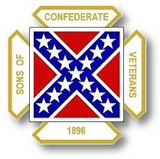
The Dispatch
The Official Publication of The Dixie Guards Camp # 1942
Sons of Confederate Veterans
Metter, Georgia

May 2006

Dixie Guards Camp # 1942
Sons of Confederate Veterans
P.O. Box 761
Metter, Georgia 30439

Postmaster Please Deliver To:

Visit Us Online at:
www.dixieguards.org
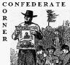 Commander’s Comments

May is here and it’s a busy time of year. Folks are busy preparing for kids to get out of school. Graduation is just around the corner. Man, everyone is so busy. The Camp is sort of the same way. It’s time to report the progress of the Camp to the Division and International Headquarters. As for that, I believe that our Camp is plugging right along and setting a wonderful pace for others to look at. For example, most camp’s set Local Membership Dues. If you’ll remember, we decided from the very beginning not to do this. Our dues are just what are required from the National & State. I have always felt that organizations can “price” themselves out of good members by setting costly local dues. Of course, it is not my place to question other Camps and I won’t, but maybe this has a little to do with some areas having smaller memberships than ours even though they are from larger towns. As for me, I choose to believe that we just have a great, patriotic membership.
Going back to the “no dues” thing…Our current fund raising event has the really good opportunity of making the Camp & the Monument Foundation a lot of money. All we have to do is just sell the raffle tickets and with such great prizes, all we have to do is just mention them in most cases. Just think about it, folks can win a beautiful quilt made by a Real Daughter, with a picture of her & a Certificate of Authenticity. These quilts are true heirlooms that in years to come could be worth untold amounts of money, not to mention that most folks will want to pass them down from generation to generation. We are selling only 2000 tickets and at $5 each, they are a steal. Just think, for $5 there is 3 chances to win 1 of these quilts. For the Camp – 2000 tickets at $5 each is $10,000. That is a lot of money for the Camp & the Monument Fund. Please help us sell the tickets. A picture of Mrs. Love & a Quilt is in this newsletter. We’re going to try to get colored pictures out to everyone to help spur ticket sales, but if we don’t, the one in here will be the same picture, just in Black & White.
Our Youth Baseball Team’s season is starting and according to reports, they are going to be really good. Plus, we hear that they are proud to have our name on their jerseys. I want to encourage everyone to turn out and support the team. It would be great to see SCV hats and shirts in the stands. This can really be a positive influence on the kids and like always, we could get membership from this. I’ve already had folks at practices ask me about the Camp and our meetings. The team schedule is posted in the newsletter. Hope to see you there!
As school comes to a close for another year, let’s pledge now to become even more active next year. Let’s set goals to request that our school system allow us to come in and tell the history of our Ancestors to the kids at all age levels. I would like to see us work towards establishing a scholarship for a graduating senior for a Confederate-themed Essay Contest next year. That can’t be thrown together at the last minute. I’d like to expand our school day with the middle grades to include the high school, especially during April. I’d like to see Confederate-themed debates and topics to be a part of the high school debate clubs and history clubs if they still have those sorts of programs in our schools. If they don’t, we should ask why? Education should move forward, not backward. We had debate and history clubs when I was in school, surely they have them now!
The Georgia Division SCV Reunion is next month in Gainesville. Gainesville will be quite a show or at least it appears that it will be. On Friday, the organizing camps are sponsoring an Ironclad Battle Re-enactment of the USS Monitor and the CSS Virginia on Lake Lanier. That will be a truly unique event to see a recreation of the famous battle between these ships. These 2 ships are possibly some of the most famous warships in American history and they certainly ushered in a new type of naval warfare with battleships made of metal rather than wood. Gainesville is also the final settlement of Lt. General James Longstreet. Though actually born in what is now North Augusta, South Carolina, Longstreet always considered himself to be Georgian and was the highest ranking General from the Deep South. He was Lee’s highest ranking General. He is buried in Gainesville in the Alta Vista Cemetery and a Tour of his Home/Hotel is a part of the Reunion. Finally, we have a current count either 8, 9 or 10 delegates/votes for the Reunion. 8, 9, or 10 because at the time I’m writing this, we’re not sure what our total membership is. But, one thing is for sure… to get the votes – we have to have the members present. If we have 8 votes – we need 8 folks to go, etc…etc. Since we are hosting next year’s Reunion, this is a great chance to go and learn how to help put one on. We’ll need all the help we can get next year and that means the more we learn the better. I sure hope you can go. It should be a great Reunion and with all the stuff going on, I’m sure it will be!

God Bless You and Your Family,
Randy


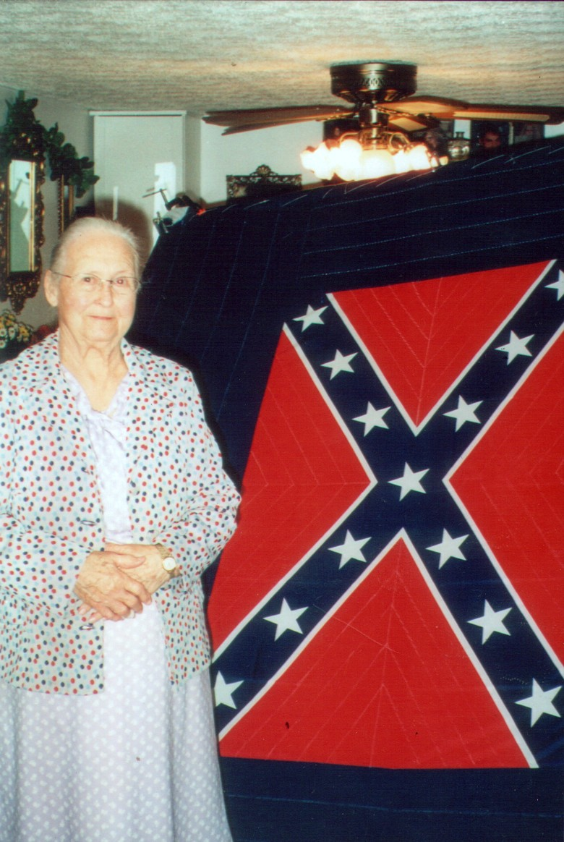
Confederate Quilt Raffle

We are raffling off 3 handmade quilts made by REAL DAUGHTER, Mrs. Katie Love. The raffle is a Fund Raising effort for our Monument Fund. We will draw the winners at the Georgia Division Reunion in June. We are asking everyone to please help us sell these tickets. This is a wonderful opportunity for our Camp and for Mrs. Love.
Her quilts are beautiful and we can provide a way for folks to get these heirloom items. Each quilt will come with a picture of Mrs. Love and a notarized Certificate of Authenticity. These quilts will be very valuable to future generations and are definitely some of the last remaining ways that we can share firsthand something so fantastic. Not many Real Sons or Real Daughters remain with us and to have such a wonderful, handmade reminder of her love for her father and his Cause is truly tremendous.
When our Camp outsold the Georgia Division to win the Musket – We sold 1000 of those tickets in just 1 Month – We sold roughly 20% of the entire Division’s tickets. Surely we can sell these tickets for something so much nicer than a replica musket?
Please gentlemen, this is important. We pride ourselves on our Confederate Ancestry. Let’s show that we deserve to be called Sons of Confederate Veterans and work to place this monument to their memory.
For Tickets call: Randy at 685-7504 or Jason at 685-9265

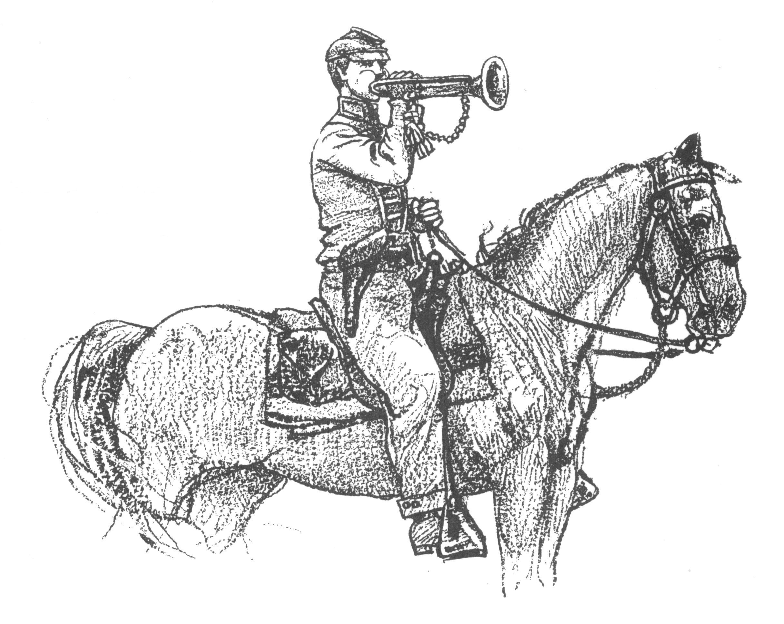 Call to Duty – Camp Calendar
Thursday, May 4th – Regular Monthly Meeting Thursday, June 1st – Regular Monthly Meeting
7 PM – Meal / 7:30 PM Meeting 7 PM – Meal / 7:30 PM Meeting
Western Steer - Metter Western Steer - Metter
Program/Speaker – TBA Program/Speaker – TBA

Dates to Remember – Mother’s Day is May 14th
3rd Weekend in June 2006 – Georgia Division SCV Reunion for 2006

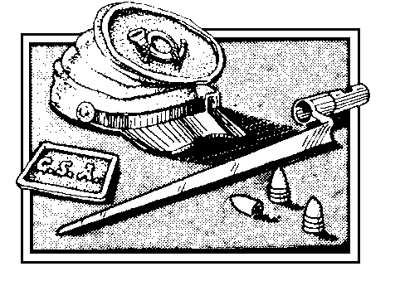
Welcome To Our New Members
Jason Patrick Lanier
Honoring

3rd Sergeant Richard Lanier
Co. C, 47th Georgia Volunteers

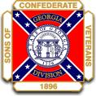
Georgia Division
Sons of Confederate Veterans
Reunion 2007 – 2nd Weekend of June 2007
Metter, Georgia

We have already secured a guest speaker for the Luncheon. He is Dr. Charles Thomas from Georgia Southern University. Dr. Thomas is originally from the Northwest Georgia area. At Georgia Southern, Dr. Thomas teaches American Military History, World War II, German History and others. Dr. Thomas is an expert on all aspects of American Military History and is a friend to our Confederate Ancestors. Dr. Thomas has already decided on a topic and is looking forward to coming.
We are searching for a Special Guest for Keynote Speaker for the Banquet. If you have someone that you would like the Division to spend the evening with, please let us know. Initially, we invited Retired US Senator, Zell Miller. He could not be with us because of calendar conflicts, but to his credit, he answered our request letter in his own handwriting and not via some secretary that typed something for him to sign. In his response, he thanked us for the invitation and showed evidence that he had a prior commitment and could not come. For the record, Zell didn’t “brush us off” and said that he would have liked to have come.
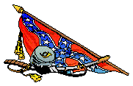Dixie Guards Youth Baseball Team 
Back a couple of months ago, the Camp voted to sponsor a Recreational Youth Baseball Team as a part of Civic Participation and Public Relations – We are proud to announce that our Team is the Sons of Confederate Veterans Mudcats. They are in the Rookie League Division and rumor has it they are going to be really good. In fact, we’ve been told that they have a really good chance of winning the Division. Whenever possible, why not head out to the “Old Ballpark” and support our team. We’ve been told that the coaches and kids on our team proudly where our name and they would probably cherish our cheering them on in person. It would be a great sight to see SCV shirts and ball caps in the stands. We can influence the kids and may be able to mention our Cause to spectators. Here’s the team’s schedule:
Tuesday, April 4th – 6 PM - Field # 2 Friday, April 7th – 6 PM - Field # 2 Monday, April 10th – 7:15 PM - Field # 2
Tuesday, April 18th – 7:15 PM – Field # 2 Friday, April 21st – 6PM – Field # 2 Monday, April 24th – 6 PM – Field # 2
Thursday, April 27th – 7:15 PM – Field # 2 Friday, May 5th – 7:15 PM – Field # 2 Monday, May 8th – 6 PM – Field # 2
Thursday, May 11th – 6 PM – Field # 2 Tuesday, May 16th – 7:15 PM – Field # 2 Monday, May 22nd – 7:15 PM – Field # 2
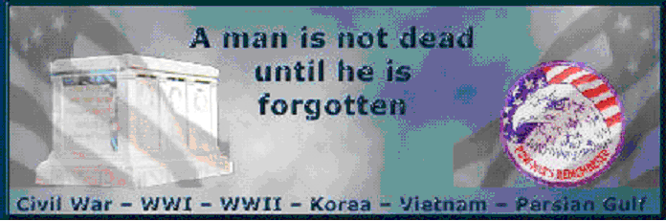
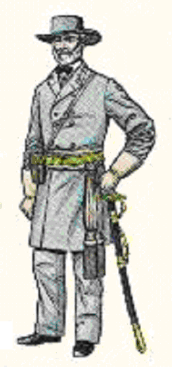
A few month’s ago, the Confederate Veteran ran an article written by conservative columnist Ann Coulter. She is a Partisan Political Journalist and many within the ranks of the SCV complained about her article being included in the magazine. I don’t worry about someone’s politics much when it comes to our Ancestors. Democrats & Republicans have proven that they aren’t always friends to the Confederate Soldier or the SCV. As for Ms. Coulter, I’m putting an article by her as this month’s feature because I like her story – Maybe it is not the same one that was in the Confederate Veteran – If it is, I’m sorry but it is worth reading again! The article dates back to the 2000 Presidential Elections & is copied here from Internet site of the Jewish World Review.
Feature Article: “McCain and the flag” by Ann Coulter
A FEW WEEKS AGO, John McCain said the Confederate battle flag is "a symbol of racism and slavery." After briefly backtracking and saying it was also, somehow, a symbol of "heritage," he immediately retreated from that position, clarifying that if he had ever said it was a symbol of heritage he had misspoken. Slavery and racism it was.
A lot of New Yorkers may not know better, but John McCain really should.
The whole country's military history is shot through with Southerners. Phil Caputo, liberal in good standing and author of the anti-Vietnam book "Rumor of War," was one of the first Marines in Vietnam, as a second lieutenant in 1965. He talks about how his best soldiers were Southerners: They could walk for hours and hit anything -- as he puts it -- just like their Confederate grandfathers.
The men that form the core of Stephen Ambrose's book "Citizen Soldier," a true account of fighting on the German front in World War II, are heavily Southern. The first Marine awarded the Medal of Honor in World War II, Hank Elrod, was from Georgia. Dwight Eisenhower was born in Texas. A vast number of military bases in this country are named after Confederate officers.
Former Secretary of the Navy James Webb describes Southern soldiers in his military novels whispering "and for the South" under their breath when saying their oaths to their country (as if Southerners needed to be reminded not to commit treason). They die at war, not for Old Glory, Webb writes, "but for this vestige of lost hope called the South."
Are you beginning to see the pattern?
It is pride in the South -- having nothing to do with race -- and its honorable military history that the Confederate battle flag represents. It is a "battle flag," after all, and represents defiance not unlike the "Don't Tread on Me" flag.
This is a shared cultural heritage among both black and white Southerners: It is not just the Sons of the Confederacy. (And there are, incidentally, black members of Sons of the Confederacy.) Five black Marines won the Medal of Honor for their service in Vietnam, all posthumously: They literally dove on exploding enemy grenades to protect their comrades. Three of the five were from the South. The disproportionate number of blacks in the military is a reflection of the disproportionate number of Southerners in the military. Southerners are truly our warrior class.
The battle flag represents a way of life, and a noble way of life, an ethic and honor that belong to both blacks and whites of the South. Not surprisingly, given the South's military pride, Colin Powell has remarked that he received his strongest support to run for president from "white Southerners." On that basis he concluded that there is no impediment to a black man being elected president.
Obviously boys from all over the country fought in this country's wars, and fought admirably, but it is simply a fact that Southerners are overrepresented in the heroic annals of this country. It is the proud military heritage of the patriotic South that the Confederate battle flag represents.
Liberals love to cluck their tongues at such admiration for the military -- which they consider a redneck trait, almost as bad as slavery itself. The military ethic of the South does place a premium on fighting, fraternity-like rituals, respect for authority, chivalry and virulent patriotism. But whether that ethic is your cup of tea or not, it was disproportionately Southerners -- some wearing Confederate battle flags under their uniforms -- who formed the backbone of the military that threw back Adolf Hitler.
Pride in being good fighters is not an endorsement of slavery.
It is completely preposterous to think that at the end of the 20th century, the Confederate battle flag represents support for slavery. Anyone who has ever met a Texan has an inkling of what Southern pride is about. The battle flag represents values -- virtues -- that exist independently of the institution of slavery. It is shameful for politicians like John McCain to call the Confederate battle flag a symbol of slavery as part of a campaign strategy, in the process defaming a symbol of America's gallant warrior class, both black and white.

Did You Know? American Secession – A Case Study Series
The Declaration of Independence says, “When in the course of Human Events, it becomes necessary for one People to dissolve the Political Bands which have connected them with another, and to assume among the Powers of the Earth, the separate and equal Station to which the Laws of Nature and of Nature’s God entitle them, a decent Respect to the Opinions of Mankind requires that they should declare the causes which impel them to the separation.”
Pure and simple, Thomas Jefferson was announcing the American Colonies’ secession from Great Britain and the rule of King George III. A 7 year war that came to be known as the American Revolution followed. Finally, on September 3, 1783, The Treaty of Paris was signed. The Preamble to the treaty stated, “His Britannic Majesty acknowledges the said United States, viz., New Hampshire, Massachusetts Bay, Rhode Island and Providence Plantations, Connecticut, New York, New Jersey, Pennsylvania, Delaware, Virginia, North Carolina, South Carolina, and Georgia, to be free, sovereign, and independent states. “
As far as King George was concerned, the colonies were now separate sovereignties free to rule themselves as they saw fit. Did this mean that the colonies were unified in the eyes of King George? Absolutely not! The colonies were each independent in the King’s eyes and the only united together by an agreed upon compact.
The 1st Compact that united the Colonies into States was called the Articles of Confederation. In the Articles the States created a “Perpetual Union”, which meant that they were to be united forever. The idea of a Perpetual Union that could never be broken bothered virtually every State. In the Articles, the States did provide for Sovereignty to remain in tact. Article II stated, “Each state retains its sovereignty, freedom, and independence, and every power, jurisdiction, and right, which is not by this Confederation expressly delegated to the United States, in Congress assembled.”

Ironically, the States of New York and Massachusetts was the most conservative of the States in those days and they were bothered by this the most by the thought of a Union of States that could not be broken. Change was sought and eventually came. Working together, the Congress evolved from the Articles of Confederation to the Constitution and submitted it to the States for ratification. In the Constitution, “a more perfect Union” replaced the “Perpetual Union” of the Articles. Problems and grievances were addressed and changes were established. In order to create the US Government under the Constitution, each and every State that joined would have to leave the behind the government created by the Articles of Confederation and join the new government under the US Constitution. In less than 10 years the Americans “seceded” from 2 Governments – the King in 1776 and The United States with the US Constitution in the 1780s.

According to Constitutional historian Kenith Andry, “Each state as it adopted the new system of government left the old Union and joined the new one. Adoption of the Constitution meant secession from the United States under the Articles of Confederation. The old Union was made up of thirteen states; the new Union with eleven states. North Carolina had not voted to ratify, and Rhode Island had not even bothered to call a convention. These two states were foreign countries when George Washington was inaugurated as the first president of the United States on 30 April 1789, and were treated as such by the new government. Those who try to prove that the United States were formed as a single nation, at an earlier date, tend to ignore this fact.” Andry goes on to say, “North Carolina ratified the Constitution and joined the union six months after Washington had taken the oath of office. Rhode Island joined the union a full thirteen months after Washington had become president.”
As the states ratified the new Constitution, they did so through the actions of their respective State Legislatures. They were careful to protect their state supremacy and made it clear in the language used to express their assent. John S. Tilley illustrated the issue, “To the Convention which considered a new “Constitution”, Georgia’s delegates carried commissions which opened: “The State of Georgia, by the grace of God, Free, Sovereign, and Independent.”
Next Month – We’ll continue to look at Secession – How important was the Right to Leave the Union to the States? We’ll see and you’ll be surprised by all the evidence.
While Tickets Supplies Last!!!

For Every 50 Tickets
Sold by an Individual or Camp –
The Name of the Individual or Camp will be placed into a separate drawing for a Queen-sized Quilt complete with Certificate of Authenticity & Photo of Mrs. Love

For Every 200 Tickets
Sold by an Individual or Camp –
The Individual or Camp will “Automatically” be awarded a Queen-sized Quilt complete with Certificate of Authenticity & Photo of Mrs. Love

Please Don’t Request Tickets Unless You Will Sell Them

Only 2000 Tickets are Available for the Entire Raffle!
Remember each Ticket has 3 chances to Win!
3 Quilts to Be Given Away!

