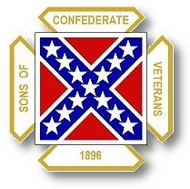
The Dispatch
The Official Publication of The Dixie Guards Camp # 1942
Sons of Confederate Veterans
Metter, Georgia

March 2007

Dixie Guards Camp # 1942
Sons of Confederate Veterans
P.O. Box 761
Metter, Georgia 30439

Postmaster Please Deliver To:

Visit Us Online at:
www.dixieguards.org
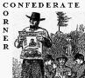 Commander’s Comments
Jason did a really good job with last month’s program. If you missed it, you missed a special treat. Our songwriter compatriot, Gary Coleman is slated to be our speaker for May, so you don’t want to miss that one. He’s going to tell the story of his song. Maybe we can look forward to a little pickin’ and singin’.
The Reunion is right around the corner. We have some very talented men in our camp and we’re going to need the support of each and every one of you guys. Please volunteer to help in any capacity that you can. We’ll need manpower and delegates.
The festivities is shaping up to be one we should all enjoy. On Friday, we’ll be having some of Jason’ famous BBQ Chicken and his daddy’s even more famous BBQ sauce. Saturday, is shaping up to be a busy business session. We’ll need to fill all our delegate slots. As of this minute, we don’t know how many delegates we’ll have – that is based upon our number of members. The shindig on Saturday night is sure to be a great one. The band is simply unbelievable. If you like old timey music, then you’re sure to love them. We’re having a whole hog barbeque and that should be good too!
Speaking of delegates, the way for us to increase our delegates is to increase our membership. I know that you may think that I never hush about recruiting – but I promise you, I never will. Honoring a Confederate soldier will never get old to me! Each time we add a member, we honor a soldier – as a Sons of Confederate Veterans camp, nothing is more important than honoring a Confederate Soldier. So, recruit a new member and help honor a soldier.
April will be a busy month and let’s not forget it is Confederate History Month. We’ve already asked the City Council and County Commission to declare April as Confederate History, Heritage and Education Month again this year. We’ve asked that they fly the Real Georgia Flag on Confederate Memorial Day and to specifically declare Thursday, April 26th as Confederate Memorial Day in Metter and Candler County. Indications are that both the City and the County will comply with our request just as they have been doing. Thank them in advance for their support and pledge to them our help anytime they need it. Friendship goes a long way and besides, these folks are our neighbors.
Remember, the Bloomin’ Festival – we are scheduled to have a Information and Recruitment Table. Our goal is to promote the SCV, our Camp and our Confederate Ancestors.
Hopefully, you will get this newsletter prior to the Boston Butt Sale. So far, indications are that sales are going good and we will need all the help we can get cooking the meat. Several grills going all night long is quite a job and no one who volunteers to help will be turned away.
The National Confederate Memorial Day is going to be April 14th at Stone Mountain. Several members have already said they plan to attend. I’m sorry, I have to work – but I’ll be there in spirit. If you would like to attend, contact Color Sgt, Ben Franklin or Compatriot Mark Cauley.
Our Camp Confederate Memorial Service is slated for Sunday, April 15th. Chaplain Rhett Kelley will be in charge of the service and I would like to urge everyone to gather at the Lake Church Cemetery at 3 PM. Plus, several of our neighbor camps will be hosting their Memorial Services and I’m certain everyone is welcome. While, I’m at it, why not drop by and visit with our neighbor camps whenever you get the chance?
We are announcing to the Georgia Division in the upcoming Georgia Confederate a plan that we hope will bring more incentive for members to attend the business session. We’re going to go ahead and announce here at home 1st. Here’s the plan – Any Georgia Division member that registers for the business session and the Banquet will be entered in a drawing for a LIFE MEMBERSHIP. Our members are just as likely as any one else to win. We’ll draw the winner fair and square and someone will win. We are offering this raffle for several reasons: 1. We want to inspire participation in the business of the Division – this is important to everyone. 2. We want to help make our Reunion a success and hopefully this will play a part in that. 3. We wanted to offer something new and unique - this is new and unique…maybe we’ll start a tradition. So, get register early and plan to attend – Good Luck, maybe you will win: Someone is going to!

God Bless You and Your Family,
Randy
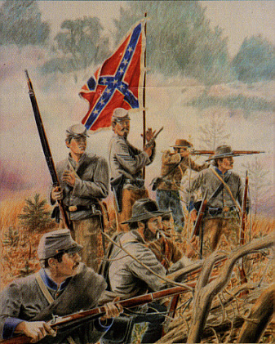 Call to Duty – Camp Calendar
Thursday, April 5th – Regular Monthly Meeting Thursday, May 3rd – Regular Monthly Meeting
7 PM – Meal / 7:30 PM Meeting 7 PM – Meal / 7:30 PM Meeting
Western Steer - Metter Western Steer - Metter
Program/Speaker – Jason West Program/Speaker – Gary Coleman

Dates to Remember – Friday, April 6^{h} – Good Friday
Saturday, April 7th – Another Bloomin’ Festival – Metter
Sunday, April 8th – Easter Sunday
Saturday, April 14th – National Confederate Memorial Day Service – Stone Mountain
Sunday, April 15th – Camp Memorial Day Service – Lake Church
Thursday, April 26th – Confederate Memorial Day
Sunday, April 29th – Millen Camp’s Confederate Memorial Day Service – Darryl Drake POC

We had NO NEW Members for February – Don’t forget to Recruit

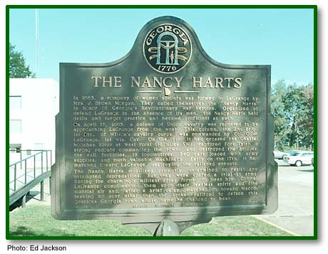
The Confederate Home Front Series
Nancy Hill Morgan &The Nancy Harts Militia
*From the Road Marker
In 1863, a company of women soldiers was formed in LaGrange by Mrs. J. Brown Morgan. They called themselves the "Nancy Harts" in honor of Georgia's Revolutionary War heroine. Organized to defend LaGrange in the absence of its men, the Nancy Harts held drills and target practice and became proficient at each.
On April 17, 1865, a column of Union cavalry was reported to be approaching LaGrange from the west. This column, the 2nd Brig., 1st Div., of Wilson's cavalry corps, was commanded by Col. O.H. LaGrange, 1st Wis. Cav. On the 16th, it had crossed the Chattahoochee River at West Point (18 miles SW), captured fort Tyler, a strong redoubt commanding the town, and destroyed the bridges, the rail facilities, 19 locomotives, 340 cars loaded with army supplies, and much valuable machinery. Early on the 17th, it had marched toward LaGrange, destroying the railroad enroute.
The Nancy Harts mobilized promptly, determined to resist any attempted depredations, but they were spared a trial at arms. Seeing the charmingly militant array formed to meet him, Colonel LaGrange complimented them upon their fearless spirit and fine martial air and, after a brief delay, marched on toward Macon, leaving no scar other than the broken railroad to deface this gracious Georgia town whose name he chanced to bear.
141-13 GEORGIA HISTORICAL COMMISSION 1957
© Carl Vinson Institute of Government, The University of Georgia

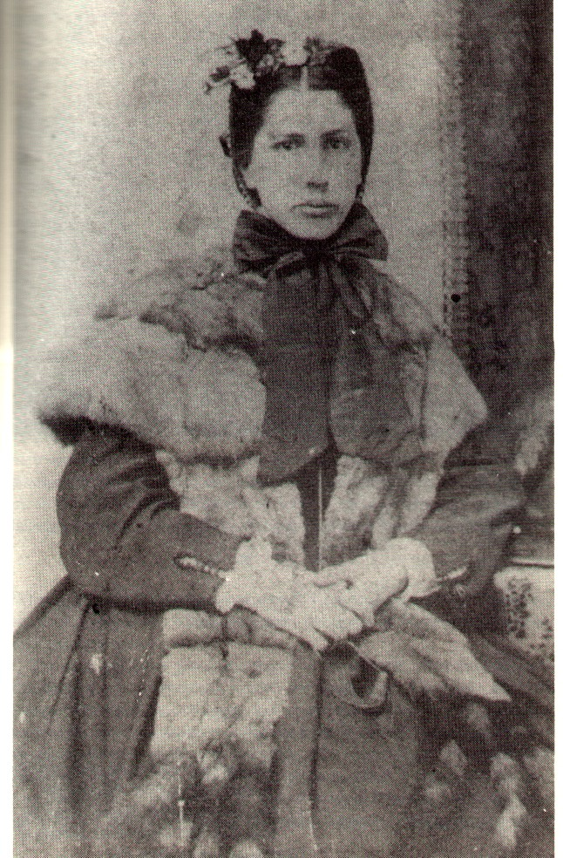

Left - Cpt. Nancy Hill Morgan
Organizer of the Nancy Harts Militia
Below Right – The Officers of the Nancy Harts Militia

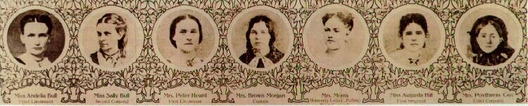

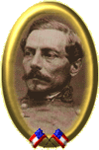General Pierre Gustave Toutant Beauregard
P.G.T. Beauregard was one of the early Confederate heroes of the Civil War. Graduated from West Point second in his class in 1838, the Louisiana native served as a staff officer with Winfield Scott in the Mexican War. He was wounded twice in action during the fighting around Mexico City.
Following the conclusion of the war in Mexico, he was engaged in clearing the Mississippi River of obstructions. In 1861 he was posted to West Point as superintendent, but served in that capacity for the shortest term recorded for that office, from January 23rd to the 28th. He resigned from the army to offer his services to the Confederacy.
Placed in command of the forces around Charleston Harbor, it fell to him to order the firing of Rebel batteries upon Fort Sumter which opened hostilities. Hailed throughout the South as the “Hero of Fort Sumter”, he was soon ordered to Virginia to command the Confederate forces opposite Washington. Reinforced by Joe Johnston’s army the day before 1st Bull Run, he exercised tactical command on the field, being more familiar with the ground. Following Rebel victory on the field, he was named full general from the date of the battle, but fell out with President Davis over the aftermath of the battle. Beauregard claimed that had Davis not prevented him, he could have taken Washington on the strength of his victory.
Sent to the West as Albert Sidney Johnston’s second in command, he drafted the attack orders for the Battle of Shiloh, and assumed command when Johnston was killed on the field during the first day of fighting. The next day his forces were driven from the field by Grant’s and Buell’s combined armies.
After a prolonged campaign, conducted by Henry Halleck, he was forced back onto his base of supply at Corinth, Mississippi, which he was eventually compelled to abandon. Shortly thereafter he went on sick leave without gaining President Davis’ permission and was subsequently relieved of his army and departmental commands by the president.
Two months later he was back in command of the Southern coast from North Carolina to the tip of Florida. He retained this command for over a year and a half and conducted the defense of Charleston against various Federal operations against the port city.
He came north to take command in North Carolina and southern Virginia while Lee faced Grant’s forces north of Richmond. There he managed to bottle up Ben Butler’s Federal Army of the James in the Bermuda Hundred after defeating him at Drewery’s Bluff. Beauregard also managed to thwart the Union attempt to seize Petersburg when Grant slipped away from Lee and shifted his army to the South side of the James in an effort to cut the supply lines into Richmond.
He continued to serve under Lee during the siege of Petersburg until September of 1864 when he was shifted once again, this time assuming overall command of the West. With no troops under his immediate command he was unable to contest Sherman’s celebrated March to the Sea. During the final days of the war he was second in command to Joseph Johnston in North Carolina.
Following the conclusion of the war he returned to New Orleans where he refused commands in both the Egyptian and Rumanian armies. He became involved with railroading, was the supervisor of the Louisiana state lottery, and was Louisiana’s adjutant general.

. 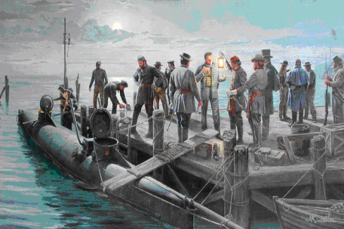 Feature Article – CSS Hunley sinks the USS Housatonic - February 17, 1864
The date was February 17, 1864. It has been said that the day was a bone-chilling day similar to the days we have recently experienced and not unlike many days of a coastal town in the depths of winter. But, this date would go down in Confederate and American history. On this date, the 3rd and final crew of the CSS HL Hunley would embark on its historic and mortal attack of the USS Housatonic.
Here is a short article on the historic events with the some of the information taken from the Hunley.org website –
The CSS HL Hunley had already lost all but 4 of its 1st crew and its entire 2nd crew during accidents amid training sessions. The Confederacy nearly scrapped the idea of the secret weapon. But, Lt. George Dixon refused to give up. He persuaded the Confederate authorities to give him another shot. Dixon was an extremely patriotic southern man and after he was spared by a miracle at Shiloh, he committed himself to the Southern cause with added zeal.
Dixon was allowed to gather an all-volunteer crew and amazingly, men stood in line to serve with Dixon. The long lines of volunteers could have been because of patriotism among the men in and around Charleston or it could have been that Charleston had been under a siege of bombardments from the US Warships just off shore. At any rate, Dixon quickly gathered a crew and they trained for the mission for several weeks prior to the fateful February night. A system was devised between the shoreline and the submarine with glowing lanterns that could lead the Hunley back to safety after her mission.
Rumors were widespread of a Confederate secret weapon and word had even spread among the US Warships that a new water-born threat was on the horizon. Submerged chain netting had been placed around some of the ships to prevent the rumored beast from approaching the ships. The Federal navy vessels weren’t convinced of a threat but they weren’t going to risk it….just in case.
Finally, the night came. Dixon and his crew set out on the frigid winter night. They hand-cranked the Hunley towards the enemy warships that had been raining bombs down on the citizens of Charleston. For years, it was believed that the Hunley attacked from the shore side of the ships. In fact, based upon where it was discovered, it is believed that the Hunley crew had cranked the submarine past the line of ships, particularly the USS Housatonic, the eventual victim.
A sailor on board the Housatonic saw something in the water. Was in a porpoise? What was it? He was sure. We know that it was the Hunley, but is it possible that since the attack came from the open water side of the ship, the sailors on board simply thought that it could not be a threat until it was too late. We’ll never know that answer. What we do know is that the Hunley crashed a barb into the side of the Housatonic. Attached to the barb was nearly torpedo bomb that weighed well over 100 lbs. The Hunley quickly backed away from the ship and once the 150 feet of rope became taught, the torpedo exploded.
The explosion ripped the Housatonic and it sank in a matter of minutes. Amazingly, only 5 US sailors lost their lives. The explosion had been witnessed from the shoreline of Charleston and would later be recollected. The Hunley came to the surface and signaled the shoreline sentries with the blue signal lanterns. The sentries stoked up the fires and awaited the return of the submarine. The return never came. The actual cause of the loss of the CSS HL Hunley has not been completed solved. Rumors and theories are to this day being scrutinized and discussed. Maybe the answers lie with the ongoing research being done by the excavation and preservation team.
The CSS HL Hunley was the 1st naval attack by submarine in maritime history. No submarine would be used in warfare again until World War I when the Germans would use them against the Allies.
We may never know what happened to cause the Hunley to be lost; but, one thing is for sure. The men of the CSS HL Hunley gave the ultimate sacrifice in defense of Charleston and the Confederacy. They died heroes. They died alone. Let us never let their memory disappear so that they died in vain.

