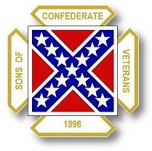
The Dispatch
The Official Publication of The Dixie Guards Camp # 1942
Sons of Confederate Veterans
Metter, Georgia

June 2006

Dixie Guards Camp # 1942
Sons of Confederate Veterans
P.O. Box 761
Metter, Georgia 30439

Postmaster Please Deliver To:

Visit Us Online at:
www.dixieguards.org
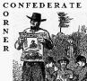 Commander’s Comments
June has arrived and it is a very important month for our Camp and Division. First, our Division Reunion/Convention is June 16th-18th in Gainesville with the Business Session on Saturday the 17th. This year’s convention will be an Election Year. We will elect a new Division Commander and other officers to lead the Division. Our Camp has 8 delegates and we are sure to be popular with campaigners. In order to get our 8 votes, we have to have 8 delegates present. If you can go, please let Tony know.
June is the month for Father’s Day. As an organization that commemorates the service of our soldier ancestors, this month is even more special. As we honor our own personal father on his special day, let us also remember those “forefathers” that came before us and sacrificed so much. From our Revolutionary Fathers all the way to our current ones, southerners have contributed great things to our country’s legacy. As certain as we honor our “dad”, then we should honor those who came before them too! Remember them all on June 18th.
At our May meeting we announced a new initiative within our Camp that we hope will inspire the membership. Tony gave a presentation on the US Veteran’s Administration Grave Markers. We are encouraging each of our members to fill out a VA form to get a marker for your ancestor. We are trying to get a couple month’s head start and starting in August, we would like to begin hosting at least 1 Memorial Service per month for a soldier ancestor of our Camp. If we have more than 1 service, then all the better, but we are hoping for at least 1 per month. Currently, we have nearly 90 members, so if everyone submits just one from their family we should have enough to carry us quite a long way. But, don’t sit back and wait for someone else. Honor your ancestor’s memory. This is a major part of our charge and it is very fitting to have a memorial service for them. If you were not at the meeting and need information about how to get the forms and filling them out, please contact Tony. We really hope to kick off the new SCV fiscal year in August with at least 1 service per month.
We also announced that we would really like to encourage members to share with us their stories of their soldier ancestors. Guest speakers are nice and we all enjoy them, but it would be great to hear about our local folks sharing the stories of the men they honor with their membership. Several of our members have done this in the past and these programs have been some of the best we have had. We all know each other and there is no reason at all to be bashful among friends. Your stories are our stories. They are special to you and they are special to us all. For example, I would love to have a meeting night to simply have our members give a testament as to why they joined the SCV. Stuff like this many times means far more to visitors and potential members than does any guest speaker’s story of a book they have written and are trying to sell.
A couple of years ago, we hosted a Family Picnic. We have actually had 2 of them. The 1st one we held at George L. Smith State Park and nearly 250 SCV members and their families came from all across the State. The next year, we held another one. No where near as many people showed up but we still had a great time. Several members has suggested that we have another one so that all of our families can come together in fellowship and allow members that aren’t always able to attend regular meetings come out and have fun, food and fellowship. We are asking you to let us know if you would like to have one in the near future.
At the convention in Gainesville, we will be kicking off next year’s Reunion here in Metter. It may sound like we are getting a huge head start on next year’s convention by talking about it at this year’s event, but rest assured we are not. Most camps that host a Reunion have much of the Administrative details prepared this way. Since the Reunion will be here in Metter, we have the luxury of setting the theme for the weekend. We will be announcing our theme for 2007 in Gainesville.
The theme is: Double The Division.
We are encouraging the entire Division to double in size by the time it comes to Metter in June 2007. We are simply urging every camp to double its current membership. Some will. Some won’t. Some, especially those who have just started new camps will do much more. Who wins? The Division. Our Ancestors. Who loses? No one - Unless you consider that our enemies will be terrified by a doubling of our numbers in just a year. No one – Unless you consider the politicians in an Election Year who watch us double in size and put the fear of lost votes in their faces should they continue to sell our Heritage and the Memory of our Ancestors.
Finally, our raffle ticket fund raiser is just over. We are drawing the winners at the Division Reunion in Gainesville. We need everyone that has ticket stubs, money & unsold tickets to turn them in no later than June 14th. That means we need to have them by the 14th in order to make sure everyone’s ticket is a part of the drawing on Saturday the 17th. We still have plenty of time to sell quite a few tickets. The Camp & our Monument Fund thanks you for the hard work in advance.

God Bless You and Your Family,
Randy


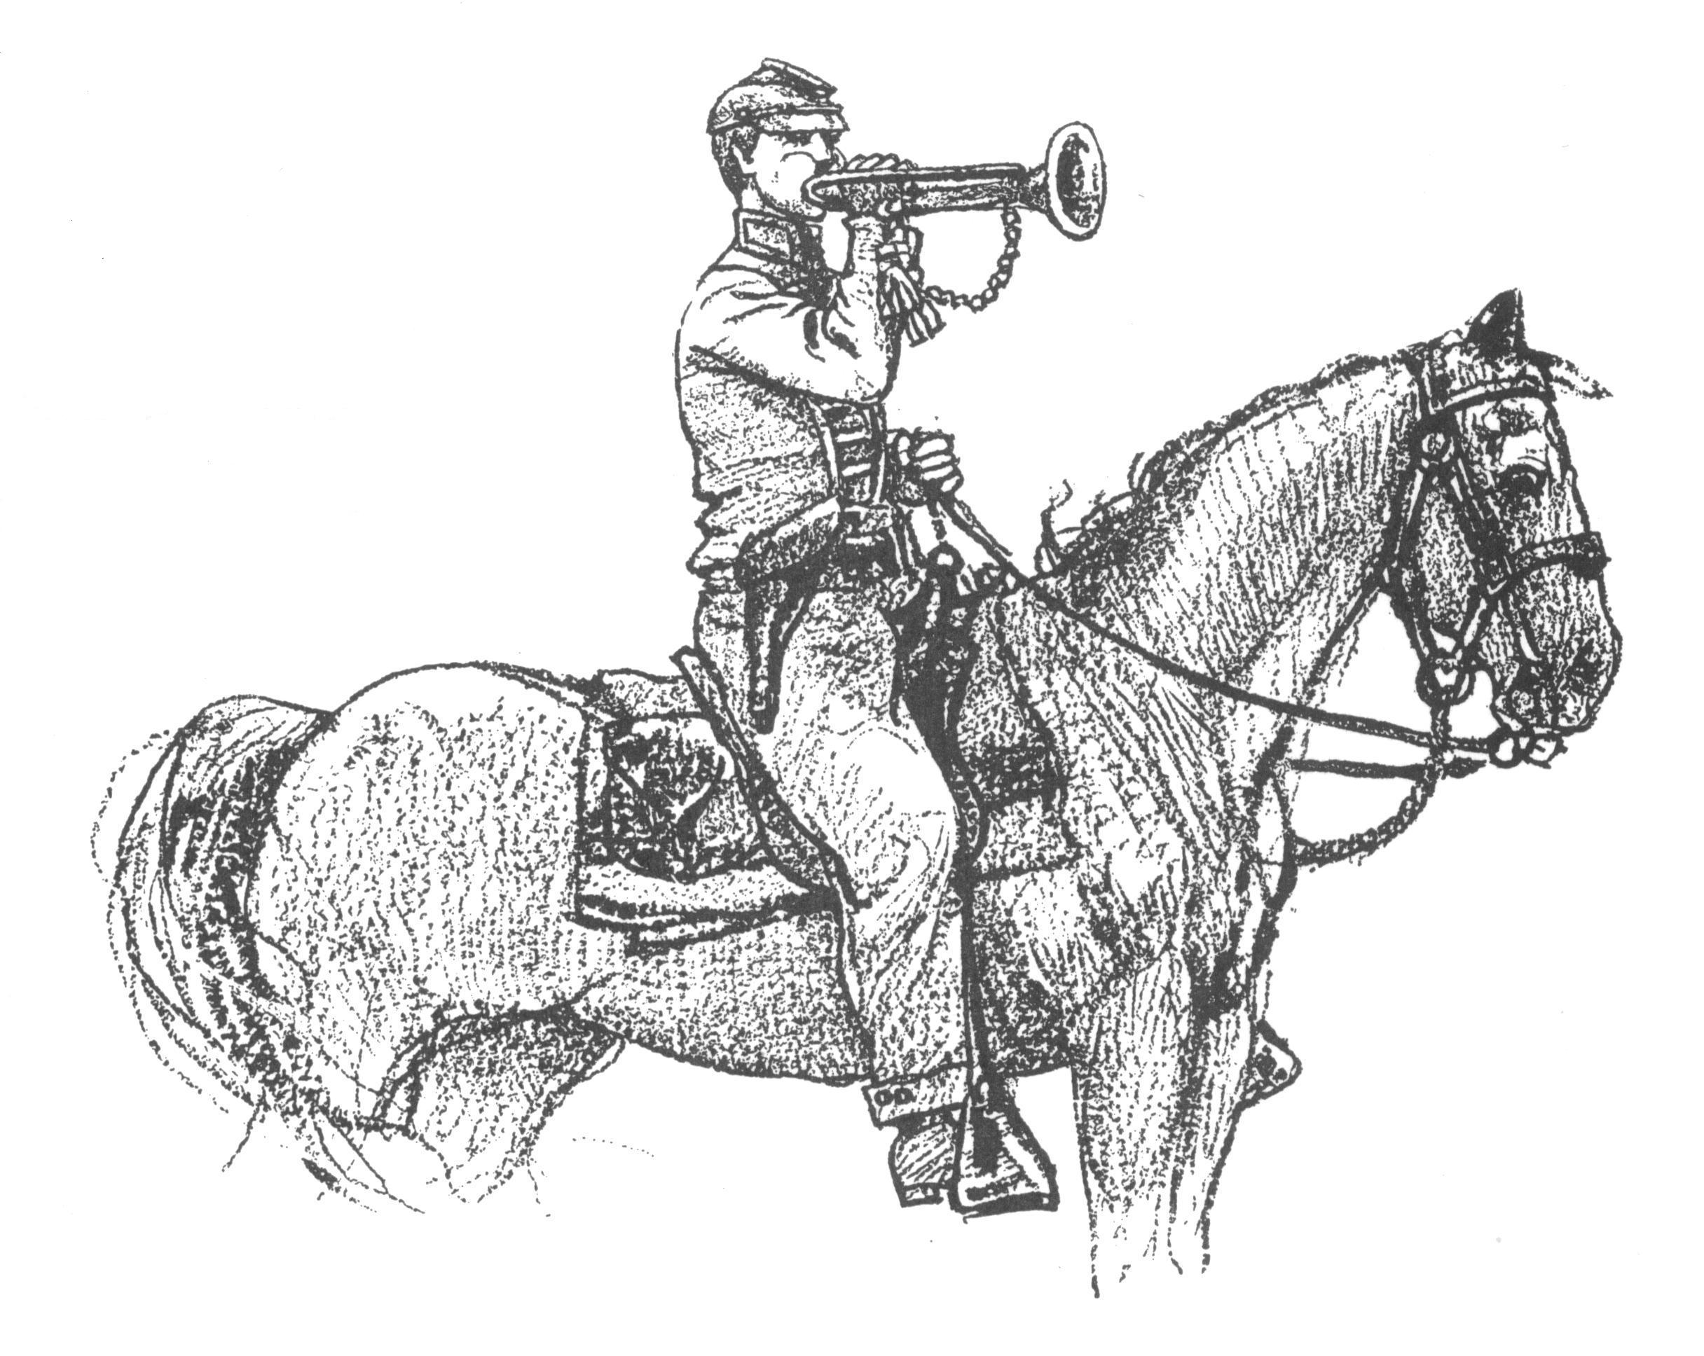 Call to Duty – Camp Calendar
Thursday, June 1st – Regular Monthly Meeting Thursday, July 6th – Regular Monthly Meeting
7 PM – Meal / 7:30 PM Meeting 7 PM – Meal / 7:30 PM Meeting
Western Steer - Metter Western Steer - Metter
Program/Speaker – Hu Daughtry Program/Speaker – TBA

Dates to Remember – Father’s Day is June 18th
3rd Weekend in June 2006 – June 16, 17, 18 - Georgia Division SCV Reunion for 2006 – Gainesville, Ga.

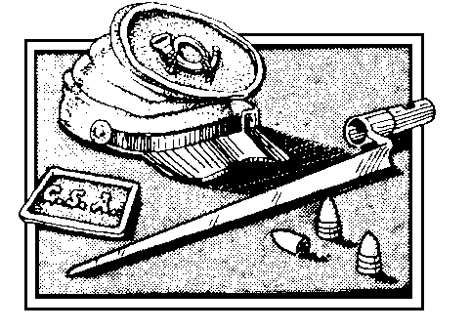
Welcome To Our New Members
Robert M. (Bob) Melton
Honoring

1st Sgt Robert J. Snodgrass
1st Battalion Tennessee Infantry

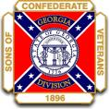
Georgia Division
Sons of Confederate Veterans
Reunion 2007 – 2nd Weekend of June 2007
Metter, Georgia

We have already secured a guest speaker for the Luncheon. He is Dr. Charles Thomas from Georgia Southern University. Dr. Thomas is originally from the Northwest Georgia area. At Georgia Southern, Dr. Thomas teaches American Military History, World War II, German History and others. Dr. Thomas is an expert on all aspects of American Military History and is a friend to our Confederate Ancestors. Dr. Thomas has already decided on a topic and is looking forward to coming.
We are searching for a Special Guest for Keynote Speaker for the Banquet. If you have someone that you would like the Division to spend the evening with, please let us know. Initially, we invited Retired US Senator, Zell Miller. He could not be with us because of calendar conflicts, but to his credit, he answered our request letter in his own handwriting and not via some secretary that typed something for him to sign. In his response, he thanked us for the invitation and showed evidence that he had a prior commitment and could not come. For the record, Zell didn’t “brush us off” and said that he would have liked to have come.
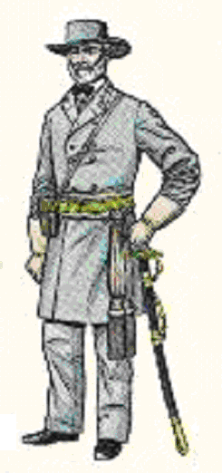 Feature Article: Seven Days Battles – June 25, 1862 ~ July 1, 1862
On June 1, 1862, an unproven Confederate General took over for the wounded General Joseph E. Johnston. Soon his name would be as famous as any army leader in world history. His name was Robert E. Lee. The Seven Days Battles were Lee’s 1st defense of Richmond.
General Lee’s plan to push McClellan’s army of over 100,000 called for coordination of attack among the several commands of the Confederate forces. Everything would have to go just right for the plan to work. Often times battle plans have your own desired movements, but also the built in mistakes of guessing the enemies movements too. In the case of Lee’s plans, the exact ideas for the saving of Richmond and the defeat of McClellan did not go just as Lee planned them. But, the overall objective to save Richmond was successful.
The first battle took place on June 25, came to be known as the Battle of Oak Grove. Here, Confederate forces prevented attacking Union forces under Joe Hooker from moving up heavy siege cannons closer to Richmond. The next day, was the Battle of Mechanicsville – the first major battle of the Seven Days. Confederate forces under General D.H. Hill grew impatient while waiting for a missing Stonewall Jackson and attacked the Union troops along his front. The battle raged for nearly 2 hours of solid fighting. D.H. Hill’s men linked up with those of General James Longstreet & General A.P. Hill and held the day. Jackson and his men played no part in the fight even after they arrived. The battle was a disappointment because great damage could have been done to the Union army had Jackson’s men joined the fight. The one key thing that did happen was that McClellan began to fear that Lee’s Confederate Army was far larger than his own. He began to feel that he could not capture Richmond and would have to fight a tactical withdrawal to escape defeat. He began to ask for reinforcements from Washington that never came. He began to argue and blame the Federal authorities for what he deemed was the sacrifice of his men to Lee’s huge army.
On June 27th, Lee launched what would be the largest Confederate attack of the entire war in the Battle of Gaines’ Mill. McClellan had the superiority of numbers but believed that Lee’s army was far bigger than his own because of trick tactics of Confederate General John Magruder. The aggressiveness of the Confederates assured him that the Southern army was nearly twice the size of his own. In fact, the Confederates were desperately short of men. A.P. Hill, Longstreet & D.H. Hill fought a tough battle to push back the larger Union forces. Again, Jackson and his command were strangely missing. By the end of the day and the fighting, McClellan was unnerved by the Confederates and ordered a complete withdrawal. He left the area and for the rest of the campaign was not a player in his own Union command. Also on the 27th & the 28th was the Battle of Garnett’s Farm. Here Confederate forces were held in check by Union forces under General Winfield Scott Hancock – but the action did further convince McClellan that he had to do whatever he could to escape Lee & certain defeat. McClellan simply believed that Lee’s army outnumbered him 2 to 1.
On June 29th, Confederate General Magruder caught up with the retreating Union army. He hoped for support from Jackson but again, Stonewall for some reason was missing. Magruder attacked anyway trying to prevent the Union armies escape. Magruder, without support was repulsed and the Union troops were able to get away. This battle known as the Battle of Savage Station was a terribly lost opportunity for the Confederates. On June 30th, 2 battles took place at the same time. Stonewall Jackson engaged in an artillery duel with Union forces at the Battle of White Oak Swamp while the rest of the Confederate forces were engaged at the Battle of Glendale or Frasier’s Farm. Here, because of the 2 separate battles confusion ruled the battlefields. Longstreet pushed his men in piecemeal because he expected to have to support on several fronts. They made progress but lost it and bogged down in the confusion. They did manage to capture several Union Generals including General John F. Reynolds. Reynolds was exchanged and would later be killed at Gettysburg.
The last battle of the 7 Days was Malvern Hill. Sadly, this went down as the worst showing for the Confederates. Lee wanted to maintain the initiative. Rather than try flank maneuvers, he order direct assault attacks. Many brave Confederates were lost in useless attacks on the heavily defended ground. D.H. Hill would recall that the attacks weren’t war, they were murder. The Confederates had 5000 casualties & the Union troops escaped again. The Union army then retreated & the campaign ended.

Did You Know? American Secession – A Case Study Series
“Any people, anywhere, being inclined and having the power, have the right to rise up and shake off the existing government, and form a new one that suits them better. This is a most valuable, a most sacred right, a right which we hope and believe is to liberate the world.” These words clearly support the Southern Right to secession. Who said these words? Abraham Lincoln said them in 1847. Strangely, as a US Congressman, he believed that Americans, or anyone for that matter, had the God given right to create a new government if the one they currently had did not suit them. Why didn’t he believe it in 1860 when he was elected President of the US? That’s simple. The US economy depended on the South. Lincoln could not afford to lose the revenue of the Southern states, both from taxes levied on Southern goods & from goods coming into the US in exchange for Southern cotton. In other words, Lincoln knew that as the South goes, so does the US economy. So, even though he probably believed and obviously knew that the US Constitution did not prohibit secession, he took & maintained the position to save the “economic hide” of the United States. In other words, as a US Congressman, Lincoln would have said that South Carolina had every right to secede – but once he was President and the weight of his country’s place in the world economy was on his shoulders he changed his mind.
There are a couple of very real facts that historians, political scientists or anyone else that claims secession was illegal fail to remember or simply overlook:
1 – When the new government was created under the US Constitution, all of the States seceded from the Articles of Confederation. They had to. There was no other way to create the new government because the Articles did claim that the government was “Perpetual”. That was one of the major complaints the States had. But – North Carolina & Rhode Island did not even attend the Constitutional Congress. In fact, George Washington had already been inaugurated President before North Carolina joined the United States under the Constitution. Rhode Island didn’t join until over a year later.
2 – At least two of the older, more established colonies/States demanded that they be able to keep their sovereignty. No, it was not South Carolina. New York demanded that its sovereignty be maintained. New York’s position was simple…“That the powers of government may be reassumed by the people, whensoever it shall become necessary to their happiness.” Virginia too, demanded that its sovereignty would not be infringed upon. Virginia said, “The powers granted under the Constitution, being derived from the people of the United States, may be resumed by them, whensoever the same shall be perverted to their injury or oppression.” Both of these states felt they could make it own their own if necessary and they would not give away their state’s power of self control.
3 – If secession was illegal, then Lincoln broke his own laws. The US Constitution does say that a state cannot be divided up to create another state. Yet, Lincoln was the sitting President when a faux government was created in Virginia to facilitate the creation of West Virginia. In 1863, West Virginia entered the Union as the thirty-fifth state. Under Lincoln’s rule, secession from the Union was considered illegal. Secession from a state was apparently embraced. In 1825, Judge William Rawle published A View Of The Constitution Of The United States Of America. The work became the textbook used to teach students of many institutions of higher learning. It was the prescribed text used to instruct the cadets of the United States Military Academy at West Point. According to Rawle, the actions taken to create West Virginia were criminal. Referring to admission of new states, Rawle stated, “No new state can be formed or erected within the jurisdiction of any other state, nor can any state be formed by the junction of two or more states or parts of states, without the consent of the legislatures of the states concerned as well as congress.” The elected government of Virginia had voted to sever ties with the Union in 1861. They did not consider themselves a part of the old Union and certainly did not give the Congress of the United States authority to create West Virginia.

Maybe Horace Greeley, publisher of the New York Tribune and famous abolitionist put it best when he said, “If the Declaration of Independence justified the secession of 3,000,000 Colonists in 1776 why did it not justify the secession of 5,000,000 Southerners from the Union in 1861.”[?]

While Tickets Supplies Last!!!

For Every 50 Tickets
Sold by an Individual or Camp –
The Name of the Individual or Camp will be placed into a separate drawing for a Queen-sized Quilt complete with Certificate of Authenticity & Photo of Mrs. Love

For Every 200 Tickets
Sold by an Individual or Camp –
The Individual or Camp will “Automatically” be awarded a Queen-sized Quilt complete with Certificate of Authenticity & Photo of Mrs. Love

Please Don’t Request Tickets Unless You Will Sell Them

Only 2000 Tickets are Available for the Entire Raffle!
Remember each Ticket has 3 chances to Win!
3 Quilts to Be Given Away!

Deadline to turn in Tickets is June 14th

Happy Father's Day

How ‘Bout This….Do you want to get mad?  Here’s what Atlanta used to think about being Southern….Things sure have changed! The South needs us more than ever!
