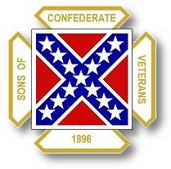
The Dispatch
The Official Publication of The Dixie Guards Camp # 1942
Sons of Confederate Veterans
Metter, Georgia

July 2007 Edition

Next Meeting – Thursday, August 2nd

Dixie Guards Camp # 1942
Sons of Confederate Veterans
P.O. Box 761
Metter, Georgia 30439

Postmaster Please Deliver To:

Visit Us Online at:
www.dixieguards.org
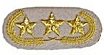Commander’s Comments
Gentlemen, I apologize for the July newsletter being late. Almost as soon as the Reunion was completed, things around my house became chaotic. That is no excuse, but it is true. Between work commitments, an expectant wife who is struggling with health issues and home damage due to faulty household equipment, our house has been like a circus.
Congratulations! In case you haven’t heard, the Dixie Guards was honored by being name Distinguished Camp of the Year for the Georgia Division SCV. The hard work showed and the Division recognized your hard work. We had some folks that really put forth a goliath effort, but everyone can celebrate this award. Every camp has a membership with a varying degree of participation. No one is more important that anyone else. It takes each type member to make a camp successful. I will say this, thank goodness for the go-getters. They help us all and they helped immeasurably in this award. Congratulations go out to Tony Thompson for a 5th Brigade Award of Appreciation. Also, congratulations go out to Carlton Clifton for a 5th Brigade Award of Appreciation and the Reunion Award for Most New Members Recruited for the Year.
As for the Reunion, it has come and gone. We received nothing but compliments from folks all across Georgia. The Division Commander told me that he couldn’t remember a better reunion. Others said the same thing. Commander-in-Chief Sullivan said that he’d never seen a small town camp do any better with a reunion and he expressed that he’d traveled all across the Confederation. Simply put, we did it! Many “nay-sayers” that questioned why we were hosting a reunion now have to re-consider. Several small town camps came up to me during the weekend and said they now think they might can do this too. I’m sure that many in our own membership thought it couldn’t be done here – but they too were wrong. All it takes is a solid plan and little or no deviation from that plan. A special thank you goes out to all those who helped during the weekend. I won’t take the chance on overlooking anyone by trying to recall everyone that helped – So, thank you to all those who helped. Please pass along to our special ladies that helped a big thank you too! They worked equally hard.
As of yet, I haven’t heard from many of our local businesses regarding any impact on their business over the weekend. I do know this, our local restaurants were packed. The hotels were packed and both bunches have the Reunion to thank for it. Ricky and his gang at the Steer passed along that they were very busy all weekend long.
This brings up a point - the Division Leadership was extremely complimentary of how we had members who had businesses along I-16. They have asked us to pass along to the Steer and to Grady’s a big thank you for supporting our Camp. They have pledged to always do business with you whenever they are near our area and they are going to urge the Division to do the same. Also, they’ve asked us to challenge both businesses to unite for an Ad in the Georgia Confederate.
Some of you have seen the nice Commemorative Medals that we had for the Reunion. Many of you may have not. We had such an interest in the medals that we had an extra batch commissioned. We have already sold about $500 worth. The medals are being sold across the Division for $20 postage paid. We are going to offer them to Dixie Guards members for $15 each if we don’t have to mail them. If we have to mail them, the $20 fee will apply.
But, Tony wanted me to remind everyone that August is Membership Renewal Time and he has a special offer for folks. While supplies last, we’re going to offer Camp Caps and Commemorative Medals for this reduced price of $15 for a cap or medal – BUT, with your paid Renewal, you can get both the Cap and Medal for just $20 extra. Tony will be mailing out a special invoice offer explaining this promotion. Basically, if you renew you can save $5 per hat or medal if you get both.
We have some members who we still need to keep near our hearts and prayers. Tony’s dad has been fighting a hard fight with health issues, please keep him in your prayers. Carlton has had a bout or two with health issues too. I would like to welcome friend and co-worker Richard Grubbs to the Camp – and, I’d also like to express sincere condolences for the loss of his father recently. Richard is a strong Southern man from South Carolina. He and I have worked together for over 20 years. He’s a few years older than me and he is retiring. He and his “lovely bride” are going to call the Mobile, Alabama area home. You might not see much of Richard, but he’ll be a loyal member unless he transfers to Alabama.
Finally, I want to urge everyone to renew your membership. Not everyone will be due. If you have joined in recent months, contact Tony at 1roundb@pineland.net or call him and check with him – you may not be due to renew because of the prorated membership system.
Congratulations again on Distinguished Camp of the Year!
God Bless You and Your Family,
Randy

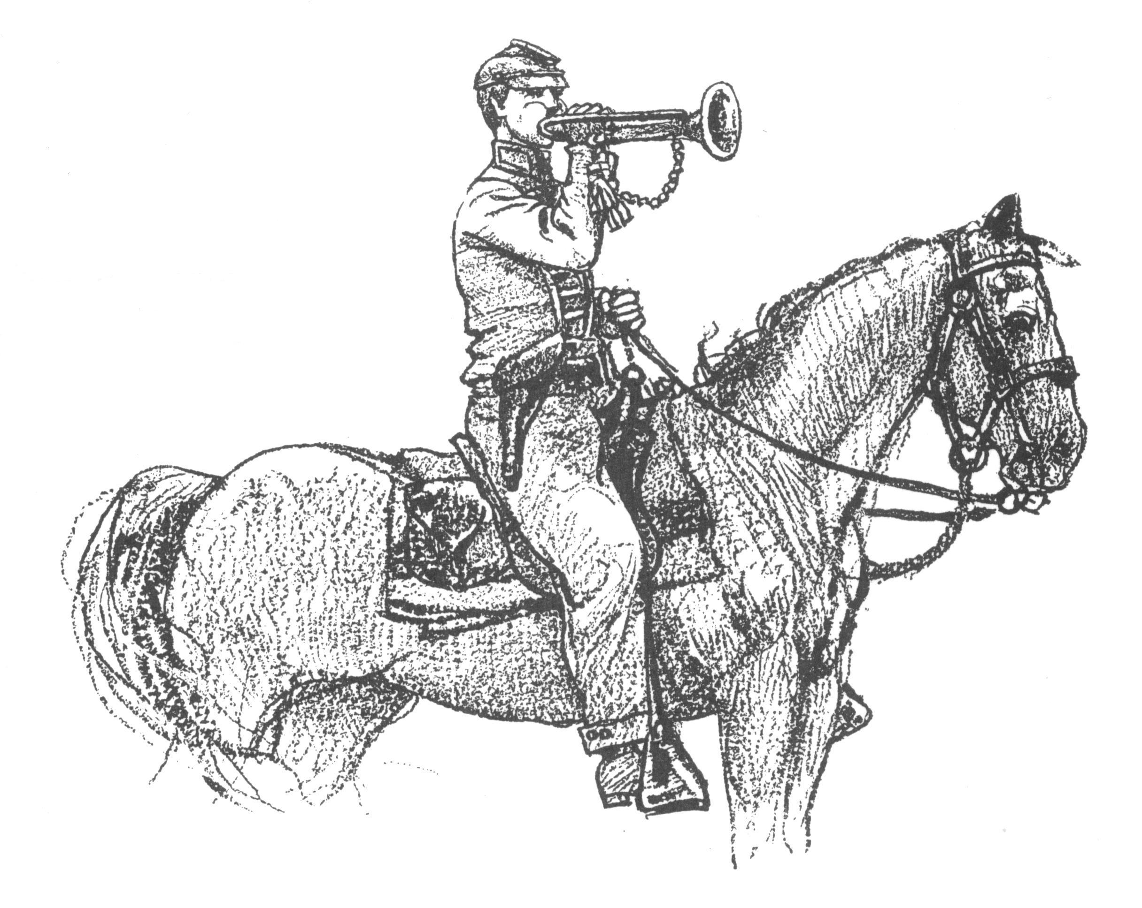 Call to Duty – Camp Calendar
Thursday, August 2nd – Regular Monthly Meeting Thursday, September 6th – Regular Monthly Meeting
Western Steer Western Steer
7 PM – Meal 7:30 Meeting 7 PM – Meal 7:30 Meeting
Program: TBA Program: TBA

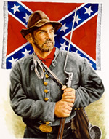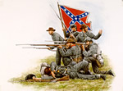
Welcome New Members - June

Richard Grubbs

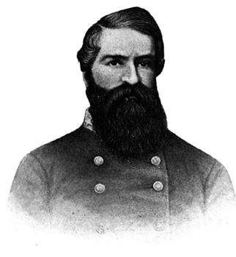
We didn’t have a winner !
Do you know this
Confederate Hero?

At the August Meeting, we’ll try again for a winner. We’ll pass out slips of paper and you can guess who this Confederate is. All correct responses will go into a drawing for a prize from the Camp Coffers.

Extra Commemorative Reunion Medals

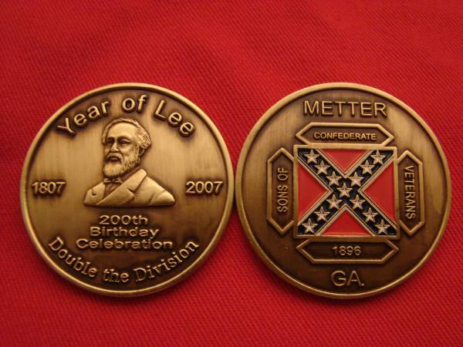
$20 each - Postage Paid
$15 – Picked up or Hand Delivered
Special ONE TIME Offer to Dixie Guards Members
For Members who Renewing their membership:
You can get a
Commemorative Medal
&
Camp Hat
Both for an Additional $20

*While Supplies Last
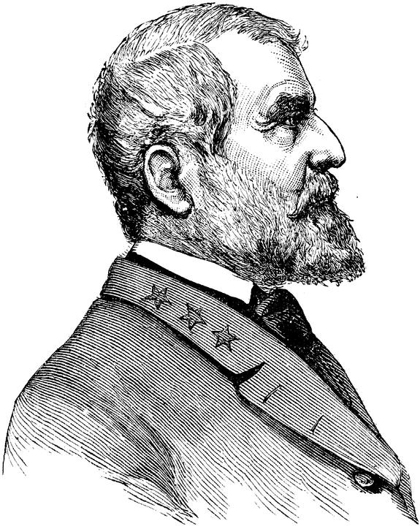 Think about this? 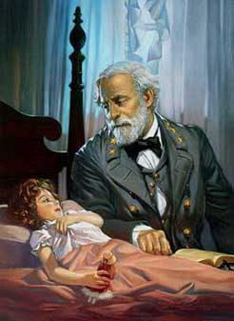
The Civil War touched the lives of everyone at the time, and it continues to do so today. Much has been written recently concerning the Confederate Flag, which most true Southerners feel represents the heritage passed down to them
from their ancestors. "It's offensive," some have said, " because it glorifies slavery, represents a period of rebellion, and romanticizes war." On the contrary...
It's not a matter of romanticizing war, for none condemned war more than those who suffered the horror and trauma of battle. The only thing it glorifies is the gritty courage of those who fought and died on this country's bloodiest battlefields. Those were our Father's and Grandfather's bodies in those countless numbers of caskets wrapped in that flag and who now rest on hallowed ground. And yes, the Southern soil where they now rest is hallowed! If the Confederate flag no longer can be acknowledged - WHAT NEXT? Are all the statues of the Confederate Generals who silently stand guard on court house lawns to be reduced to rubble? Will we ever be allowed to sing "Dixie" in polite society again?
In an article which appeared in the New York Tribune, during the war-between-the -states, a correspondent wrote:
"A people separated from their heritage are easily persuaded," This particular correspondent zealously supported the Northern side in the bitter conflict. He went on to say: "If you erase the symbols of a people's heritage, you erase their
public identity and memory, and then you can "persuade" them in whatever you want." For once in his life, this correspondent knew what he was talking about. His name was Karl Marx. (Editor’s Note: Karl Marx is the father of considered the Father of Communism and the icon upon which the Soviet Union’s government was developed)
It's not inappropriate for people in the South to honor their Confederate soldiers. It's a heritage of sacred memories of our beginnings. Better said, "our ROOTS." These were honorable men who were doing their duty as they saw it. Most all Confederate soldiers were volunteers. They fought not for glory, nor for money, but for a cause in which they believed deeply. They longed for peace and for a safe return to their families. To revile his flag is to revile his memory.
He sleeps--what need to question now
If he were wrong or right?
He knows, ere this, whose cause was just
In God the Father's sight.
He wields no warlike weapons now,
Returns no foeman's thrust--
Who but a coward would revile
An honest soldier's dust?
from "A Georgia Volunteer" by Mary Townsend
Nobody is doubting that slavery is a stain on the very soul of this nation. It is. But slavery was not the true cause of the war. The issue of slavery developed in the course of the war. It was an element in the cause of the war, but it was not the reason the war began. The primary cause was whether the federal government could dominate state government. Bottom line..dollars and cents. For some that's too simple an explanation of it and will never be accepted. But 'tis true...
"That flag represents the "heritage" of only a certain specific people," one prominent flag hater is quoted as saying. It seems apparent he is more concerned with destroying the heritage than destroying the flag. Life is too short to cherish revenge. The present urges. The future beckons. Animosity can only mar the happiness of both, and narrow indeed must be the mind of anyone who could wish to keep it up.

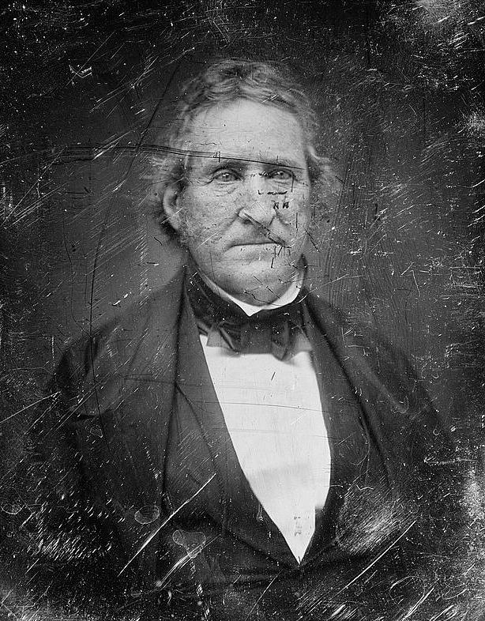
Antebellum America Series
Senator Thomas Hart Benton of Missouri
"Under Federal Legislation, the exports of the South have been the basis of the Federal Revenue. Virginia, the two Carolina's, and Georgia, may be said to defray three fourths of the annual expense of supporting the Federal Government; and of this great sum, annually furnished by them, nothing or next to nothing is returned to them, in the shape of Government expenditures. that expenditure flows in an opposite direction -- it flows north, in one uniform, uninterrupted and perennial stream. This is the reason why wealth disappears from the south and rises up in the north. Federal Legislation does this." - Senator Thomas Hart Benton
Thomas Hart Benton nicknamed "Old Bullion" (March 14, 1782 – April 10, 1858), was an American Senator from Missouri and a staunch advocate of westward expansion of the United States. He served in the Senate from 1821 to 1851, becoming the first member of that body to serve 5 terms. Benton was an architect and champion of westward expansion by the United States, a cause that became known as Manifest Destiny.
Benton was an unflagging advocate for "hard money," that is, currency backed by gold. Soft currency, in his opinion, favored rich urban Easterners at the expense of the small farmers and tradespeople of the West. He proposed a law requiring payment for federal land in hard currency only, which was defeated in Congress but later enshrined in an executive order, the Species Circular, by Jackson (1836). His position on currency earned him the nickname Old Bullion.
Senator Benton's greatest concern, however, was the territorial expansion of the United States to meet its "manifest destiny" as a continental power. He originally considered the natural border of the US to be the Rocky Mountains, but expanded his view to encompass the Pacific coast. He considered unsettled land to be insecure, and tirelessly worked for settlement. His efforts against soft money were mostly to discourage land speculation, and thus encourage settlement.
Benton was the author of the first Homestead Acts, which encouraged settlement by giving land grants to anyone willing to work the soil. He pushed for greater exploration of the West, including support for his son-in-law John C. Frémont's numerous treks. He pushed hard for public support of the intercontinental railway and advocated greater use of the telegraph for long-distance communication. He was also a staunch advocate of the disenfranchisement and displacement of Native Americans in favor of European settlers.
He was an orator and leader of the first class, able to stand his own with or against fellow senators Daniel Webster, Henry Clay, and John C. Calhoun. Although an expansionist, his personal morals made him opposed to greedy or underhanded behavior -- thus his opposition to Fifty-Four Forty. Benton advocated the annexation of Texas and argued for abrogation of the 1819 Adams-Onís Treaty in which the United States relinquished claims to that territory, but he was opposed to the machinations that led to its annexation in 1845 and the Mexican-American War. He believed that expansion was for the good of the country, and not for the benefit of powerful individuals.
Benton’s Connection to the War Between the States:
Father-in-law of Union General and 1st Republican Presidential Candidate, John C. Fremont.
Uncle of Confederate General Samuel Benton of Mississippi
Uncle of Union Brigadier General Thomas H. Benton, Jr.
Relative of US Vice-President, US Presidential Candidate, & Confederate General, John C. Breckinridge

