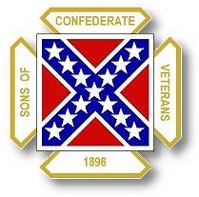
The Dispatch
The Official Publication of The Dixie Guards Camp # 1942
Sons of Confederate Veterans
Metter, Georgia

July 2006

Dixie Guards Camp # 1942
Sons of Confederate Veterans
P.O. Box 761
Metter, Georgia 30439

Postmaster Please Deliver To:

Visit Us Online at:
www.dixieguards.org
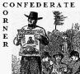 Commander’s Comments
Have you ever stopped and taken a few moments to consider how many significant historical events have taken place during July. Whew! It is mind boggling. Of course, there is Independence Day. To me, remembering July 4th is more than celebrating our Nation’s Birthday, it is a time to remember the chances and sacrifices that our Founding Fathers endured by signing the Declaration of Independence. Do you realize that they risked the lives, the lives of their families, everything. In the eyes of the British, they committed treason and were rebels. They won their war and are remembered favorably for it. Two generations later, America had a 2nd War of Independence. It was not a Civil War, but understandably, no one recognizes any other term anymore. The men of the 1860s were ridiculed and accused of treason too. They lost their war, so they are not looked upon as favorably…even among Southerners.
Southerners like Thomas Jefferson, James Madison, George Washington, Francis Marion and Elijah Clarke are celebrated heroes in American culture and folklore. Men like Robert E. Lee, Stonewall Jackson, James Longstreet and JEB Stuart are ridiculed and called Slave Owners who fought to preserve slavery. Wrong! Jefferson owned over 600 slaves….Madison over 200…Washington owned them too! Robert E. Lee owned no slaves of his own. Neither did Jackson or Longstreet. But…enough on the slavery argument. Whether it was morally right or wrong is not the real question…it was legal just like other immoral vices are today. Politicians like Ted Kennedy will look down upon a patriotic Southern man who reveres his American and Confederate Ancestry as being bigoted and he’ll shout with a drunken voice to throw down men like Lee. Then there is Georgia’s own Cynthia McKinney. Boy is she a real winner. She gets more publicity by acting like an idiot brat and punching a policeman performing his duty. Before you go to thinking that I’m picking on the party of the Donkey at least none of them have been caught with their hands in the cookie jar and run out of office because of election manipulation like DeLay. What I’m trying to say is that modern politicians, at least very few of them, are men the like of Washington, Jefferson, Madison, Lee, Jackson, Longstreet and those of the 1700s & 1800s. They just can’t match up. I don’t know if there is such a thing as a Patriot Politician in the modern day….Regardless of Party.
But what makes July special. Sure, it is the month of Independence Day. It is also the month that man 1st stepped on the moon. During the height of the Cold War, the US beat the Soviets to the moon and we placed Old Glory there. What a courageous adventure that was. But, July is much more to Southern Americans. It’s the month of Gettysburg and the loss of over 50,000 Americans. Over 20,000 Southern men in Gray were lost. What a sacrifice on the alter of freedom! There was Vicksburg. People starved to death there during Grant’s siege of the city. 30,000 Confederates became POWs there. It can be argued that the Southern Cause was lost there with the loss of the Mississippi River. July is a special month for America. It is a very important month for remembrance of sacrifices and struggles. For Southern Americans, we have even more to remember. Don’t forget them during this special month.
August 1st starts the renewal period for dues. Please everyone contact Tony regarding your dues. Some of the newer members actually joined under the new program with pro-rated dues, so you might not be set to renew your dues yet. For the members who have been around for more than a year, now is the time to get them in. The deadline for getting the dues to International Headquarters is November 1st. So, we have got to have them long before that to make sure everything is in order.
August 1st also begins the countdown for Our Year to Host the 2007 Georgia Division Reunion. We have set as the theme for the Reunion….Double the Division. We are trying to encourage every single camp in the Division to double in size by the time they get to Metter next June. We need to set the example. I know that we can do it. It probably sounds outrageous and hard. But, really it is not. Each and every one of us knows at least 1 person who is qualified to join. All it will take to double our camp’s size is for everyone to recruit that 1 person. Just 1…not a have a dozen. Just 1!
We also need to remind those members that we’ve lost to non-renewals over the past couple of years how important they are to our Camp and to Their Ancestors. Several of the members that we have lost are the only person on roll for the soldier that they represent. Because they are now lost members, their soldier has lost his representative. Think of it this way, your ancestor/soldier represented your family. Now it is your turn. Your soldier did his duty and now it is your turn. Gentlemen that is the way that I see it. I’m sorry if that is blunt. But, that’s it. My Ancestor stood up for my family and now it is my turn to stand up for them and him. Period!
How About You? Now’s The Time to Be on Roll for Your Family…Will You Be Present & Accounted For or AWOL. The choice is yours!

God Bless You and Your Family,
Randy
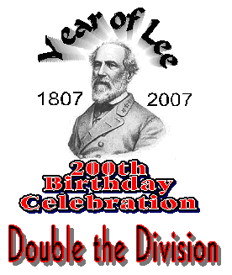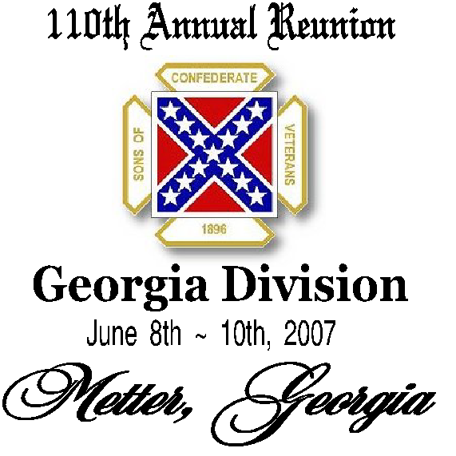
Here are the logos for Our Reunion. In the coming months you will here a lot about this. The whole Division is in competition to try to double itself by the June 2007 Reunion. Each Camp will try to double its membership. WE need to set the pace. WE have been leaders since we chartered and WE can do this!

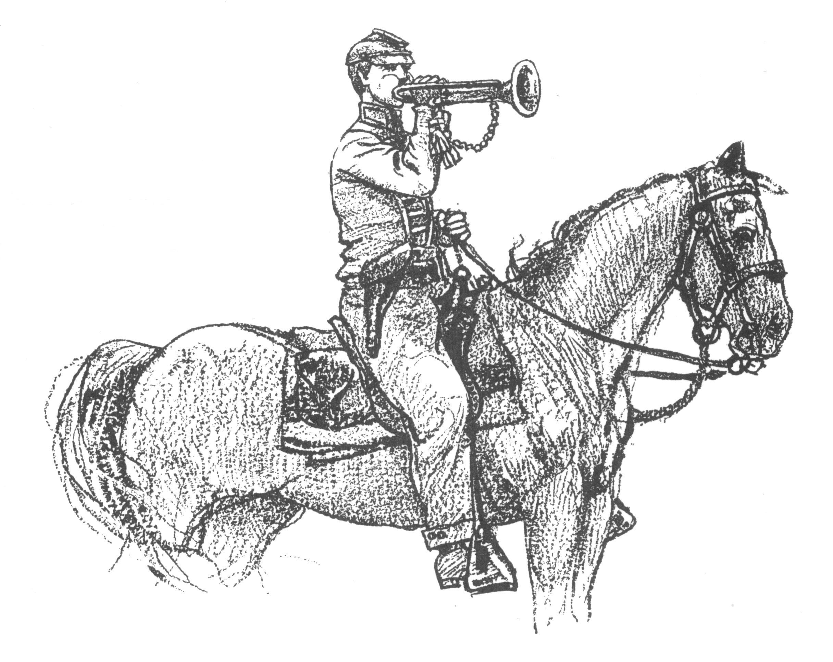 Call to Duty – Camp Calendar
Thursday, July 6th – Regular Monthly Meeting Thursday, August 3rd – Regular Monthly Meeting
7 PM – Meal / 7:30 PM Meeting 7 PM – Meal / 7:30 PM Meeting
Western Steer - Metter Western Steer - Metter
Program/Speaker – TBA Program/Speaker – TBA

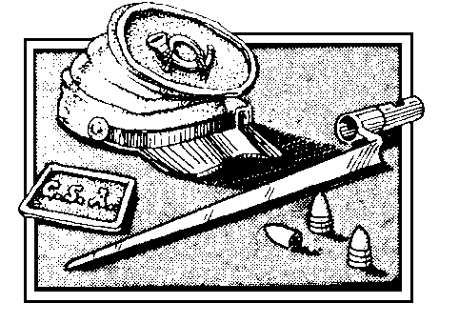
Remember Gettysburg
Nearly 55,000 Total American Casualties
20,000 plus Confederate Casualties

Remember Vicksburg
Thousands lost to War & Starvation
30,000 Confederate POWs


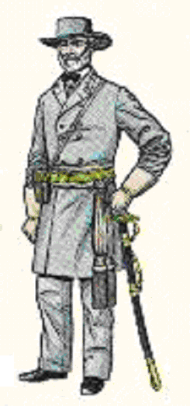 Feature: Robert E. Lee, American – Soldier - Patriot - Christian
Sure, we’ve all heard many stories about Robert E. Lee. Here are a few interesting tidbits that reveal the intimate ideals of General Lee. These are the very principles that he lived by and what made him great. Some of these quotes and words may be familiar to you, but they are worth repeating. Some say that emulation is the greatest form of flattery. Though he would be humbled by the flattery, we should all try to emulate him.

Robert Edward Lee was born at Stratford, Westmoreland County, Virginia on January 19, 1807. He was the 4th of 5 children to Richard Henry “Light-Horse Harry” Lee & Ann Hill Carter Lee. He died on October 13, 1870. He was just 63 years old. He had attended West Point and finished 2nd in his class and is the only cadet to ever graduate without demerits accounted to his record. He served with distinction on the staff of Major General Winfield Scott during the Mexican War. General Scott claimed that Robert E. Lee was the greatest living soldier in the world…the greatest soldier in American History to that time. He was a Commandant of Cadets of West Point. He rose to the rank of Lt. Colonel in the US Army. He was offered Overall Command of the US Armed Forces in the field at the beginning of the War Between the States by the Lincoln Administration. He declined and resigned his commission to offer his services to Virginia. He commanded in the Shenandoah. He commanded the Department of Georgia-South Carolina-Florida. He was an advisor to President Jefferson Davis. He took command of General Joseph E. Johnston’s army after Johnston’s wounding. He renamed it the Army of Northern Virginia. He and his Army became famous…world famous. He rose to General-in-Chief of all Confederate Armed Forces. He surrendered an out-numbered, starving army to save an ongoing loss of American lives. Mercifully, he saved a few Southerners to return home and rebuild the South. After the war, he was a model American citizen and advised his soldiers to do the same. He died a Southern & American Icon.
Quotes of Robert E. Lee:
“I prefer the Bible to any other book. There is enough in that to satisfy the most ardent thirst for knowledge; to open the way to true wisdom; and to teach the only road to salvation and eternal happiness. It is not above human comprehension, and is sufficient to satisfy all its desires.”
To his son…”You must study to be frank with the world. Frankness is the child of honesty and courage. Say just what you mean to do on every occasion, and take it for granted you mean to do right…Never do a wrong thing to make a friend or to keep one…Above all, do not appear to others what you are not…We should live, act and say nothing to injury of anyone.”
To his son…”Hold yourself above every mean action. Be strictly honorable in every act; and be not ashamed to do right. Acknowledge right to be your aim and strive to reach it.”
“The doctrines and miracles of our Saviour have required nearly two thousand years to convert but a small part of the human race, and even among Christian nations what gross errors still exist!”
“Knowing that intercessory prayer is our mightiest weapon and the supreme call for all Christians today, I pleadingly urge our people everywhere to pray.”
When told by Confederate Chaplain J. William Jones that many prayers had been offered on his [Lee’s] behalf – Lee’s reply: “Please thank them for that, sir – I warmly appreciate it. And, I can only say that I am nothing but a poor sinner, trusting in Christ alone for salvation, and need all of the prayers they can offer me.”
In response to claims that General Grant was starving Confederate POWs – “The prisoners we have here, General _______, are my prisoners; they are not General Grant’s prisoners, and as long as I have any rations at all, I shall divide them with my prisoners.”

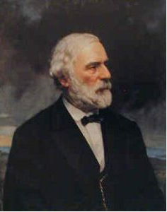 Robert E. Lee, American – Soldier - Patriot – Christian (Continued)
In response to a General officer in his presence shouting that he wished all the enemy were dead – “Now I wish that they were all at home attending to their own business, and leaving us to do the same.”
Once at Lee’s home, a minister expressed resentment towards the US Government in regards to the indictment of General Lee – Lee responded, “Well, it matters little what they may do to me. I am old and have but a short time to live anyhow.” Later, as the minister was leaving, General Lee followed him to the door and said, “Doctor, there is a good old book which I read, and you preach from, which says, ‘Love your enemies, bless that curse you, do good to them that hate you, and pray for them which despitefully use you. Do you think your remarks were quite in the spirit of that teaching? I have fought against the people of the North because I believed they were seeking to wrest from the South dearest rights. But, I have never cherished toward them bitter or vindictive feelings, and have never seen the day I did not pray for them.”
Lee rebuked younger officers who advocated continuing the war with guerilla tactics; he refused to countenance or support large scale emigration of Confederates to foreign lands; he urged Southerners to work lawfully and cheerfully within the existing laws of the United States to rebuild their fortunes and their land; and most of all, he beseeched them to forgive and forget wrongs committed against them by Federals past and present. ---- taken from a biography of General Lee.
To a young female admirer and friend of the Lee family related to hatred towards Yankees and the US Government – “I want you to take a message to your friends. Tell them from me that it is unworthy of them as women, and especially as Christian women, to cherish feelings of resentment against the North. Tell them that it grieves me inexpressibly to know that such a state of things exists, and that I implore them to do their part to heal our country’s wounds.”
General Lee’s General Order No. 73 (Regarding Confederates and Union Citizens during the Northern Invasion of the Gettysburg Campaign) ….
“It must be remembered that we make war only upon armed men, and that we cannot take vengeance for the wrongs our people have suffered without lowering ourselves in the eyes of all whose abhorrence has been excited by the atrocities of our enemies, and offending against Him to whom vengeance belongeth, without whose favor and support our efforts must all prove in vain.
The commanding general therefore earnestly exhorts the troops to abstain with most scrupulous care from unnecessary or wanton injury to private property, and he enjoins upon all officers to arrest and bring to summary punishment all who shall in any way offend against the orders on this subject.”
After the war, Lee’s wartime chaplain J. William Jones dropped by the General’s home for a visit. As he approached Lee’s home, he saw General Lee give money to a haggard man. When he entered Lee’s yard Jones asked who the man was. Lee replied, “One of our old soldiers.” Jones then asked where he was from and which Confederate unit he served in. Lee said, “Oh, he was one of those who fought against us. But we are all one now, and must make no difference in our treatment of them.”
Perhaps General Lee’s wife summed up the General’s life best….She said,
“I have never so truly felt the purity of his character as now, when I have nothing left me but its memory. God knows the best time for us to leave this world, and we must never question either His love or wisdom. This is my comfort in my great sorrow, to know that had my husband lived a thousand years he could not have died more honored and lamented even had he accomplished all we desired and hoped.”
In the years after the war and the days close to his death, General Lee said, “The march of Providence is so slow and our desires so impatient; the work of progress so immense and our means of aiding it so feeble; the life of humanity is so long, that of the individual so brief, that we often see only the ebb of the advancing wave and are thus discouraged. Just as the dominant party cannot reign forever, and truth will at last prevail, in a larger way – it is history that teaches us to hope.”
 Feature Article: The Vicksburg Campaign
Union Major General US Grant’s Vicksburg Campaign was actually the 2nd major attempt to take the Confederate stronghold of the Mississippi River. Grant’s campaign to take the city and the Confederate defenses began on November 2, 1862. Grant took 30,000 troops and Grand Junction, Tennessee. At first, he moved his troops in 3 columns down the Mississippi Central Railroad towards Holly Springs. Grant found that the Confederates under Pemberton had fortified the rivers in the area and Grant was forced to withdraw to Grenada. From there, he detached Major General William T. Sherman to lead a flotilla attack from north of Vicksburg’s defenses while he attacked from the southern sectors. On paper, his plans looked good. But, he forgot about Confederate Calvary under Brigadier Nathan B. Forrest. Forrest and his men severed Grant’s supply lines and wreaked havoc in the Federal rear. Grant had to again withdraw from his plans. But, Sherman was already committed and attacked anyway. Sherman and his force of 32,000 men disembarked near Chickasaw Bayou and ran into Confederate defenders under Brigadier Stephen D. Lee. 3 days later, Sherman had to withdraw in disaster for the Federals on January 2, 1863.
By the end of January 1863, Grant’s plans had turned to an isolation and a siege of Vicksburg because its formidable fortifications. He decided to use maneuver rather than attack to dislodge the Confederates. He maintained his army in separate sectors in attempts to confuse Pemberton. Troops moved a little at a time, almost in feints. Skirmishes and battles were common place and though modern historians may consider them minor, they were very fights for those involved. Many troops from both sides paid the ultimate sacrifice in the struggles.
Finally, Grant’s troop movement began to persuade Pemberton that the Federals were actually abandoning their struggle. He expressed to President Davis and Army Commander Joseph E. Johnston that Vicksburg was safe and the Federals were withdrawing. By mid-April, the Confederate high command was informed that Grant was not in fact withdrawing but maneuvering. Pemberton was order to hold Vicksburg and Port Hudson. By then, Grant had maneuvered into position to cause Pemberton trouble. The indecisive and incorrect information that had been relayed to the Confederate high command may have cost Pemberton re-enforcements. But, it certainly caused the isolation and siege of Vicksburg.
On May 19th, Grant attacked Vicksburg’s defenses. He hoped to avoid a protracted engagement and in ways that would later become typical when he faced Lee in Virginia, he attacked believing that his superior numbers meant certain victory. He attacked twice believing his superior numbers would win the day and both times he was repulsed with heavy losses. He realized that a siege was the only way to gain victory over Vicksburg and resorted to the less than gentlemanly means of starving out the entrenched Confederates.
News of the siege spread quickly and many Confederate field commanders urged attempts to assist the trapped Confederates. General Johnston and General Beauregard suggested it. Johnston claimed he had nearly 25,000 troops available to embark on the attempt. Lt. General James Longstreet urged the attempt to save Vicksburg and delay any movement into the North. He, along with Johnston, Beauregard and others felt that the loss of Vicksburg meant the loss of the Mississippi. Johnston pushed his troops into action and set out to try to help all that he could. No support would come from Virginia.
The citizens of Vicksburg and Confederate defenders were daily exposed to Union bombardment. Citizens hid in cellars, basements and by digging cave into adjacent hillsides. By June, people inside the entrapment were eating mule and rat meat to survive. The staple was the Black-eyed Pea. After 46 days of constant bombardment, loss of fresh water and nearing starvation, Pemberton surrendered his command to Grant on July 4, 1863. In the surrender, the Confederates lost 2166 officers, 27,230 enlisted troops, 115 surviving civilians, 172 cannons and 60,000 long arms.
On July 5th, Johnston engaged General Sherman and after he heard of the surrender fell back to prevent his own entrapment. 11 Days later, he evacuated the Mississippi capital of Jackson. The loss of the 30,000 men of Vicksburg, along with the nearly 25,000 of Gettysburg was a severe blow to Confederate manpower. The loss of the Mississippi River and its supply lines put nails into the Confederate coffin. The Confederacy was cut into 2 pieces and no longer had the Mississippi as a source for blockade running and supply.

Can you name these great Southern warriors? Fill in the blanks with the correct answers and bring them to the August meeting. All sheets with all these great Southerners correctly identified will go into a drawing for a framed and matted print to be given away at the meeting. GOOD LUCK! * HINT…THE 2 NON -CONFEDERATES AT THE BOTTOM ARE GEORGIANS.
 

