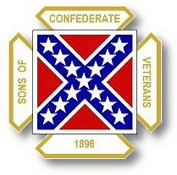
The Dispatch
The Official Publication of The Dixie Guards Camp # 1942
Sons of Confederate Veterans
Metter, Georgia

January 2007 Edition

General’s Banquet: Saturday, January 27th – 7 PM

Next Meeting: Thursday, February 1st – 7 PM

Dixie Guards Camp # 1942
Sons of Confederate Veterans
P.O. Box 761
Metter, Georgia 30439

Postmaster Please Deliver To:

Visit Us Online at:
www.dixieguards.org
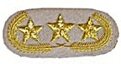Commander’s Comments
I hope everyone had a Blessed Holiday Season! I received a great gift January 2nd and I have to share it with everyone. First, let me say that I want to apologize to everyone if I’ve been a little distracted lately. But, here’s why. In October, my son was diagnosed with a Cyst in his brain. He has been undergoing tests and seen several doctors & specialists since then. January 2nd, we received the glorious news that he had a clean bill of health and was okay. I had decided to keep it to myself because we didn’t know many details and couldn’t answer any questions about his condition anyway. Several did find it out and I want to thank you for your thoughts, calls and prayers. Little Brian is okay and will be a Cadet real soon!
You’ve probably noticed that the newsletter is running a bit late. Normally, we try to get it out in time to remind everyone about the monthly meeting. This time, I decided to wait and try to remind everyone about the Banquet instead. We suffered a poor attendance for our January meeting, so please let’s make up for it with the Banquet! Commander-in-Chief, Chris Sullivan is our Special Guest Speaker and we really need to come out a give him our support.
Like I said, we had a really tiny group for the January meeting. Maybe it was because of the Holiday Season / New Year’s or maybe it was the late newsletter. If it was the newsletter, I’m sorry! But…Wow! We started off 2007 with a BANG! We had 7 new members join. That was great and I would like to welcome the new members. Thanks to Carlton Clifton for bringing in 6 of these guys. After the meeting, Carlton said that it was easy – He said, “All I had to do was ask them.” It might not be that easy for everyone, but we won’t know without asking. Some folks need to be asked to feel welcome. Rejection isn’t painful, so let’s all ask someone between now and the Banquet…certainly before the February meeting and see how it turns out. What do you have to lose? A Confederate Soldier’s name may be called out for the 1st time since Roll Call and how wonderful it would be to add to the list of soldiers whose name and sacrifice has been recognized. To you new members, I’d like to encourage you to recruit a new member as soon as you can. It is a good feeling to know that you helped get a Confederate Soldier recognized by someone you recruited. I really enjoy reading the names of the soldiers on the applications.
The Chamber of Commerce Gala was a success and I want to thank the Camp for helping make it so. The donations that the Camp and individual members donated brought in the neighborhood of $800 for the Chamber. That was roughly 10% of their total. As far as I know, we were the only Civic Group to participate and I received quite a bit of compliments from folks in attendance. I know that we received new members from it, so it was well worth it. Honestly, I think if the quilts had been auctioned earlier, they would have made even more money. But, they did okay and we did our part.
With the New Year, has come “The Year of Lee” – and the Reunion will be here before we know it. We had a very successful 2006 and we have the opportunity to have an even better 2007. And, it is a great year to be the host of the Reunion - The Bicentennial Year of General Lee’s Birth. We get the chance to make the Georgia Division shine, commemorate General Lee’s memory, make Metter-Candler shine and our Camp shine all at the same time. We will pick back up with our Reunion planning meetings very soon. The Commemorative Program is just about ready for the printer and I want to thank Carlton Clifton and Wayne Lesesne for the outstanding job the have done with Ad Sales. We don’t know the final costs for printing the book, but I think it is safe to say that all the costs will be covered. On behalf of the Camp and the Reunion, thanks gentlemen.
We haven’t quite gotten the Big Camp Grill completed yet, so our Boston Butt Sale was delayed. We plan to have it completed soon and will have a sale as soon as we finish. We have gotten a lot of requests for another Boston Butt Sale and in fact, we’ve been asked when we were going to have another BBQ Chicken Sale too. We certainly hope to be able to have one soon. With this grill it will be much easier.

God Bless You and Your Family,
Randy
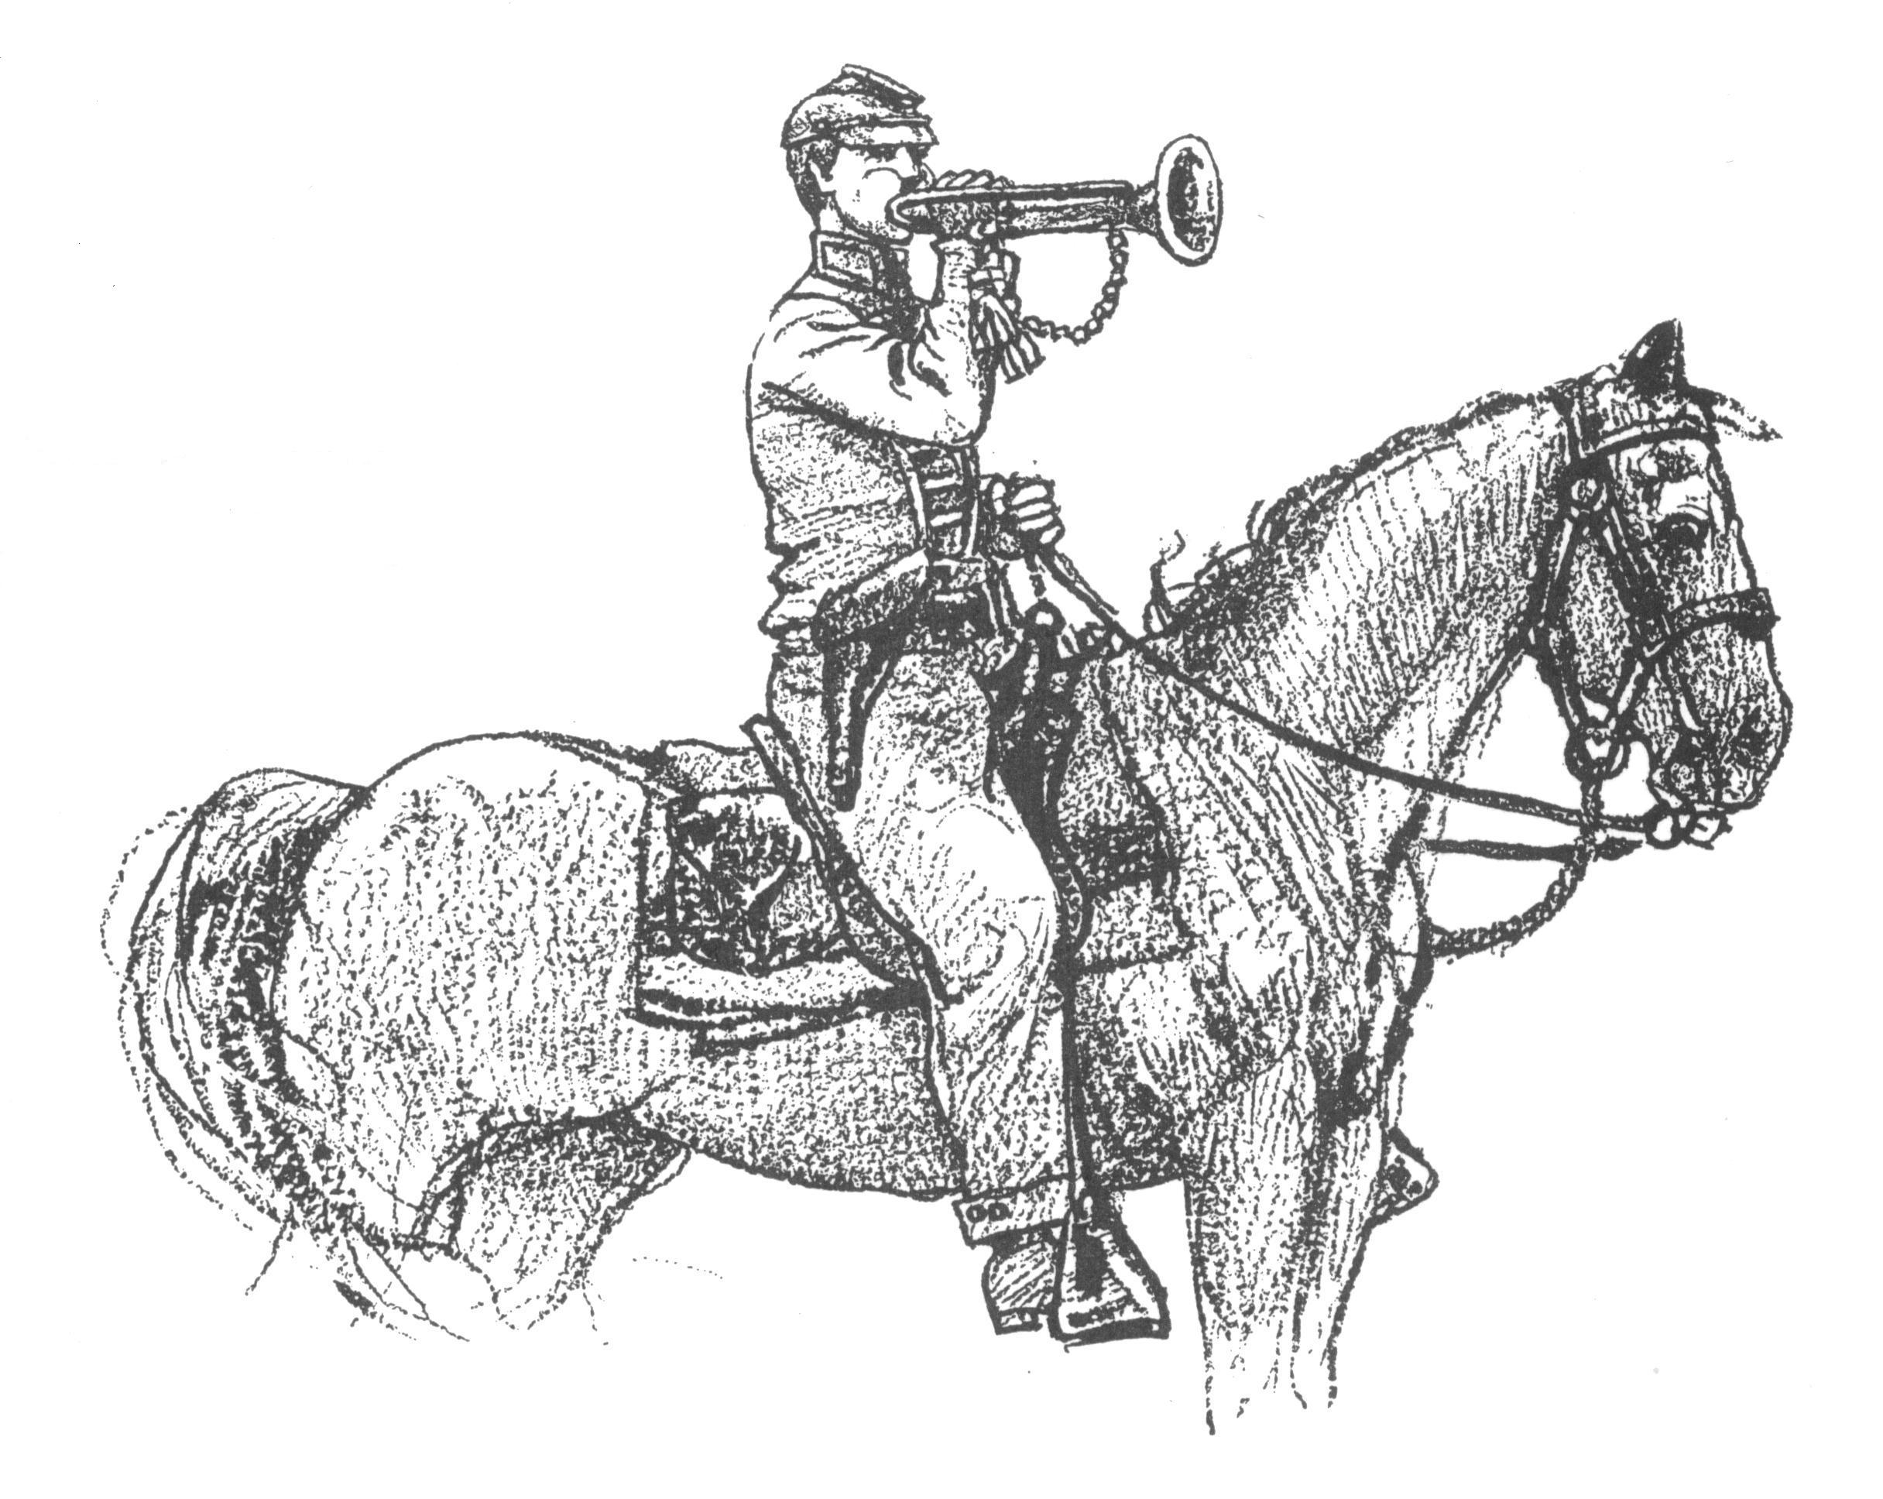 Call to Duty – Camp Calendar
Thursday, February 1st – Regular Monthly Meeting Thursday, March 1st – Regular Monthly Meeting
Western Steer Western Steer
7 PM – Meal 7:30 Meeting 7 PM – Meal 7:30 Meeting
Program: Compatriot Jason West Program: Compatriot Ted Lewis

Welcome New Members

Charles E. Johnson, IV honoring 2nd Lt. Ebenezer Walden – Co. I, 28th Georgia Volunteers (Jefferson Greys)
Heath Kemp honoring Pvt John D. Johnson – Co. K, 28th Georgia Volunteers
Michael Thigpen honoring Pvt General George Washington Woods – Co. I, 9th Georgia Volunteers
William Alan Thigpen honoring Pvt General George Washington Woods – Co. I, 9th Georgia Volunteers
John Morgan Trapnell honoring Pvt Christopher Columbus Morgan – Co. C, 54th Georgia Volunteers
Allen Keith Tyler honoring Pvt Levi Sylvester Tyler – 2nd South Carolina Artillery (Cpt Medicus Rickenbaker’s Company)

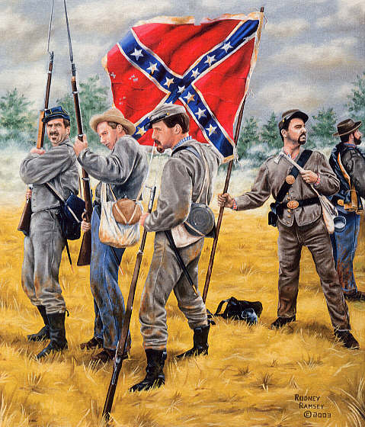

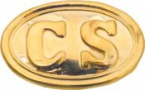Trivia: How many men did the Army of the Confederate States have? Answer later in newsletter!
Did You Know?
Stonewall Jackson’s Valley Campaign is often credited to be the cooperative ideas of General Lee and General Stonewall Jackson. Actually, that story is not correct and proper credit should be given where the credit is due. When it appeared that Federal General George McClellan was going to embark on an attempt to turn the Confederate Right Flank and maneuver against Richmond, General Joseph E. Johnston authorized and directed Stonewall to take his troops on a “Diversion” mission in the Shenandoah Valley to prevent reinforcements from being sent to McClellan. Johnston’s plan was to prevent as many troops as possible from being added to McClellan’s forces on the Peninsula. Jackson knew the area and was Johnston’s choice for being able to carry out the movements with the least amount of support. Since Jackson was familiar with the area, Johnston believed his command could maneuver in the face of the Federals then in the Valley with the most success and speed. General Johnston was severely wounded at Seven Pines and was replaced by General Robert E. Lee. In a short time, the Confederates turned back McClellan’s attempt to capture Richmond. Lee and his newly christened Army of Northern Virginia became famous. Johnston’s credit for developing the plan for the Diversion in the Valley disappeared and was forgotten with the arrival of the fame and success of Lee and the Army of Northern Virginia.
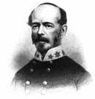
Confederate General Joseph E. Johnston
How About this? Harper’s Ferry changed hands 15 times during the course of the War.
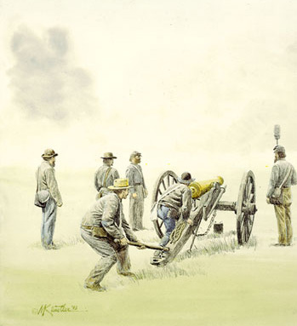 Feature Article: The Battle of Galveston – January 1, 1863
In late November of 1862, Major General John B. Magruder was placed in command of Confederate forces in Texas. Hoping to reinvigorate coastal Texas and rally the Texas population, Magruder wanted to retake Galveston from the Federals even though the blockade was in full force in the Gulf of Mexico.
Magruder coordinated with what Confederate Naval Forces that were available to his command and requested an attack of Union Naval Forces on New Year’s Day, 1863. The Confederates attacked via Galveston Bay with four gunboats and gained the attention of the Union command in Galveston. Magruder used the distraction to launch and attack of his Confederate Infantry. The Confederates overran the Federals of Colonel Isaac Burrell and took control of Galveston. The simultaneous operation of the Confederate Infantry and Navy forced the surrender of the Federal forces.
In the actions, the Confederates captured and boarded the USS Harriet Lane along with three other ships of the Federal Squadron. Attempting to support the Harriet Lane, the squadron flagship, USS Westfield ran aground and was the order to blow up the ship rather than surrender it was given by US Naval Commander W.B. Renshaw.
Galveston was costly for the Federals. They lost 3 ships to capture, including the prized Harriet Lane. The squadron Flagship was a permanent casualty of war and rests at the bottom of Galveston Bay. In addition to the loss of the naval vessels, the Federals lost 650 men in the lopsided Confederate victory. Suffering only fifty casualties, the Confederates had retaken Galveston in a largely symbolic victory. The Federal Naval Blockade still controlled much of the area.
Don’t Forget… Our Annual General’s Banquet
January 27, 2006 - 7PM
Metter Recreation Department’s Strickland Building
Special Guest Speaker: SCV Commander in Chief, Chris Sullivan
Bring a Guest and a New Member!

If you plan to attend, please RSVP by Saturday, January 20th so that the caterer can have an accurate count for preparation –

RSVP Numbers: Randy Crooms 912-685-7504 - Tony Thompson 912-685-3347 – Carlton Clifton 912-685-5138

Or send an email to 1roundb@pineland.net – hrcrooms@pineland.net

Reserved seats are $15 per person and can be paid at the door. Seating is limited so please contact as early as possible. Walk-ins will be accepted provided space is available but food will be prepared based upon reserved seats.

Trivia Answer
The Army of the Confederate States of America consisted of 5 men – The Full Generals of the CSA. The volunteers, conscripts and militiamen that made up the troop units that served in the field were actually the Provisional Army of the Confederate States of America. The key word is “Provisional”. Men like Stonewall Jackson, JEB Stuart and all the private soldiers made up the Provisional Army. The 5 Full Generals that made up the Army of the Confederate States were (in no particular order):
1. Robert Edward Lee 2. Joseph Eggleston Johnston 3. Samuel Cooper
4. Albert Sidney Johnston 5. Pierre Gustave Toutant Beauregard

