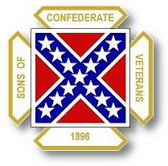
The Dispatch
The Official Publication of The Dixie Guards Camp # 1942
Sons of Confederate Veterans
Metter, Georgia

February 2007

Dixie Guards Camp # 1942
Sons of Confederate Veterans
P.O. Box 761
Metter, Georgia 30439

Postmaster Please Deliver To:

Visit Us Online at:
www.dixieguards.org
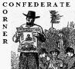 Commander’s Comments
Some of this month’s editorial isn’t Confederate-themed and for that I apologize in advance. But, it is American-themed and for that, of course, I won’t apologize. Some of this is in fact political, or more, the fact that I hate that everything has become political. My reasoning for even mentioning this stems from the memory of my recent series on American Political Correctness and Morality. Recently, a commander of another camp asked if he could get copies of the series for his newsletters and I am only too happy to comply. But, the off-Confederate comments here are directly in tune with the themes that I shared in those articles. I’ll explain. Remember that I said that we’ve have sunken to terrible depths of Political Correctness in our society. Because of this sinking, I have predicted terrible things ahead for our Country and for our Ancestors. Well, here’s some proof of how far we’ve fallen.
Two articles, one Confederate related and the other not show the true colors of the Modern Media & Political Correctness. During the week of January 16th -20th, the USA Today printed an article about the latest King Kong movie. You may be asking, where is this going? Well, in the article the paper or at least, the author of the article is claiming that King Kong is a racist movie. Not because of any bad portrayal of the black natives in the movie, but rather that the theme is that the Big Black Gorilla cannot have the pretty Blond White Woman. Somehow, the person writing the article is able to dream up the idea that King Kong represents blacks and they must be prevented from having the white woman. How absurd? Wait, there’s more…
It was brought to my attention by Compatriot Ted Lewis that the Atlanta Journal-Constitution had an article about General Robert E. Lee in the paper on his birthday. There was a picture of the carving at Stone Mountain that dated back to 1928 when the carvers were working on General Lee’s face. The caption written under the picture is where the Journal’s scathing of our ancestors continues. Under the picture the article said that “Stone Mountain was the largest memorial to failure in the world”. How about that? That is from our home state’s largest newspaper. Now I know that the Atlanta Journal-Constitution hasn’t been a friend to Dixie and the SCV for quite awhile, but this takes the cake. I’ve said that our enemies are after Stone Mountain; I believe that this is proof that the Atlanta Journal-Constitution will lead the way with the propaganda needed to change the minds of the people of Georgia to go along with the idea.
In his book Mein Kampf, Adolf Hitler wrote that “A lie told loud enough and long enough will become the truth in the eyes of the people.” Well, I believe this is the beginning of the movement to rid us of Stone Mountain. I believe that the propaganda campaign is beginning in earnest. Between the ridiculous politicians like Tyrone Brooks, Cynthia McKinney and their cohorts, along with the liberal media, the mass of non-Georgians now living here won’t care one bit about Stone Mountain by the time their efforts are done.
Now for the real non-Confederate stuff – As most of you know, recently the US bombed a building in Pakistan where an Al-Qaeda meeting was taking place. Several of the Al-Qaeda bigwigs were reported killed or injured. Since then a big out cry has come from the Pakistanis people, France, Germany and even folks here in the United States that are saying we killed innocent women and children along with the bad guys. Wait a minute…Why were the “innocent women and children” at the meeting? Plus, how soon do people forget! How about this….During the Blitz bombing of Great Britain during WWII, Germany killed 50,000 British Civilians in just two months! How about the Terror Bombing of Dresden and other German cities by the United States and Britain during the waning months of the war? Dresden had no real military significance to it, certainly not by the time of the bombings. No one, not anyone complained that the United States did a terrible thing by bombing Germany! I don’t ever recall hearing too much complaint about the Atomic Bombing of the Hiroshima or Nagasaki either. Thousands of Japanese died there. Now, we are mortified that a handful or innocent women and children were killed while in attendance of an Al-Qaeda meeting.
When will all this Political Correctness end? The public is more worried goofy stuff that their own country, their own family, their own safety, their own ancestors and history. It’s no wonder why organizations like the SCV, The Sons of the American Revolution and the women’s groups – the DAR, UDC can’t get anymore participation that we do….It is largely because people are worried about what someone will say or think about them. They are worried about their reputations? I ask ….What reputation?
I would rather be looked at poorly by my peers than to have to face my ancestors, my kinfolks and explain to them that I was ashamed of them. I simply won’t turn my back on my kinfolks or my family. I wasn’t born into this world with friends….but I was born into it with family. Think about it! Who deserves your homage more…the public and its perception of you or your ancestors and family.
Maybe I’m the wrong one, but as for me, it’s and easy answer and I don’t care what the Political Correct Crowd thinks! What about you?

God Bless You and Your Family,
Randy
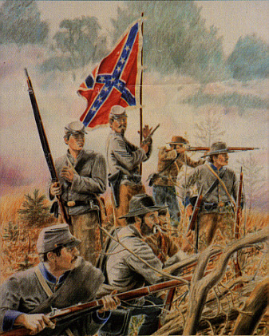 Call to Duty – Camp Calendar
Thursday, March 1st – Regular Monthly Meeting Thursday, April 5th – Regular Monthly Meeting
7 PM – Meal / 7:30 PM Meeting 7 PM – Meal / 7:30 PM Meeting
Western Steer - Metter Western Steer - Metter
Program/Speaker – Ted Lewis Program/Speaker – Jason West

Dates to Remember – Friday, April 6^{h} – Good Friday
Saturday, April 7th – Another Bloomin’ Festival – Metter
Sunday, April 8th – Easter Sunday
Thursday, April 26th – Confederate Memorial Day

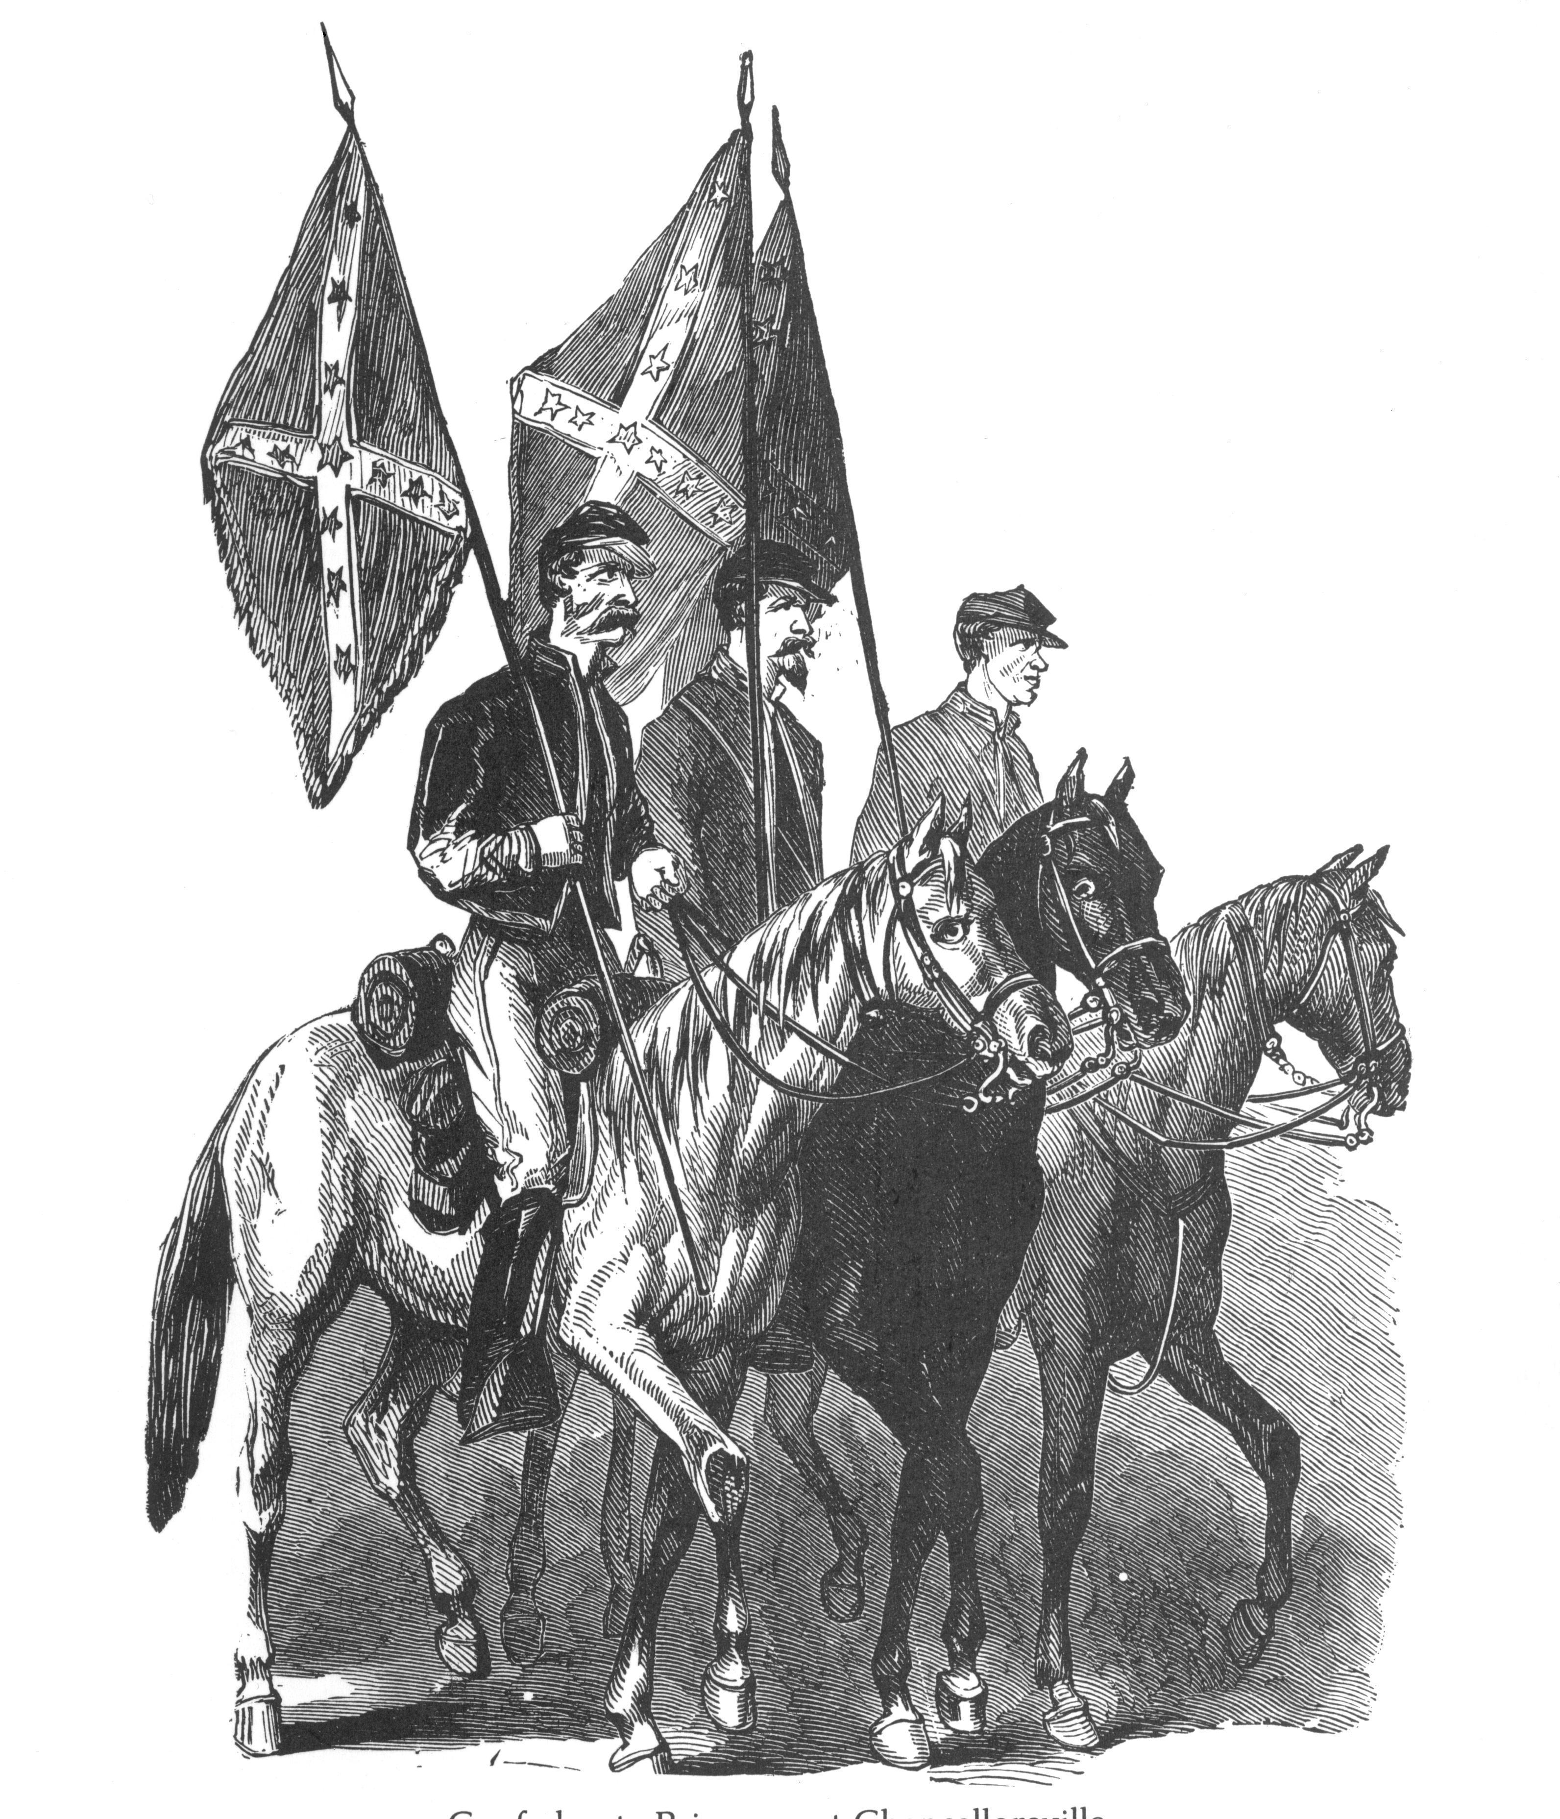 Did You Know?
It has often been perpetuated by school textbooks, teachers, historians and politicians that from the beginning, the Confederate States government was hostile towards the US Federal government and in particular, the Lincoln Administration. E. A. Pollard was the editor in chief of the Richmond Examiner, a Richmond, Virginia newspaper during the period before, during and after the War Between the States. He chronicled this tumultuous period and it can be argued that he can be credited with being as good an eyewitness as anyone else of his day relating to public life and policy of the Confederate States government. He was critical when he felt the need and supportive when events dictated cheering. Here is what he shares about the myth that the Confederacy planned war from the beginning….
“As early as February, prior to the inauguration of Mr. Lincoln, the Confederate Congress had passed a resolution expressive of their desire for the appointment of commissioners to be sent to the Government of the United States, for the purpose of negotiating friendly relations between that government and the Confederate States of America, and for the settlement of all questions of disagreement between the two governments upon principles of right, justice, equality, and good faith.”
The entire paragraph above is a quote of Pollard’s statement on the subject. – But, he also is quoting the resolution or minutes from the Confederate Congress. The words printed in bold are the words he quoted from the official position of the Confederate Congress in the resolution for cohabitation with the United States.
So Much for the Myth!

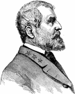

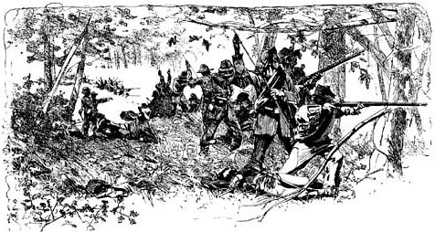 Feature Article: The Battle of Olustee –February 20, 1864

The Battle of Olustee or Battle of Ocean Pond was fought near Lake City, Florida, on February 20, 1864 and was the largest battle fought in Florida during the war. In early February, 1864 Union Major General Quincy Gilmore directed Brigadier General Truman Seymour on an expedition into northern Florida to disrupt Confederate supply routes, gain and control the port of Jacksonville, gain and control other ports and supply routes from the east and west coast of lower Florida. Another potential aim was to gain control of much of Florida in order to make it easier for Union troops to attack Georgia, Alabama or other deep south Confederate States. Possibly the single most important aim of the expedition was to try to set up a base of support for a localized Union government in exile within northern Florida. General Seymour had 5,500 troops under his command to accomplish the task.
The Confederate forces in northern Florida were under the command of Brigadier General Joseph Finegan. He had under his command approximately 5000 Confederates to defend the area. Among these troops were troops from Georgia. The 32nd Georgia, which can be called a Special Forces Unit, if compared by today’s standards were detached from their Coastal Georgia/South Carolina Command and sent to assist General Finegan. Other Georgia troops were, the 64th, 6th, 9th, 28th Infantry Regiments, the 28th Georgia Siege Artillery Unit and the Chatham Artillery of Savannah.
The 32nd Georgia was famous for the diversity of skills of its troops. All of the 32nd Georgia troops had the skills of engineers, infantry soldiers, artillerists, and cavalry. They designed and constructed earthworks that could withstand an attack and Finegan’s troops dug in for the battle. The 32nd Georgia had become famous for the design, construction and defense of Battery Wagner in Charleston Harbor. Using the area’s natural terrain and swamps, they again designed and constructed defenses that the attacking Union soldiers would wish they had never seen.
As the Union troops entered the area, General Finegan ordered his cavalry forces forward to engage them and to try to cause them to drift towards the defensive lines that had been constructed. The Union troops were able to hold off the Confederate Cavalry attack and did not completely move before the Confederate defensive lines. General Finegan order additional troops forward to attempt to drive the Union forces from the field. Leading the attacking Confederates was the Georgian, Brigadier General Alfred Colquitt. The Confederate troops quickly took the ground in heavy action and the Union troops scattered in panic and confusion.
By the end of the battle, the Union forces had been soundly defeated. Union casualties were 203 killed, 1,152 wounded, and 506 missing, a total of 1,861. The Union forces lost about 40% of the troops engaged in the battle. Among the Union troops were the 54th Massachusetts, the47th New York, which lost 313 of its troops, the untrained 8th United States Colored Troops Unit, which lost 310. On the Confederate side, the losses were not nearly as bad. Confederate losses were 93 killed, 847 wounded, and 6 missing, a total of 946. The 32nd Georgia, whose troops were engaged at the front on all portions of the battlefield, lost 164 men.
The Union forces were forced to vacate the field and retreat. By February 22nd, they had retreated all the way back to Jacksonville. The north Florida expedition failed in almost every aspect of Gilmore’s and Seymour’s plans. Florida supply lines were not lost to the Confederacy. No safe bases of operation against Georgia or Alabama were established. And, most importantly, no Unionist Government was established in northern Florida.
The Confederate forces led by Brigadier Finegan and Brigadier Colquitt save North Florida. After the battle the 32nd Georgia returned to their normal duties. General Colquitt returned to the Army of Northern Virginia, as did the detached units of the 8th Georgia, 28th Georgia and the 28th Georgia Siege Artillery.

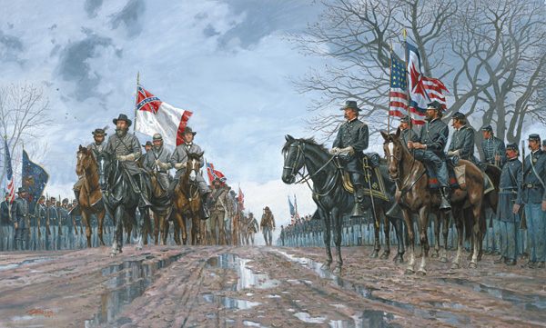

At Appomattox, at the Official Ceremony of Lee’s Surrender, Lee’s men marched into the Union Camps by rank and file. Union Major General Ulysses S. Grant gave the privilege of being the Official Union Army Representative to Brigadier General Joshua L. Chamberlain. Chamberlain rose from Lt. Colonel of the 20th Maine Volunteers to the rank of Brigadier General and was wounded in battle and given up for dead several times. In fairness to Chamberlain, though he was a Union soldier and an enemy to our Confederate troops, his is truly an American story of heroic proportions in service to his country. But, this is not a story about Brigadier General Joshua L. Chamberlain of Maine. Rather, it is the story of the words that he said about our Confederate Ancestors as they marched in to the Union Camps to lay down their arms for the last time. Chamberlain’s words reflect the honor and patriotism of our Confederate heroes. Here is what Chamberlain said as he watched the Confederate troops march by and come to attention.
"...On they come, with the old swinging route step and swaying battle flags. In the van, the proud Confederate ensign. Before us in proud humiliation stood the embodiment of manhood; men whom neither toils and sufferings, nor the fact of death could bend from their resolve; standing before us now, thin, worn, and famished, but erect, and with eyes looking level into ours, waking memories that bound us together as no other bond; was not such manhood to be welcomed back into a Union so tested and assured? On our part not a sound of trumpet more, nor roll of drum; not a cheer, nor word, nor whisper or vain-glorying, nor motion of man, but an awed stillness rather, and breath-holding, as if it were the passing of the dead!"
In fact, General Chamberlain had issued an order to the Union troops that there would be no jeering of the Confederate troops and that the utmost respect would be shown to them. He reminded his troops that the Confederates had won far more battles than they had lost and that they had earned the respect that he was demanding. He issued orders that the Union military bands were to play Confederate music in honor of the Army of Northern Virginia and songs like the Bonnie Blue Flag and Dixie were played over and over for the Confederates. As it turned out, General Chamberlain’s orders not to belittle or jeer the Confederates was unnecessary and many letters were written home by Union troops indicating that they cheered the Confederates as they marched by and came to attention themselves in honor of them.
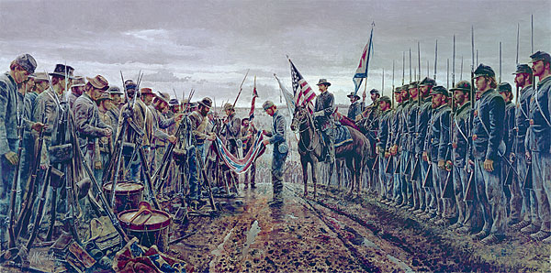
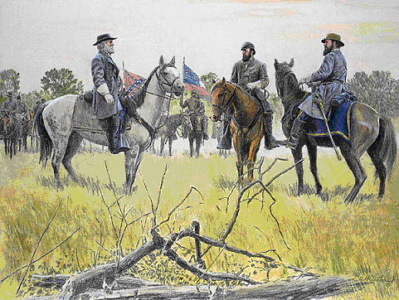
General’s Banquet Report
Saturday, January 27, 2007

Pictured at left: General Lee, General Jackson, General Longstreet by Mort Kűntsler
We had a wonderful General’s Banquet to kick off our new year. Over 100 came out to help us celebrate the successes of 2006 and to usher in an even better 2007. The Strickland Building is a nice establishment to host such an event and we will enjoy it in June – and from now on!
We kicked off the New Year by gaining several new members, one of which is a second-generation member. These younger members are not only the future of our Camp, but the future of our Organization. Another of the new members has been on the potential member list since we chartered in early 2001. His membership is a testament to not giving up on anyone. One we’ve helped search for an ancestor for a long time. Never – Never give up on a recruit. If you do, you give up on a soldier’s memory!
Commander-in Chief Sullivan gave a wonderful tribute to our beloved Robert E. Lee. The speech was truly remarkable, as was General Lee. Overall, everyone enjoyed the evening – the food was great, the fellowship was great. If you missed it, you missed a extraordinary evening.

.
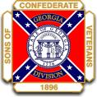
Georgia Division, Sons of Confederate Veterans
Reunion 2007 – June 10 -11, 2007
Metter, Georgia

We have already secured a guest speaker for the Luncheon. He is Dr. Charles Thomas from Georgia Southern University. Dr. Thomas is originally from the Northwest Georgia area. At Georgia Southern, Dr. Thomas teaches American Military History, World War II, German History and others. Dr. Thomas is an expert on all aspects of American Military History and is a friend to our Confederate Ancestors. Dr. Thomas has already decided on a topic and is looking forward to coming.
We have already made an “Official Invitation” towards our Keynote Speaker for the Banquet Dinner for Saturday night. Until we get an answer, we don’t want to reveal who it is. But, it’s safe to say that he is a famous, household name and will bring a lot of publicity to Metter, our Division and to our Camp if he accepts.

History of Confederate Memorial Day in Georgia –
In 1874, the Georgia General Assembly approved legislation adding as a new public holiday "The 26th day of April in each year--commonly known as Memorial Day." April 26 marks the anniversary of the end of the Civil War for Georgia, for it was on this day in 1865 that Confederate General Joseph E. Johnston's surrender to General William Sherman in North Carolina became official. Johnston had been in charge of Georgia's defense, so this day marked the end of the war for Georgia.
Exactly when Georgians began commemorating April 26 as Memorial Day is unclear, but the language of the 1874 act clearly recognizes that April 26 was already being celebrated as an unofficial holiday. The day of observance may trace to the women of Columbus, Georgia, who on April 12, 1866 organized a memorial association and began a campaign to have a special day for "paying honor to those who died defending the life, honor and happiness of the Southern women." Three days later, the Atlanta Ladies' Memorial Association was organized, and on April 26, 1866, the association held a Confederate memorial observance at Oakland Cemetery.
While Florida would later join Georgia in marking April 26 as Confederate Memorial Day, other states celebrated different dates. By 1916, ten southern states marked June 3--Jefferson Davis's birthday--as Confederate Memorial Day. Alabama and Mississippi celebrate the fourth Monday in April, while North and South Carolina celebrate May 10--the anniversary of Jefferson Davis's capture by Union troops--as Memorial Day.
Until 1984, Georgia observed as official state holidays:
- January 1 (New Year's Day)
- January 19 (Lee's Birthday)
- Third Monday in February (Washington's Birthday)
- April 26 (Confederate Memorial Day)
- Last Monday in May (National Memorial Day)
- June 3 (Jefferson Davis's Birthday)
- July 4 (Independence Day)
- First Monday in September (Labor Day)
- Second Monday in October (Columbus Day)
- November 11 (Veterans' Day)
- Fourth Thursday in November (Thanksgiving
- December 25 (Christmas Day)
The 1984 General Assembly changed state law with respect to public and legal holidays observed in Georgia. The new law (O.C.G.A. sec. 1-4-1) provides:
(a) The State of Georgia shall recognize and observe as public and legal holidays:
(1) All days which have been designated as of January 1, 1984, as public and legal holidays by the federal government; and
(2) All other days designated and proclaimed by the Governor as public and legal holidays or as days of fasting and prayer or other religious observance. In such designation the Governor shall include at least one of the following dates: January 19, April 26, or June 3, or a suitable date in lieu thereof to commemorate the event or events now observed by such dates.
(b) The Governor shall close all state offices and facilities a minimum of 12 days throughout the year and not more than 12 days in observance of the public and legal holidays and other days set forth in subsection (a) of this Code section and shall specify the days state offices and facilities shall be closed for such observances.
The result of the 1984 legislation was to drop the names of all official state holidays from the Georgia Code. In one sense, this eliminated any state holiday known as Confederate Memorial Day, Robert E. Lee's Birthday, or Jefferson Davis's Birthday--or Thanksgiving or Christmas. Rather, Georgia observes whatever federal holidays were observed as of January 1, 1984. Additionally, the governor is charged with selecting January 19, April 26, or June 3--or an alternative date more suitable--for commemorating any or all of the persons or events formerly recognized on those three dates.
For some time, the University of Georgia's Main Library has marked Confederate Memorial Day by placing the original Confederate Constitution on display. Each Confederate Memorial Day, the Confederate Constitution can be viewed from 9 am to 5 pm on the third floor of the University of Georgia's Library.
© Carl Vinson Institute of Government, University of Georgia
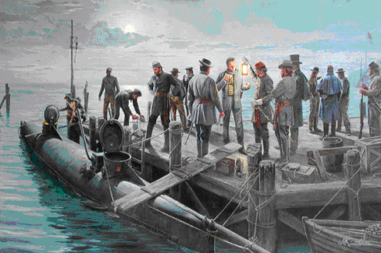 Feature Article – CSS Hunley sinks the USS Housatonic - February 17, 1864
The date was February 17, 1864. It has been said that the day was a bone-chilling day similar to the days we have recently experienced and not unlike many days of a coastal town in the depths of winter. But, this date would go down in Confederate and American history. On this date, the 3rd and final crew of the CSS HL Hunley would embark on its historic and mortal attack of the USS Housatonic.
Here is a short article on the historic events with the some of the information taken from the Hunley.org website –
The CSS HL Hunley had already lost all but 4 of its 1st crew and its entire 2nd crew during accidents amid training sessions. The Confederacy nearly scrapped the idea of the secret weapon. But, Lt. George Dixon refused to give up. He persuaded the Confederate authorities to give him another shot. Dixon was an extremely patriotic southern man and after he was spared by a miracle at Shiloh, he committed himself to the Southern cause with added zeal.
Dixon was allowed to gather an all-volunteer crew and amazingly, men stood in line to serve with Dixon. The long lines of volunteers could have been because of patriotism among the men in and around Charleston or it could have been that Charleston had been under a siege of bombardments from the US Warships just off shore. At any rate, Dixon quickly gathered a crew and they trained for the mission for several weeks prior to the fateful February night. A system was devised between the shoreline and the submarine with glowing lanterns that could lead the Hunley back to safety after her mission.
Rumors were widespread of a Confederate secret weapon and word had even spread among the US Warships that a new water-born threat was on the horizon. Submerged chain netting had been placed around some of the ships to prevent the rumored beast from approaching the ships. The Federal navy vessels weren’t convinced of a threat but they weren’t going to risk it….just in case.
Finally, the night came. Dixon and his crew set out on the frigid winter night. They hand-cranked the Hunley towards the enemy warships that had been raining bombs down on the citizens of Charleston. For years, it was believed that the Hunley attacked from the shore side of the ships. In fact, based upon where it was discovered, it is believed that the Hunley crew had cranked the submarine past the line of ships, particularly the USS Housatonic, the eventual victim.
A sailor on board the Housatonic saw something in the water. Was in a porpoise? What was it? He was sure. We know that it was the Hunley, but is it possible that since the attack came from the open water side of the ship, the sailors on board simply thought that it could not be a threat until it was too late. We’ll never know that answer. What we do know is that the Hunley crashed a barb into the side of the Housatonic. Attached to the barb was nearly torpedo bomb that weighed well over 100 lbs. The Hunley quickly backed away from the ship and once the 150 feet of rope became taught, the torpedo exploded.
The explosion ripped the Housatonic and it sank in a matter of minutes. Amazingly, only 5 US sailors lost their lives. The explosion had been witnessed from the shoreline of Charleston and would later be recollected. The Hunley came to the surface and signaled the shoreline sentries with the blue signal lanterns. The sentries stoked up the fires and awaited the return of the submarine. The return never came. The actual cause of the loss of the CSS HL Hunley has not been completed solved. Rumors and theories are to this day being scrutinized and discussed. Maybe the answers lie with the ongoing research being done by the excavation and preservation team.
The CSS HL Hunley was the 1st naval attack by submarine in maritime history. No submarine would be used in warfare again until World War I when the Germans would use them against the Allies.
We may never know what happened to cause the Hunley to be lost; but, one thing is for sure. The men of the CSS HL Hunley gave the ultimate sacrifice in defense of Charleston and the Confederacy. They died heroes. They died alone. Let us never let their memory disappear so that they died in vain.

