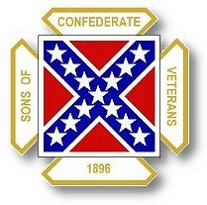
The Dispatch
The Official Publication of The Dixie Guards Camp # 1942
Sons of Confederate Veterans
Metter, Georgia

December 2006 Edition

Next Meeting: Thursday, January 4th – 7 PM

Dixie Guards Camp # 1942
Sons of Confederate Veterans
P.O. Box 761
Metter, Georgia 30439

Postmaster Please Deliver To:

Visit Us Online at:
www.dixieguards.org
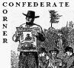 Commander’s Comments

I had the privilege of attending the Annual School Day presentation on Friday, November 17th. Jay Clifton is always the point of contact for the Camp and he brought along several of his reenactor buddies. The school kids loved the presentation. As can be expected, the cannon firing and musket firing brought the biggest cheers – but these kids were very attentive to the presentations. They listened to the story of Sherman’s March and the history of the Confederate Flags. No negative comments were heard and the reenactor presentations were well received. A big thanks goes out to Jay for his work. I came away from the event with a couple of wonderful beliefs – 1. as long as we put forth the effort, we’ll be invited back again and again. 2. as long as we’re active, we can reach these kids – I can tell a difference in the knowledge of the South this group had over years past and they seem to be getting better each year. We are making a difference – both with the kids and with the teachers.
It is Christmas time and it is a wonderful time for family. December was a significant month for the Confederacy. In the Eastern Theatre, there was Fredericksburg – one of General Lee’s most solid victories. In the Western Theatre, there was Murfreesboro – a setback for the Confederacy. Both battles have glorious acts of courage and heart wrenching stories of loss. More that likely the ancestor you joined under, if he was in active service at that time, was at one of these two battles. Let us commit ourselves to their honor.
The Year of Lee is upon us. General Robert E. Lee, one of our Greatest Americans turns 200 years old on January 19th. There is no greater way to honor General Lee’s memory and place in history that to honor the men who served under him. General Lee was a modest man. He didn’t seek or want fame. He did want credit for good deeds. But, he did revere his men’s service and he did want the reputation of his men to be preserved. IT IS OUR CHALLENGE TO LIVE UP TO HIS LEGACY.
I believe that if we strive to act like General Lee and do our utmost to honor him and the troops he loved so, then we too will go down as legendary Southern men. We have an opportunity to make the SCV the honorable organization that General Lee made of the Confederate Army. Of course, Confederate soldiers beloved him. We’ve all read the stories of how they praised him. But, the Federal troops did too! And, after the war, the entire country North and South praised him for his virtue, his military skill and his high moral values. He was the epitome of a Southern and American Gentleman and more importantly, he was a living example of a Christian. His minister even told stories of General Lee offering him good Christian advice. General Lee was a man among men.
The Charge to the SCV deliberately urges us as descendants of Confederate Soldiers to do all that we can to ensure that their legacy is preserved and protected. Their hope was that we would take over the mantle of their legacy. With the Charge, they asked us to do just that – every time we recite the Charge we renew that promise to do the Duty that the Charge declares is Ours!
Many of you know that my favorite quote is General Lee’s quote regarding Duty. He said, ‘Duty is the most sublime word in the English language. Do you Duty in all things! You cannot do more; you should never wish to do less!” When I think of General Lee, that quote always comes to mind. I hope that it always does. What a great way to remember General Lee. He had a genuine devotion to Duty and he emphasized that Duty in everything he held dear.
What about this? Did you realize that Duty is the key word in this quote of General Lee and the Charge to the SCV? Take a minute to evaluate what Duty means here. General Lee said that we should never do or want to do anything less that our duty. The Charge to the SCV says it is our duty to ensure that the Confederate Soldiers legacy and place in history is preserved. I truly believe that our central theme is the preservation of the Confederate Soldier’s Good Name and Place in History. I believe we should strive to do just that. I believe that this is an honorable mission.
General Robert E. Lee and the men of the Confederate Armies were great and honorable men. They were our forebears and ancestors. They were our blood kin. We should honor them in the best ways that we can. We should strive to encourage people to join us in our task. It is their Duty too. Part of our duty is to spread this message. We should take this message to everyone, just as if we were couriers in the field of battle. We know our Duty! Let’s do it!
Merry Christmas to you all and I hope God richly blesses you. Remember the season and the birthday! Have a safe and glorious new year. The General’s Banquet is just around the corner. Please pray for Our Troops and Our Country.

God Bless You and Your Family,
Randy
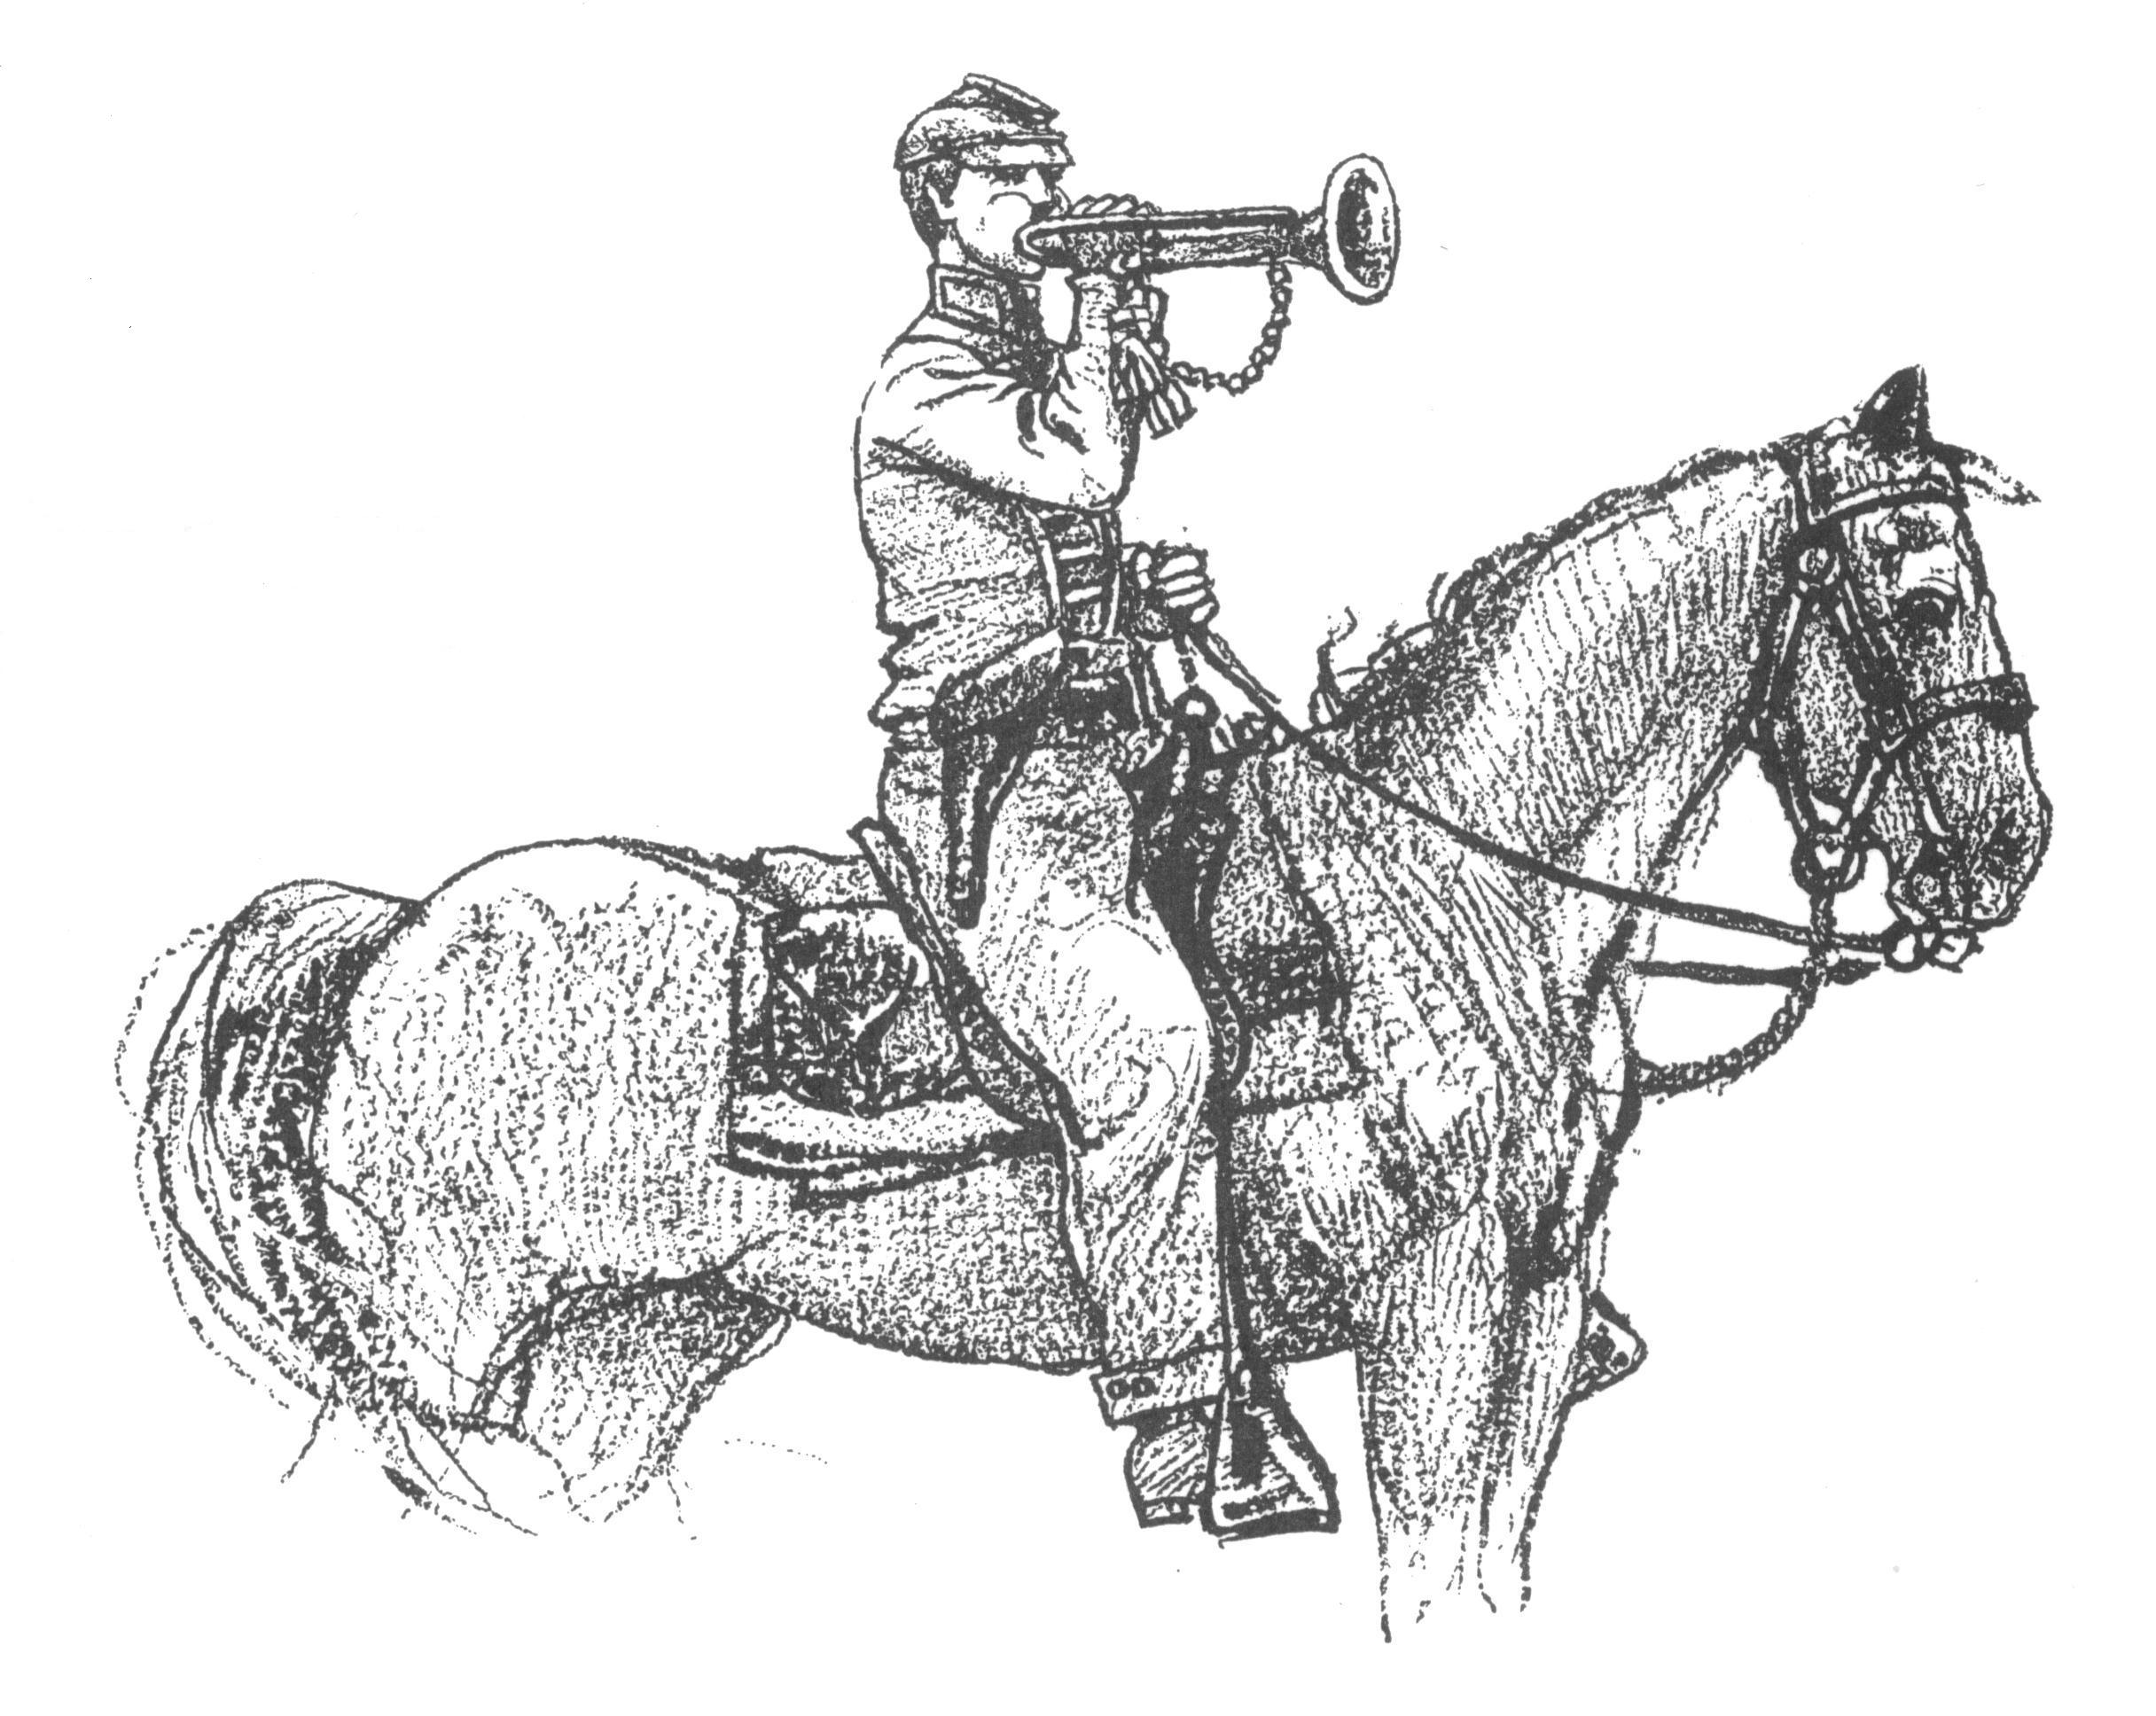 Call to Duty – Camp Calendar
Thursday, January 4th – Regular Monthly Meeting Saturday, January 27th – Annual General’s Banquet
Western Steer Metter Recreation Department Pavilion
7 PM – Meal 7:30 Meeting 7 PM Meal & Banquet
Officers Elections SCV Commander-in-Chief, Chris Sullivan

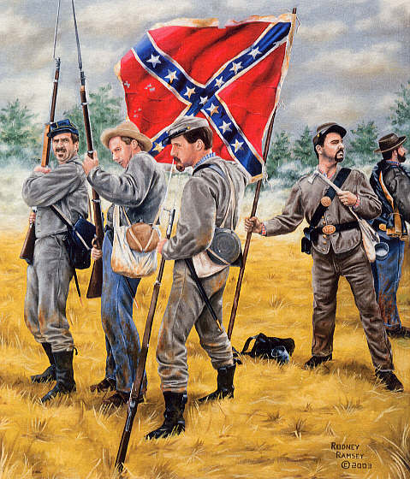 Did You Know? At the Battle of Murfreesboro in December 1862 – January 1863: A company of Confederates exhibited what can be called phenomenal valor and commitment to their Cause.
The Company was ordered forward as a part of the many Confederate attacks to repulse the Federal Army of the Cumberland. The Company received the order to advance and immediately rose and formed their ranks. The Company moved out and attacked as ordered. Up to this point, this Company of Men did like many other Confederate and Federal units had done before and would do again…However, This Company of Men formed ranks and attacked the Federals as ordered….EVEN THOUGH NOT A SINGLE ONE OF THEM HAD A WEAPON. THEY ATTACKED WITH STICKS AND CLUBS THEY HAD FASHIONED INTO WEAPONS…THE ONLY WEAPONS THEY HAD!
THAT IS COMMITMENT TO A CAUSE!!
Don’t Forget… Our Annual General’s Banquet
January 27, 2006 - 7PM
Metter Recreation Department’s Strickland Building
Special Guest Speaker: SCV Commander in Chief, Chris Sullivan
Bring a Guest and a New Member!

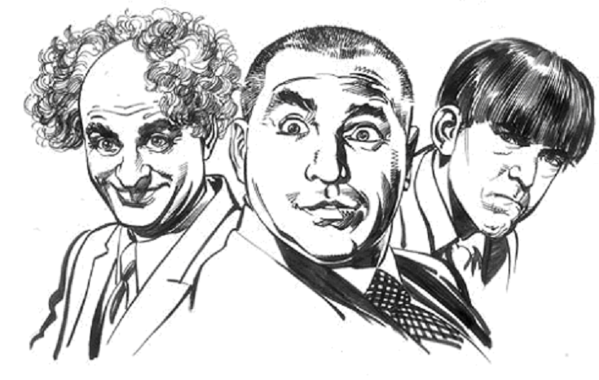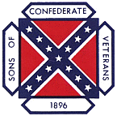
Even the Stooges know that SCV Memberships make great Christmas Gifts ! Why not give one this year ?

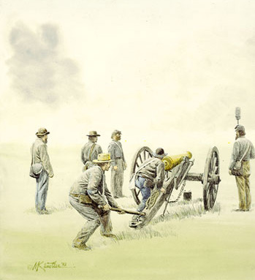 Feature Article: The Battle of Murfreesboro
In late 1862, the Confederate Armies in the Western Theatre of Operations underwent reorganization. Their commander, General Braxton Bragg, decided to reorganize them after the Campaign in Kentucky that resulted in the Battle of Perryville. Their new name would be the Army of Tennessee, a name which would last until their surrender in April of 1865.
December of 1862 found the Army of Tennessee operated near Murfreesboro, Tennessee. The Confederates were preparing to go into winter quarters, but were also initiating cavalry raids throughout the state. Cavalry under John Hunt Morgan and Nathan Bedford Forrest were detached from Bragg to carry out raids and attempt to deter Federal supply lines. Only Joseph Wheeler and his troopers remained with the Army.
The Federals, under Major General William Rosecrans, also were reorganized. They became the Army of the Cumberland. They maneuvered and followed Bragg’s Army and planned to attack him while the Confederates were preparing their winter quarters. Almost as soon as the Federals left Nashville and set out to catch the Confederates off guard, the Confederates learned of the expedition through spy and intelligence networks. The Confederates laid in waiting and concentrated at Murfreesboro.
Each Army Commander planned to launch an attack on the enemies Right Flank in a turning movement. This was quite typical of many engagements of the war. Had both sides attacked at once, the ensuing battles would cause the armies to move in a circular pattern like a merry-go-round. On December 29th, a day or two before the Battle, Brigadier Joseph Wheeler and his troopers were able to ride completely around the maneuvering Federals like JEB Stuart had done in the East. Stuart’s ride is famous, but Wheeler’s is seldom recalled. Wheeler and only 2500 men inflicted a great deal of damage to Rosecran’s supply and communications lines and captured nearly 1000 Federal troops.
The Battle began on December 30th when the Confederates caught the Federals completely off guard and attacked first. The attack pushed the Federals and the Confederates held the day. At day’s end, the two rival armies hunkered down and prepared for further action. That evening, the Federal Army Bands and the Confederate Army Bands dueled back and forth with tunes like “Yankee Doodle” and “Dixie”. Later, they joined together to play songs of home, love and Christmas that brought cheering from both armies.
The fighting recommenced on December 31st and again the Confederates held the advantage at the end of the day. That night before the chiming of the New Year, Rosecran’s had a Council of War to decide whether the Federals should retreat or stay and fight. New Year’s Day brought a lull in the fighting and a rest for both armies. Maybe it was the Holiday or maybe it was exhaustion but nothing more than skirmishing took place on New Year’s Day. Bragg was convinced that the Confederates had won the Battle and thought Rosecrans would use the lull to retreat – but that was not the case. Rosecrans’ Council of War had decided that “there was no better place to die.” So, on January 2nd, Bragg decided he had to finish Rosecrans once and for all. He ordered an attack on the Federal lines. Breckinridge, the commander whom Bragg ordered to attack objected to the plan and said the request was “impossible to achieve.” Breckinridge was supported by Polk and other Confederate officers but Bragg was determined to have the charge.
Breckinridge charged and was repulsed with heavy losses in the area that became known as “Hell’s Half Acre”. In the assaults, Breckinridge’s command suffered over 1800 casualties in under an hour. In the end, the Confederates could claim a Tactical Victory but the Federals could claim a Strategic Victory. The Confederates lost a large number of irreplaceable men and gained very little. According to one historian of the Battle, “Few battles have been fought which have better exhibited the soldierly virtues than the Battle of Murfreesboro or Stone’s River. The Confederate assaults were conducted with the utmost gallantry and with untiring energy. They were met with great coolness and resolution.” The Federals had engaged 41,000 troops and lost 13,000. The Confederates had approximately 35,000 troops and suffered nearly 12,000 casualties.

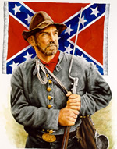 "I must not forget our old flag — though torn & tattered & faded. In the three days of fighting, although about 18 inches was torn off the end & lost — there is fifteen bullet holes through the flag & three through the staff — & besides there is a large rip made by a piece of a bomb. Three color bearers were shot down & the fourth now carries it. If I should live through the war I would want no brighter monument than this faded flag to decorate my parlor walls — (Provided I ever have a parlor)." … James C. Bates CSA

Can You Help Us Remember Men Like James C. Bates…Men Like Your Ancestor?
Please help us by sharing the names & information of 4 potential members – if you can’t contact them, we’ll contact them for you. We’ll still honor you as the recruiting member if they join! Just fill this out & bring it to the next meeting.

Name_____________________________ Name_____________________________
Address___________________________ Address___________________________
___________________________________ ___________________________________
Phone_____________________________ Phone_____________________________
Recruiting Member_______________________________ Recruiting Member_______________________________

Name_____________________________ Name_____________________________
Address___________________________ Address___________________________
___________________________________ ___________________________________
Phone_____________________________ Phone_____________________________
Recruiting Member_______________________________ Recruiting Member_______________________________
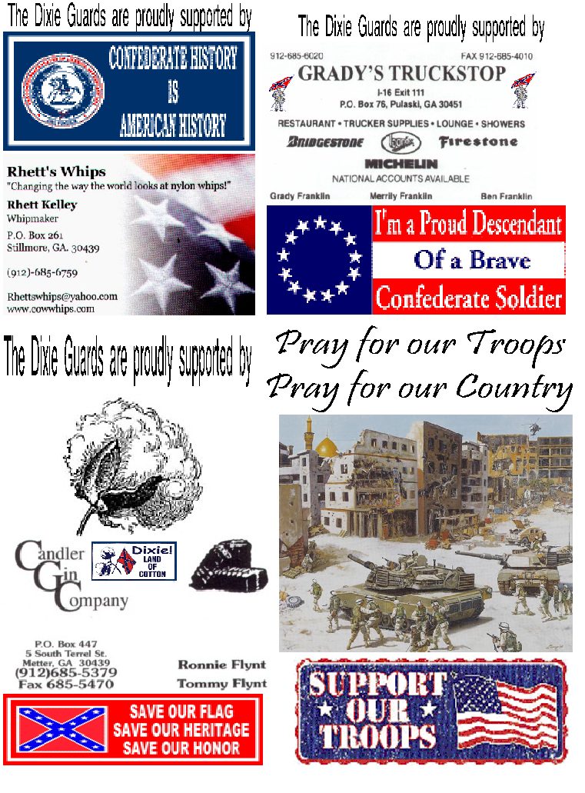
 Away at Christmas Time 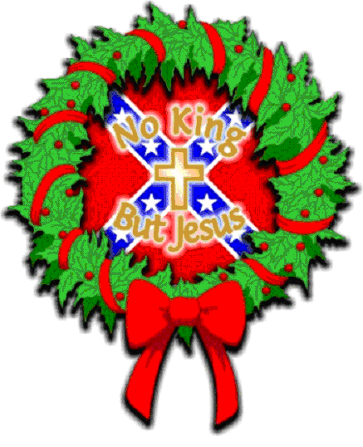

I watched the aging warrior as silently he wept;
He was thinking of his family during the time they slept.

He lay there still, in the cold chill of night;
He had become a prisoner in a previous fight.

He realized this Holiday no toys he’d be bringing;
Suddenly, to ease his grief he started singing.

“O Holy Night”, I believed the song to be;
His frail, cracking voice became beautiful to me.

As he continued through his chorus and rhyme;
I remembered we were away at Christmas time.

I began to notice the others were joining in;
Forgetting for a time we were in Elmira’s pen.

The song became saintly and full of love;
It sounded like Angels were singing from Heaven above.

The tune and the tears came from most every face;
Each one was remembering a more peaceful time and place.

A guard joined in from outside by the wall;
For at that moment nothing else mattered at all.

Though we were caught under a prison camp’s net;
It became a happy time I’ll never forget.

It was wonderful how this little chorus and rhyme,
eased the pain of being Away at Christmas Time.


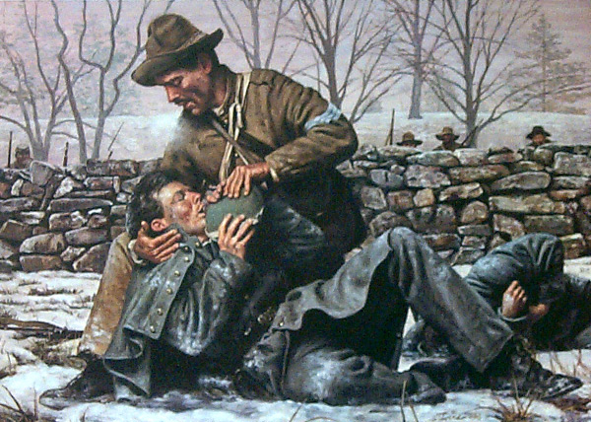

The Angel of Marye’s Heights

At the Battle of Fredericksburg in late December 1862, the Confederate Army of Northern Virginia under General Robert E. Lee repulsed repeated attacks by the Federal Army of the Potomac under Major General Ambrose Burnside. The famous attacks and repulses are depicting in the movie “Gods and Generals”. One very wonderful event that the movie missed was the story of Sergeant Richard Kirkland.
Sergeant Kirkland was a South Carolinian serving in Lt. General Longstreet’s 1st Corps ANV. He was a part of the Confederates that anchored the famous line of Marye’s Heights above the city of Fredericksburg. Longstreet’s men had been positioned behind a rock wall placed to prevent erosion along a roadway above the city. The hill sloped towards to city. Because of the wall and the slope, the Confederates had a nearly impenetrable position as long as their ammunition held up.
The Federals repeatedly attacked the Confederates only to be cut down by volley after volley. The Federals that were not killed outright were forced to lay wounded in place with no help available. They laid there overnight in the frigid December cold. Many succumbed to the cold, compounded by their wounded condition. The night was filled with the agony and cries for help.
The morning brought the sunlight and some warmth, but no relief. Behind the Confederate wall, Sergeant Kirkland, was quoted as “observing a Masonic request for help” from a Federal troop. Already full of compassion for the agonizing wounded troops, Kirkland gathered as many Confederate canteens as he could gather and hopped the wall. He went straight to the fallen Union soldier who was pleading for help. Kirkland cradled the head of the wounded Union soldier and gave him water. Kirkland ran from soldier to soldier and gave the living ones water until his canteens were dry. Soldiers watched from both the Confederate and Union lines and not a shot was fired. He was cheered by all the soldiers who witnessed his act of kindness.
When he emptied his canteens, he ran back to his lines and re-hopped the rock wall. Again, he gathered as many canteens as he could…this time his comrades gave up their canteens more readily and again he went on his mission of mercy. Kirkland for a second time gave water to as many Union troops as he could until his canteens went dry.
History documents that Kirkland performed his mercy dash twice and legend has it that he did it three times. For his act of mercy and kindness, he became known as the Angel of Marye’s Heights. The name became famous among the Confederates and though the Federals did not know his name, they spoke of the Angel of the Heights of Fredericksburg who gave water to their buddies lying in the snow.
Sadly, Sergeant Richard Kirkland was killed in September of 1863 at the Battle of Chickamauga.

