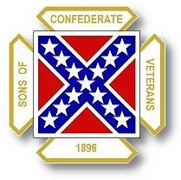
The Dispatch
The Official Publication of The Dixie Guards Camp # 1942
Sons of Confederate Veterans
Metter, Georgia

August 2007 Edition

Next Meeting – Thursday, August 2nd
Thursday, September 6th

Dixie Guards Camp # 1942
Sons of Confederate Veterans
P.O. Box 761
Metter, Georgia 30439

Postmaster Please Deliver To:

Visit Us Online at:
www.dixieguards.org
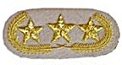Commander’s Comments
Gentlemen - It is August and the Official SCV fiscal year is here. This means that those members who need to renew are due. The deadline set by International Headquarters is November 1st. Our administrative deadline is much earlier than that in order to get all the paperwork in on time. On behalf of Our Camp, Our Ancestor’s, and the Protection of Their Place in History – I urge you to renew your commitment to honor their service. I ask you to consider this: Without the SCV, how much longer will Southern and Confederate History survive? You are a vital part of the SCV – if for numbers alone. If you are active, it is all the more important.
I want to apologize for my recent absence. My job is requiring me to work about 6 days a week. This will be ongoing until near the end of September. At about this same time, we are expecting a new baby at our house, so things won’t get much better.
I’ve been thinking on this a long time and these recent events at home and work have made my decision easy. I want to announce officially that I will be stepping down as Commander at the end of the year. We have two outages at Plant Vogtle next year and I return to Georgia Southern for Graduate School in January. With the new baby, work and school, I just won’t have the time to do the job anywhere near the level it should be done. The Camp deserves better than I have to offer. I believe that it is long overdue for some new and fresh ideas anyway.
Just because I’m stepping down, doesn’t mean that I’m leaving. I’ll just take a less active roll and let new leadership guide us. We chartered in 2001 and time has flown for me. It doesn’t seem to me like it was all that long ago when I was concerned about whether or not that initial crowd would be daddy, Uncle Herbert, and me. Y’all surprised me then and you still amaze me now. In less than six years, we’ve grown to 100 members; we’ve hosted the State Reunion/Convention; and we’ve been named Camp of the Year.
I feel very blessed to be allowed to be a member of an organization that takes pride in its kinship. That is exactly what the SCV does – we honor our kinfolk. Politics aside, we honor our kinfolk. Radicals from both sides cause Southern Heritage to be a point of concern these days. In the overall scheme of things, it hasn’t been too terribly long ago when the South and our Heroes were commonplace and still revered by the media and even Hollywood. It was a John Wayne character, who spoke the famous movie line, “A man has to commit to something, and I committed to the Confederate States of America.” – Or something like that! The Beverly Hillbillies didn’t make fun of our heritage – nope, they honored it and Granny was Unreconstructed to the end. No one ever complained about the General Lee and the Dukes of Hazzard.
The enemies of Confederate Heritage have made tremendous headway and they have swayed the media and Hollywood. Now, you would be hard pressed to find the movie where John Wayne was proud he was a Confederate. Granny may not be reconstructed, but she’s gone from the airways – I don’t think she is even on TV Land cable anymore.
Now more than ever, we must continue to honor our ancestors. Their place in society, other than ours, is gone. Their place in history is in jeopardy. I’ve been a member of this organization for a long time. I saw the persistence of Tyrone Brooks pay off and I forecasted that he would not give up. Why should he, he didn’t have anything to lose. He hated Our Flag and he made it his priority to get rid of it. People in the Georgia Legislature laughed at him and SCV members all across Georgia said the Flag would never be touched. I remember hearing things like…”Those radicals are out West and up in New York.” I ask you…who won in the end? Tyrone Brooks and his bunch that’s who! Southern Gentlemen sat around and let our enemies take Our Flag and we were unprepared. In many ways, we still are unprepared. And, as long as we are Our Heritage is in Jeopardy. Tyrone Brooks and many of his friends would like nothing better than to deface Stone Mountain. They’ve said it and they’ve said it publicly.
How safe are the statues on the courthouse lawns all across our State?
God Bless You and Your Family,
Randy

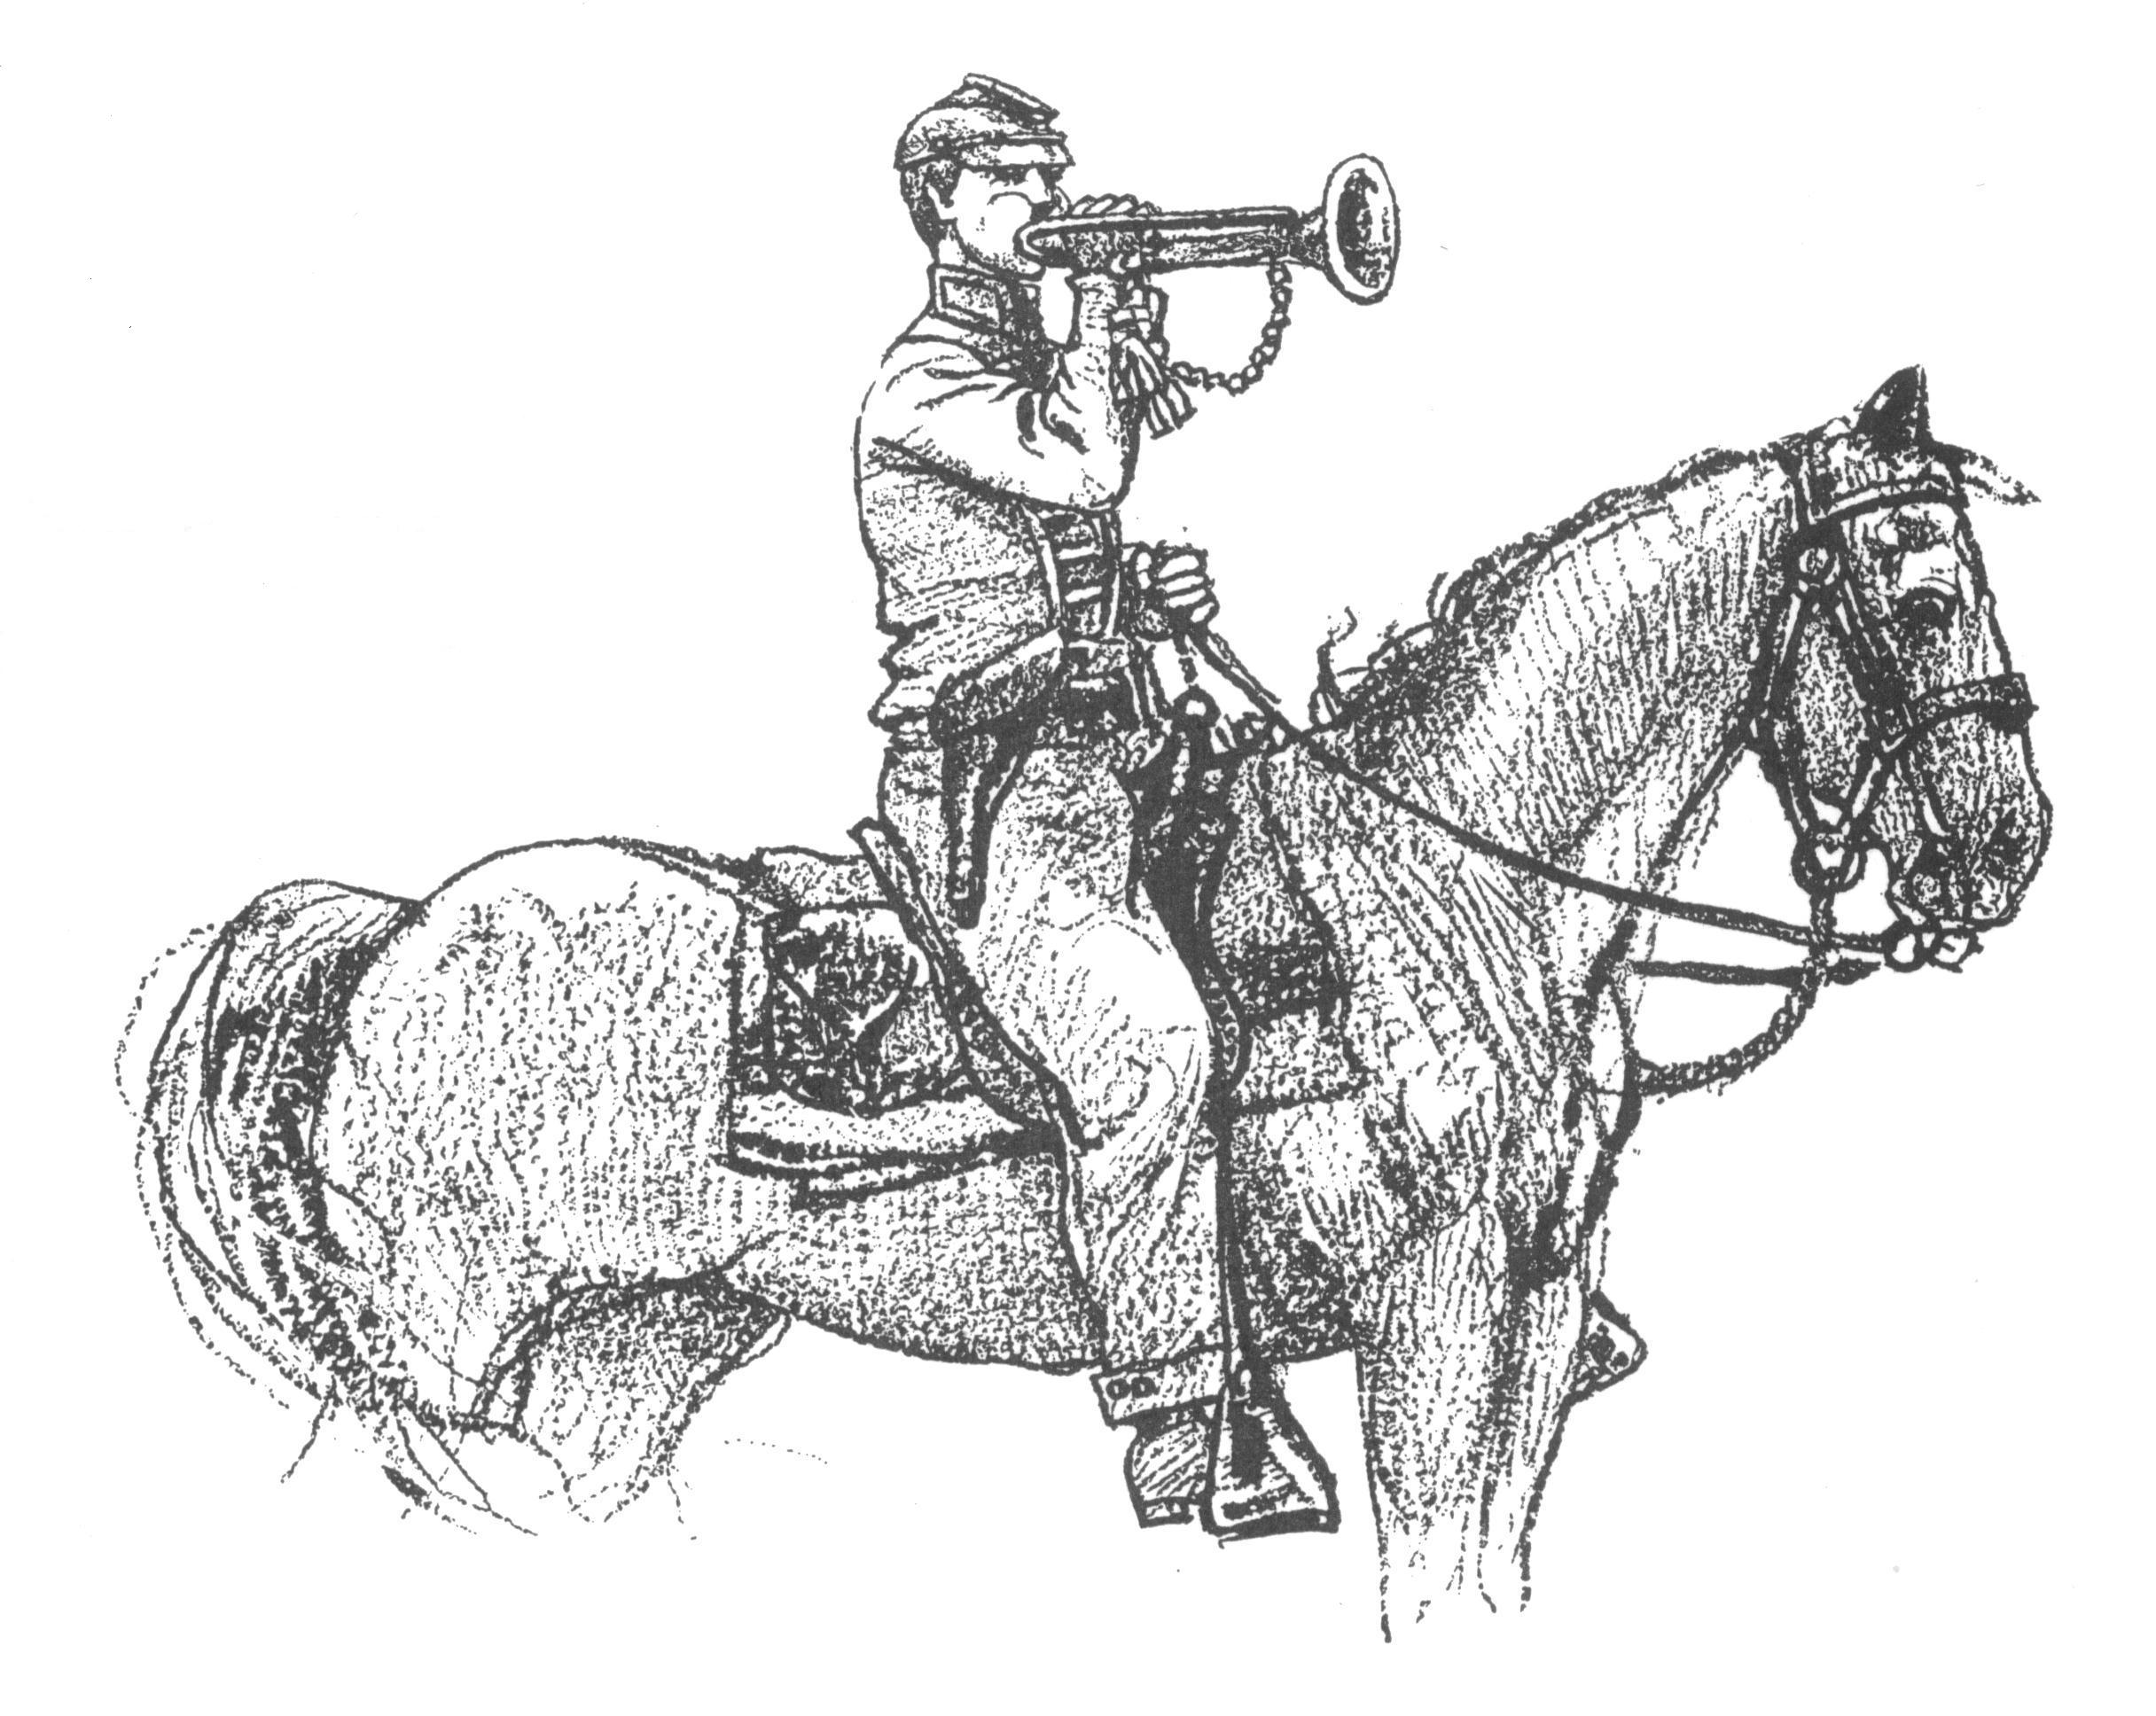 Call to Duty – Camp Calendar
Thursday, August 2nd – Regular Monthly Meeting Thursday, September 6th – Regular Monthly Meeting
Western Steer Western Steer
7 PM – Meal 7:30 Meeting 7 PM – Meal 7:30 Meeting
Program: TBA Program: TBA

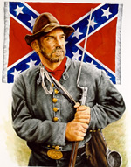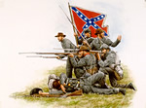
No
New Members for July

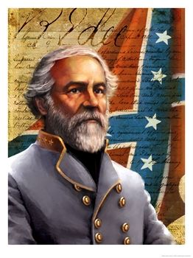
"Everyone should do all in his power to collect
and disseminate the truth, in the hope that it may
find a place in history and descend to posterity.
[Southern]History is not the relation of campaigns and battles
and generals or other individuals, but that which
shows the principles for which the South contended
and which justified her struggle for those principles."
--Robert E. Lee

Did you know this?
Very few Federal soldiers felt that the War was over slavery. In fact, many Federal soldiers deserted after the famous Emancipation Proclamation. Moreover, New Yorkers took to the streets and lynched black citizens because of the draft in 1863. Most Federals soldiers claimed they were fighting to “preserve the Union” or because of anger from the US flag being “fired upon at Fort Sumter”. Most cared very little the reason why the flag was fired upon, only anger for it. Here is what on soldier from Maine wrote in a letter home to his mother.
"A nation preserved with liberty trampled underfoot is much worse than a nation in fragments but with the spirit of liberty still alive. Southerners persistently claim that their rebellion is for the purpose of preserving this form of government." --Private John H. Haley, 17th Maine Regiment, USA - written in a letter to his mother back home in Maine.
Extra Commemorative Reunion Medals

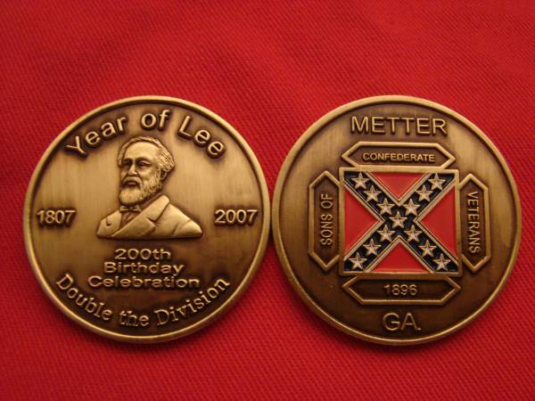
$20 each - Postage Paid
$15 – Picked up or Hand Delivered
Special ONE TIME Offer to Dixie Guards Members
For Members who Renewing their membership:
You can get a
Commemorative Medal
&
Camp Hat
Both for an Additional $20

*While Supplies Last
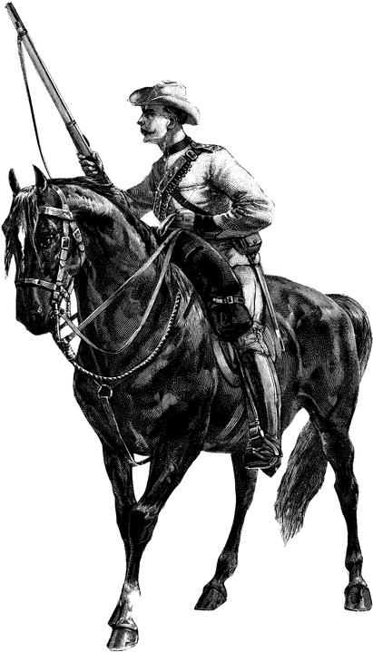
The Battle of Ball’s Bluff
aka. The Battle of Leesburg or the Battle of Harrison’s Landing

On October 21, 1861, Confederate forces under Brigadier General Nathan “Shanks” Evans stopped a badly coordinated attempt by Union forces under overall command of Union Brigadier General Charles P. Stone. Stone’s forces and those of Union Colonel Edward D. Baker attempted to cross the Potomac River at Harrison’s Landing and capture the Leesburg, Virginia. The Confederates stood their ground and held against the Federal attacks. Poor coordination by the Federals and the resolve of the Confederates led to a Confederate counterattack that routed the Federal troops. The Confederates drove the poorly led Union troops back into the river, where they where roughly 700 Federal troops were captured when they threw their away their weapons into the river and surrendered rather than risk further counterattack or possible drowning.
Federal Colonel Baker, who was also a United States Senator, was killed during the Federal rout and flight back across the river. The terrible showing by the Federal troops, which came soon after the rout of 1st Manassas had serious ramifications for the US Army. The United States Congress was so disgusted by the Federal Army’s performance and morale of US Army troops that they created the Joint Committee on the Conduct of War.
The Battle of Ball’s Bluff turned out to be one of the most lopsided victories that the Confederates inflicted upon the Federals during the war. The Confederates had roughly 1500 troops and the Federals had over 2000. The Confederates suffered less than 150 casualties – (wounded, captured or killed). The Federals suffered nearly 50% casualties – losing over 1000 to capture, battle wounds or killed.
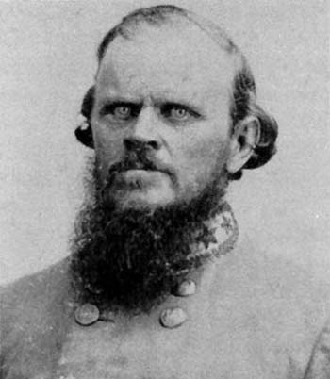
Brigadier General
Nathan “Shanks” Evans

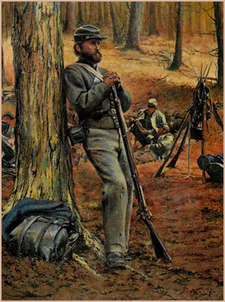Feature Article: Harper’s Ferry – A prelude to Sharpsburg
One of the goals of General Robert E. Lee during his Maryland Campaign was to make an effort to attack and capture the Federal munitions at Harper’s Ferry should the opportunity warrant. Lee expected the Federals to act prudently withdraw the troops and equipment once word spread that the Confederates had entered Maryland. For some reason, the Federals did not withdraw and Lee knew the garrison was vulnerable.
The only problem for the Confederates in taking Harper’s Ferry was that it would take a division of Lee’s forces to attempt the capture. Possibly, the Federals did not leave simply because they did not believe the Confederates would make such a bold move. But, Lee did – even though both his chief subordinates Major General Stonewall Jackson and Major General James Longstreet argued against the splitting of the Confederate forces. Both generals urged Lee to keep the Army of Northern Virginia intact; otherwise, the whole army risked being taken piecemeal. Jackson and Longstreet knew that the Federal Army was much larger than Lee’s army was, even with all the Confederates together – separated, they risked total destruction.
By modern standards, most historians or military leaders would probably criticize Lee’s splitting of his army, but history has shown that Lee’s audacity was a major part of his and the Confederacy’s success. In the face of uncertainty and with his chief generals angered by the maneuver, Lee divided his beleaguered forces into 4 columns. Lee sent 3 of the 4 columns towards Harper’s Ferry. Lee took select units from both Jackson and Longstreet and dispatched them to Harper’s Ferry under overall command of Jackson, while Longstreet was to maneuver towards Hagerstown and confuse the Federals.
On September 15, 1862, after 3 days of skirmishing around the bluffs overlooking the city and arsenal, the Federals surrendered the garrison to Jackson. The Federals surrendered nearly 12,500 men and an enormous supply of munitions. The Federal defeat was the largest surrender of troops in US history to that time and remained the largest until the Battle of Corregidor in the Philippines early during WWII. Harper’s Ferry cost the Confederates less than 300 total casualties and only 39 were killed.
Yet, the lopsided victory came at a terrible expense. On September 17, 1862, the Confederates found themselves caught scattered all across the countryside trying to reunite in the face of the Federals troops under Major General George McClellan. A Federal Sergeant had discovered papers that had the troop displacement of Lee’s entire army. McClellan was provided the information and had over 100,000 troops available to catch Lee’s split army. Sharpsburg or Antietam was the result – America’s Bloodiest Day. The Confederates held off the Federals in the most gruesome fighting of the entire war for both sides.
Instead of capitalizing of Lee’s vulnerable condition, McClellan bungled the Federal army’s best opportunity to end the war. Even once Lee’s army became entrenched around Petersburg late in 1864; it was no more vulnerable until attrition strangled the thin gray line.
Modern textbooks and many historians consider the battle a Union victory. But, General Longstreet considered Sharpsburg Lee’s greatest battle. As Jackson and his men arrived in the area of Sharpsburg, Lee ordered their placement for defensive battle. Jackson’s men fought with the tenacity they were known for and Lonstreet’s nickname of “Old Bulldog” proved to be a good one. Lee held off wave after wave of Union troops in what should have been an easy victory for McClellan. It proved anything but.
The claim for Union victory comes from the point of view that after the battle Lee and his army retreated to Virginia. That is only partially correct – That is, Lee and his army did go back to Virginia. But, Lee had intended to go back to Virginia with or without battle with the Army of the Potomac. Lee’s intentions for the Maryland Campaign were Harper’s Ferry, food and material requisition, troop recruitment and the hopes that Maryland might secede.
Lee’s only failure was his perception that Maryland might secede and that he might gain a large number of troops through recruitment. Maryland was largely Pro-Confederate – but not in the areas that Lee and his troops visited. In fact, they were quite Unionists in these areas. This was Lee’s only mistake during the Campaign – his campaign had no hope to draw Maryland to the Confederacy, but it did relieve Virginia.
As for the claim that Lee “retreated” to Virginia – Lee, even though his army was outnumbered by 3 or 4 to 1 stood his ground the morning after Sharpsburg. He refused to abandon the field and prepared to fight McClellan again. McClellan had more troops that had not fought at all than Lee had available. Yet, McClelland did nothing. Lee had contempt for the Federal commander and did not retreat. In fact, he was daring him to attack again. So much for modern historians!

