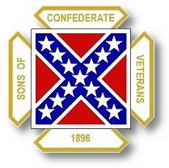
The Dispatch
The Official Publication of The Dixie Guards Camp # 1942
Sons of Confederate Veterans
Metter, Georgia

August 2006

Dixie Guards Camp # 1942
Sons of Confederate Veterans
P.O. Box 761
Metter, Georgia 30439

Postmaster Please Deliver To:

Visit Us Online at:
www.dixieguards.org
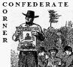 Commander’s Comments
August – It’s the month that school begins a new year. It is also the month that the SCV begins a new year. Both beginnings start out with many unanswered questions. For school, kids always wonder who will be their teacher - Will there friends be in their classrooms – that sort of thing. For the tiny kids just starting Pre-K, it is their first time away from home. It’s a whole new environment. I’m sure that it is sort of scary for them – but in the end, they always seem to make it just fine. When summer rolls around, the tiny little Pre-K folks want to jump out of their parents cars and rush off to their classrooms alone, without anyone holding their hands. By the time the school year plays out, the high school seniors will be planning what to do next. And, this year, I’ll finally graduate college with my Bachelor’s degree in History. Where am I going with all of this?
Like I said, August is also the brand new year for the SCV. Just like the little kids starting Pre-K, our camp is doing something that we’ve never done before. We are beginning the year that will see us host the Georgia Division SCV in Metter when the summer rolls around next June. We’re starting a great, new adventure. And, all the eyes are on us. I am very excited for our Camp and for Metter. By the time the Division Reunion is over next year, we will have put in a lot of work, but we’ll have graduated with honors. I’m sure of it. Next year is the 200th Anniversary of the birthday of General Robert E. Lee. Remember how everyone celebrated the Bicentennial in 1976. This will be like that!
I also have to admit, I’m really excited about the added theme….Double the Division. Gentlemen, I’m sure there are those among us that think I’m crazy for believing this, but I’m convinced that we can do this if we will only put forth a little effort. I’m surer that our Camp can double in size than our Division, but I have faith in the Division too! There’s no doubt in my mind that our Camp can do it – it does remain to be seen if we will, but I know that we can! All we have to do is to recruit 1 new member per current member and BOOM! There you have it. That’s all we have to do. I for one promise to recruit at least one and my goal is from 5 to 10.
What about you? Can you recruit a new member? Can you recruit several? Why not make a goal to recruit 5 to 10? An article announcing the preliminary plans for our Reunion will be in the next Georgia Confederate newspaper. In that paper, we’re announcing that the Georgia Division member who recruits the most new members between August & our Reunion will receive several nice prizes. We have the support of the Division on this and there may be some added prizes later on. But, rest assured it will be worth it! Really worth it!
August is also the beginning of the Renewal Period for existing members. Any member who has been a member for more than a year, your dues are certainly due to be renewed. For those who have joined during the last few months of 2005 and so far in 2006 please check with Tony, your dues may not be due because of a special “pro-rated” dues program that International Headquarters started.
Over the past couple of years, we have lost a few members to non-renewal of dues. For that, I take full responsibility. They quit for various reasons. But, I won’t to concentrate our efforts on bringing these members back. I would like to ask everyone’s help in contacting these folks and reminding them that they may be the only representative that their ancestor has. Remind them of that special bond that they share and urge them to please come back. Tell them that their ancestors need them now more than ever and so does our Camp. Tony has a list of the “Lost Members”. Please check with him and try to help us bring these men back.
Gentlemen, our new fiscal year looks great from where I stand. A lot of the work for the Reunion is well under way and we’re only now reaching the point where we are gonna start needing help. We already have secured the Luncheon Speaker for Saturday’s Division Reunion Luncheon. We’ve already secured the Entertainment for Saturday night. We already secured permission for the City of Metter to host a Living History Encampment at the Industrial Park on Friday…complete with a Cannonade at Dusk. We launch our Ad sales for the Commemorative Program on August 1st. By the time you get this, we’ll have met with members of the Chamber and several key business owners to help us secure a Local Tour for the wives and members on Saturday afternoon. This is going to be a Great Reunion and a Great Year.
I’ve also already spoken with current Lt. Commander-in-Chief (as of July 17th) Chris Sullivan about speaking at our next General’s Banquet. I’m expecting he’ll be coming to Metter as Commander-in-Chief. We talked about the Reunion & some of our plans. He loves the Double the Division theme and plans to challenge every Division to follow our lead…especially our Deep South neighbors – Florida, South Carolina, Tennessee and Alabama.
Saddle up men, we’re about to Charge into a Great New Year and Victory can be Ours! Let’s Double Time to Double Up!

God Bless You and Your Family,
Randy

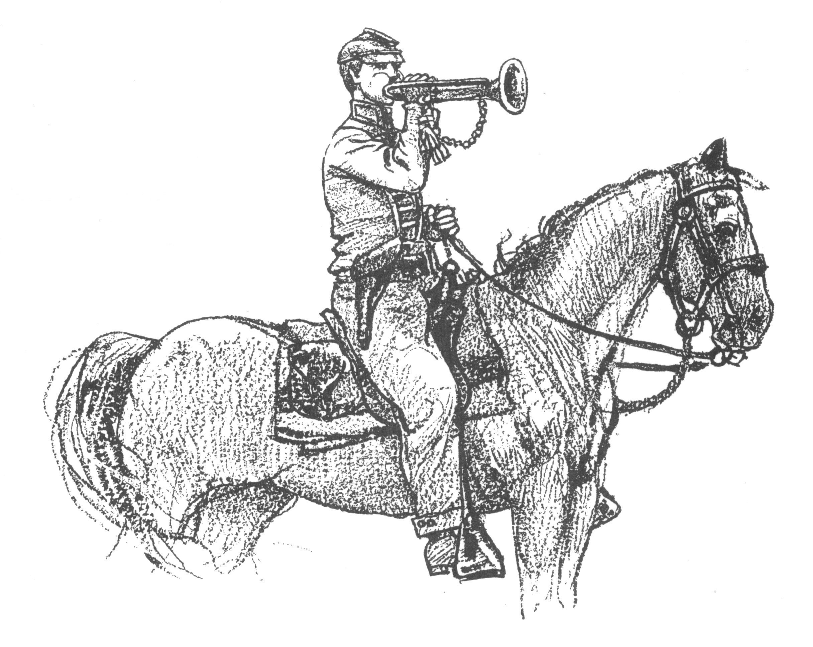 Call to Duty – Camp Calendar
Thursday, August 3rd – Regular Monthly Meeting Thursday, September 7th – Regular Monthly Meeting
7 PM – Meal / 7:30 PM Meeting 7 PM – Meal / 7:30 PM Meeting
Western Steer - Metter Western Steer - Metter
Program/Speaker – TBA Program/Speaker – TBA

Treasury Report - $1403.36



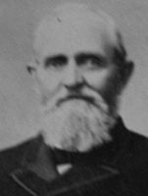
Feature Profile : GENERAL WILLIAM FLANK PERRY, CSA

BORN: 1823 in Jackson City, GA DIED: 1901 in Bowling Green, KY.
CAMPAIGNS: Second Manassas, Sharpsburg, Gettysburg, Chickamauga, Wilderness and Spotsylvania.
HIGHEST RANK ACHIEVED: Brigadier General

William Flank Perry was born in Jackson County, Georgia, on March 12, 1823. His family move to Chambers County, Alabama, in 1833, and Perry was unable to obtain much formal education. Despite this, he taught in country schools in Talladega County from 1848 to 1853, while studying law. Perry was admitted to the bar in 1854, but never established a practice. He worked to improve the state's educational facilities, and was twice elected state superintendent of education, playing a major role in laying the basis for the free public school system in Alabama. In 1858, Perry resigned and became president of East Alabama Female College at Tuskegee. A year after the Civil War began, Perry enlisted as a private, and quickly rose through the ranks to become a lieutenant after Second Manassas and a colonel after Sharpsburg. Leading the 44th Alabama Infantry in the attack on Little Round Top, he was cited for gallantry at Chickamauga. Perry took part in the Battles of the Wilderness, Spotsylvania, and Cold Harbor; and was promoted to brigadier general as of February 21, 1865. Leading his troops until they were paroled at Appomattox, he left the military when the War ended. Perry went on to farm in Alabama for two years, then went back to working as an educator, holding the position of professor of English and philosophy at Ogden College, in Bowling Green, Kentucky. Perry died there, on December 18, 1901.
According to President Lincoln, the 11 seceding states that made up the Confederate States of America never left the Federal Union. But, after Lincoln’s death, the US Government considered them to be fully outside of the Union and required several measures for them to be “Re-admitted”. Here are the dates for their “Readmission” by Act of Congress. Here is a picture of Reconstruction. Mr. Lincoln might have thought the Confederate States had not left the Federal Union but the Government left in control after his death sure did. Only Tennessee escaped the heavy hand of the US Military’s Reconstruction efforts. Georgia experienced it twice.
State | Date of Act of Congress | Date US House Representative Allowed | Date US Senator Allowed | Date US Military turned control back over to State
Tennessee | July 24, 1866
Arkansas | June 22, 1868 | June 24, 1868 | June 23, 1868 | June 30, 1868
South Carolina | June 25, 1868 | July 18, 1868 | July 22, 1868 | July 24, 1868
Louisiana | June 25, 1868 | July 18, 1868 | July 17, 1868 | July 13, 1868
Alabama | June 25, 1868 | July 21, 1868 | July 25, 1868 | July 14, 1868
Florida | June 25, 1868 | July 1, 1868 | June 30, 1868 | June 29, 1868
Virginia | January 25, 1870 | January 26, 1870 | January 26, 1870 | January 28, 1870
Mississippi | February 23, 1870 | February 25, 1870 | February 25, 1870 | February 28, 1870
Texas | March 30, 1870 | March 31, 1870 | March 31, 1870 | April 16, 1870
Georgia (1st Time) | June 25, 1868 | July 25, 1868 | Rejected by US Senate January 25, 1869 | US Military Did Not Leave Totally – 2nd Reconstruction by US Military: December 22, 1869
Georgia (2nd Time) | July 15, 1870 | December 1870 | February 1871 | Spring 1871

"All that was, or is now, desired is that the error and injustice be excluded from the textbooks of our schools and from literature brought into our homes; that the truth be told, without exaggeration and without omission; truth for its own sake and for the sake of honest history, and that the generations to come after us not be left to bear the burden of shame and dishonor unrighteously laid upon the name of their noble sires."
- Rev. James Power Smith, Last survivor of the staff of General Stonewall Jackson
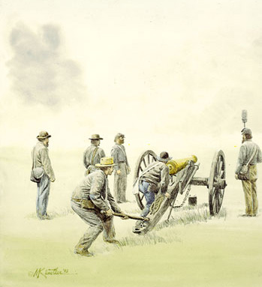 Feature Article: 2nd Manassas (August 1862)
In August 1862, the war came for a second time to the plains and meadows near Manassas, Virginia. By August of 1862, both the Confederate and Union troops were far better trained and had been seasoned by combat. In the end, the Battle of 2nd Manassas would have over 100,000 troops from both sides and have over 23,000 battle casualties. 14,000 USA & 9000 CSA.
When General Robert E. Lee took control of the Confederate troops in Virginia after the wounding of General Joseph Johnston, he first encountered US Major General George McClellan in the 7 Days Battles. Here, Lee and his army saved Richmond from invasion and decidedly repelled the Union troops. Once McClellan’s threat was repelled, Lee turned his sights to the Major General John Pope and his newly christened US Army of Virginia. Lee felt that Pope’s army threatened the vital contact with the Virginia Central Railroad which connected the Shenandoah Valley with Virginia’s heartland…which would also open the way to Richmond from the west.
To challenge Pope’s threat, Lee dispatched Major General Thomas J. “Stonewall” Jackson and his men to make contact and force Pope in battle. To ensure that McClellan was no longer a threat to Richmond from the east, Lee had Major General James Longstreet control the areas of the 7 Days Battle fields.
After watching each other like boxers in the first round of a championship fight, Jackson attacked an exposed flank of Pope’s army on August 9th. Jackson was successful but had to retire from the field because of overwhelming Union troops arriving on the field. On August 15th, Lee decided that McClellan was no longer a threat to Richmond and dispatched Longstreet to join Jackson. Jackson’s and Longstreet’s forces united at Gordonsville. For the next few days, the Confederates probed the Union lines trying to draw Pope into battle. Only minor skirmishes occurred. Lee’s hopes for a decisive battle to remove the threat to the railroad, Virginia’s heartland and Richmond would have to wait.
With his sharp, engineer mind, Lee found an opening in Pope’s troop movements that he found to his liking. Feeling he had the upper hand because of Pope’s indecisiveness and unwillingness to offer a general engagement, Lee divided his army. To keep Pope in check and to make him believe that the Confederates were preparing to attack his front, he ordered Longstreet to face off with the Union Army with his 30,000 troops. He then ordered Jackson to take his 24,000 men on a wide flanking march around Pope’s right flank. In the flanking movement, Jackson’s men marched 54 miles in just 36 hours, severed and captured the Union supply lines.
Pope quickly evacuated the field in the face of Longstreet in search of Jackson’s threat. All the while, Jackson lay in wait for Pope near Groveton along the Warrenton Turnpike and waited for Pope…also waiting for Longstreet’s troops to arrive to secure the trap. Jackson knew that Longstreet was en route to support him and on August 28th he attacked General Rufus King’s Division of Pope’s Army. Longstreet was rushing to Jackson. He encountered a Union force at Thoroughfare Gap, brushed it aside and moved on towards Jackson. On the morning of August 29th, Longstreet’s leading columns formed battle lines in support of Jackson’s right. Pope knew Jackson was on the field but had no clue that Longstreet was their too. Pope thought that he was still near the 7 Days Battlefields. Once Longstreet and his men completely arrived, the Confederate battle lines resembled a large pair of scissors waiting to snap shut on Pope. Pope concentrated his plans against Jackson and attacked on the 29th. At the end of the day, Pope had met resistance but still felt he had the opportunity to push Jackson aside.
On August 30th, Pope concluded that Jackson and therefore, the Confederates, were retreating. He still didn’t know that Longstreet was on the field. He ordered detachments of troops to pursue Jackson. In fact, the Confederates were not leaving but concentrating. At 3 PM, Pope launched his largest attack of the battle against Jackson. During the melee, many of Jackson’s men ran out of ammunition and resorted to throwing rocks at the attacking Federals. Quickly, reinforcements were coming to Jackson’s aid forcing the Union troops to retreat in confusion.
Sensing opportunity, Longstreet ordered a counterattack just minutes before the dispatches from General Lee arrived asking if a counterattack was possible because of the Union retreat. Lee would later claim that Longstreet must have read his mind with the attack. Longstreet pushed forward 20,000 of his 30,000 troops and Pope’s confused and panicking troops melted away in their front.
Confusion also engulfed the successful Confederates. Their success appeared much to easy because of the panicking Federals. Their attacks then became somewhat unorganized which, in the end, allowed Pope’s subordinate Generals to salvage his army. Pope vacated the field under the cover of darkness. Lee and his Army of Northern Virginia came nearest to total defeat of the Union army on these fields near Manassas. Pope lost more than 16,000 troops killed, wounded or captured. A model team of Lee, Jackson and Longstreet emerged and name Army of Northern Virginia became legend. The South had its greatest opportunity slip away to minor confusion and Federal luck on these fields.

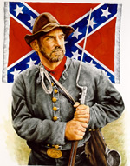 "I must not forget our old flag — though torn & tattered & faded. In the three days of fighting, although about 18 inches was torn off the end & lost — there is fifteen bullet holes through the flag & three through the staff — & besides there is a large rip made by a piece of a bomb. Three color bearers were shot down & the fourth now carries it. If I should live through the war I would want no brighter monument than this faded flag to decorate my parlor walls — (Provided I ever have a parlor)." … James C. Bates CSA

Can You Help Us Remember Men Like James C. Bates…Men Like Your Ancestor?
Please help us by sharing the names & information of 4 potential members – if you can’t contact them, we’ll contact them for you. We’ll still honor you as the recruiting member if they join! Just fill this out & bring it to the next meeting.

Name_____________________________ Name_____________________________
Address___________________________ Address___________________________
___________________________________ ___________________________________
Phone_____________________________ Phone_____________________________
Recruiting Member_______________________________ Recruiting Member_______________________________

Name_____________________________ Name_____________________________
Address___________________________ Address___________________________
___________________________________ ___________________________________
Phone_____________________________ Phone_____________________________
Recruiting Member_______________________________ Recruiting Member_______________________________

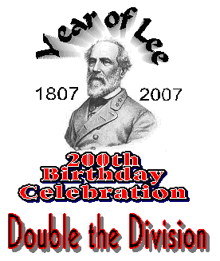
Honor General Lee
Honor Your Ancestors
Help Make Our Camp Stronger
Help Make The SCV Stronger

Let’s Renew, Recruit, Reactivate & Double Our Membership

