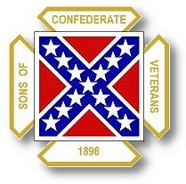
The Dispatch
The Official Publication of The Dixie Guards Camp # 1942
Sons of Confederate Veterans
Metter, Georgia

April 2007 Edition

Next Meeting: Thursday, April 5th – 7 PM

Dixie Guards Camp # 1942
Sons of Confederate Veterans
P.O. Box 761
Metter, Georgia 30439

Postmaster Please Deliver To:

Visit Us Online at:
www.dixieguards.org
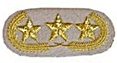Commander’s Comments
April is here and that means it is Confederate History Month. It is time for us to reflect on the sacrifices of our Ancestors, and celebrate their memory while we pledge to preserve their place in American History. They deserve our best effort. With that, we have presented the Metter city government and the Candler County government requests that both of them declare April as Confederate History Month and the 26th as Confederate Memorial Day in Metter-Candler County. They supported us last year and we have no reason to suspect that they won’t support us this year. If you see any of them, thank them in advance for their support.
Our spring Boston Butt sale / cooking will be Friday night, March 30th. We need everyone that can to come help cook so that it won’t fall upon just a couple to man the grills all night alone. Please come out and help. Last year, only a couple of folks showed up and they were stuck all night long. Many thanks go out to a few folks for making this sale a success. We’ve ordered 200 Boston Butts for the sale. Thanks go out to member, Ricky Patrick for ordering the meat for us, supplying the freezer to store them and even offering an extra grill if we need it. Thanks Ricky! Many, many thanks go out to Carlton Clifton. As of me typing this newsletter, Carlton had sold somewhere around 150 or more Boston Butts by himself. It goes without saying that his effort is exemplary. Thanks Carlton! Thanks go out to Sale Chairman, 1st Lt. Commander, Jason West. Jason got “volunteered” again and I know that it is challenging during the spring while trying to get the farm ready for planting.
I know that many of you may not have gotten the word on the sale. That is somewhat my fault. The newsletters have been running a little late lately, so you may not have gotten the word. I’m sorry for that! But, we did decide on the sale and date in a meeting.
Speaking of a meeting. I really want to thank our members for our recent meetings. Over our last few meetings, we’ve had our very own members provide the programs. As for me, I like them better than I do those from “speakers” we invite in. We all know each other and when we share the stories of our Ancestors and Families, it means more to me. I really get a good feeling when I see one of our members championing the contributions of his ancestor. I would like to challenge and invite any member to do a program. We’d love to hear about your ancestor. I know I would!
The Reunion is right around the corner now. We’re just about into the home stretch. We are going to resume our planning meetings and we need every member that will take an active roll in the reunion to do so. I will say this for sure. We will have somewhere in the neighborhood of 9, 10 or 11 votes based upon our current membership. There will be a core group of us that are really busy taking care of administrative duties during the convention and it will be impossible to serve as delegates and do our jobs. We are going to need members to be delegates and we’re going to need working members. We really need to pull together and put on our game face. Members are going to be coming from all across the State to Metter and I really would like for them to find a proud and active Camp here at home! I want them to discover what I already know. The Dixie Guards are as good a camp as there is in Georgia. You men have made it that way. We’re not as old a camp as some of the others and we don’t have battlefield landmarks that some of them do – but we make that up with spirit and honor. To me, you men exemplify the Charge!
From what I’ve heard, the Girl Scout event at Rose Dhue Island was a big success. Thanks go out to Jay Clifton for spearheading this for us. I don’t know if our camp received any of the credit or whether Jay was mentioned, but I know and the Girl Scout Administrator that called me and asked if we would help knows who helped make this happen. Thanks Jay!
To all of our new members over the past couple of months, welcome! I really want to apologize to you folks regarding the tardy welcome and the tardy newsletters. Normally, I am a little more organized. I promise I am. Right now, I’m struggling with my last semester at Georgia Southern and my Senior Thesis paper. Would you like to hear about George Armstrong Custer and the Battle of the Little Bighorn? See me if you would! I’ve come to know him quite well in the last couple of months. Not just Custer, I’ve also been busy studying Terrorism…worldwide and domestically. The Union troops weren’t just cruel to our Confederate Ancestors and their families. They were slaughtering Indians that supported the Confederacy while they were burning and pillaging our Southland. Some of the things that the Federal troops did to the Indians are unbelievable and simply atrocious.
Please take the time during April to remember your Confederate Forebear. He sacrificed quite a lot. He marched thousands of miles. He fought battle after battle. He was hungry. He was cold. He lost arms and legs. He saw his father, brother, son or best friend die, often a horrible death. He was imprisoned and starved. He was buried in mass unmarked graves. He did it all for honor, home and you. Won’t you remember him?
God Bless You and Your Family,
Randy

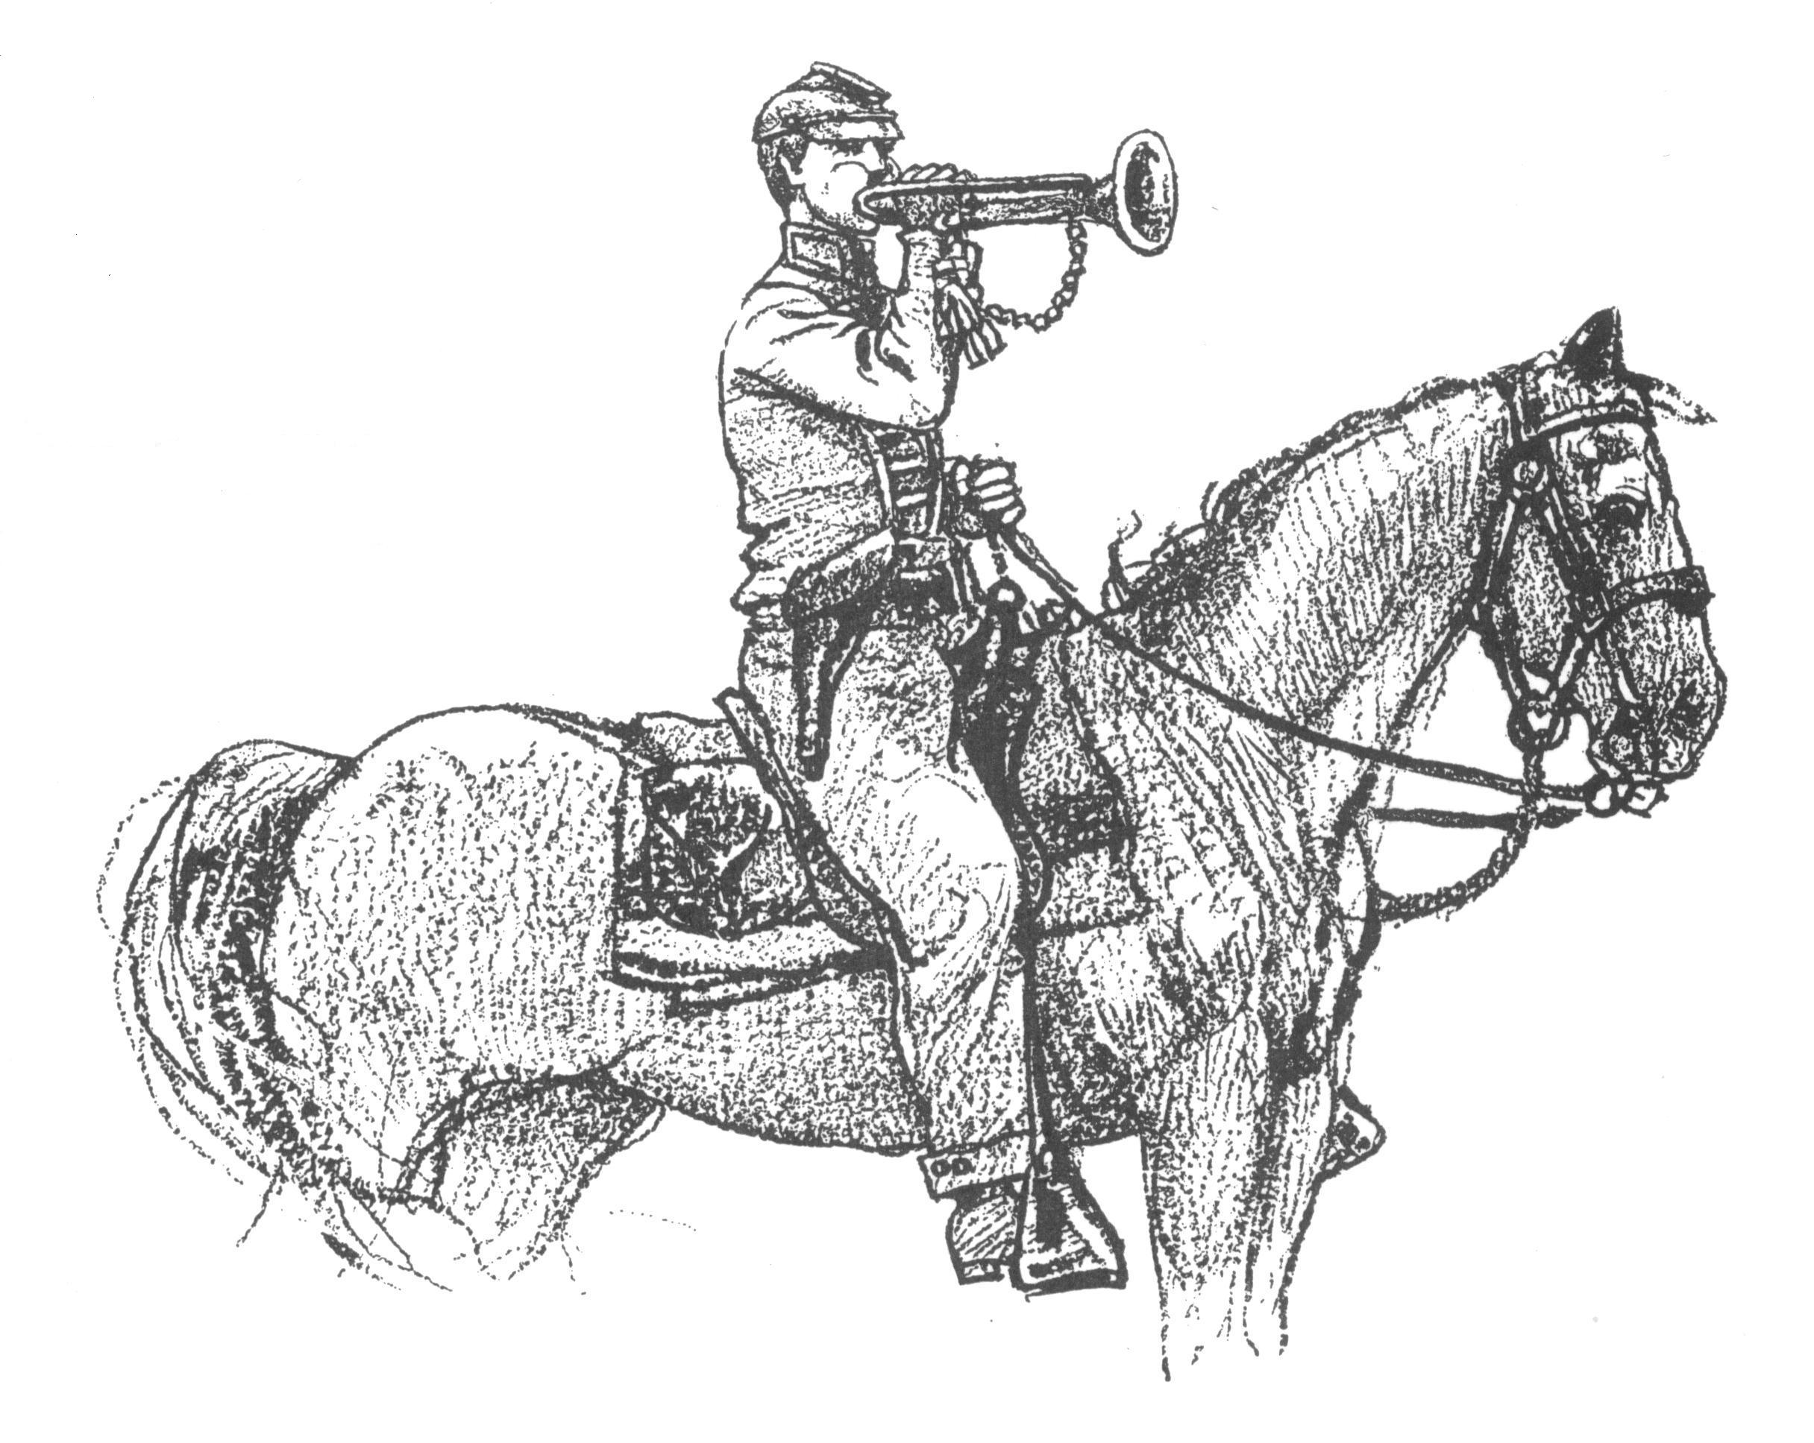 Call to Duty – Camp Calendar
Thursday, April 5th – Regular Monthly Meeting Thursday, March 1st – Regular Monthly Meeting
Western Steer Western Steer
7 PM – Meal 7:30 Meeting 7 PM – Meal 7:30 Meeting
Program: Compatriot Jason West Program: TBA
Welcome New Members

Charles E. Johnson
Heath Kemp
Michael Thigpen
William Alan Thigpen
John Morgan Trapnell
Allen Keith Tyler
Jason D. Atteberry
Freddie Thomas Ellis
Matthew Noah Bird
John Vaughn Lanier
Gordon F. Hinkle Jr.

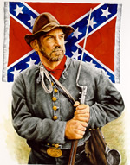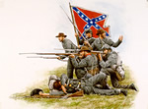
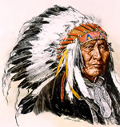 Heritage of Dishonor - Our Confederate Ancestors have been called many disparaging names over the years. Most of those names are due to a lack of education or a prejudice that has come from Political Correctness. Our Ancestors have left us a Heritage of Honor. That cannot always be said of the descendents of the Federal Troops. For example…The Sand Creek Massacre, November 28, 1864.
On November 28, 1864, Federal Colonel John Chivington, an ardent Indian-hater attacked a village of Cheyenne Indians along Sand Creek in Colorado. The village was made up of Cheyenne and Arapahoe Indians. Flying over the village was the United States Flag. Chivington’s militia attacked the camp, upon his orders, and destroyed it. The Indians were there at the request of the Governor of Colorado so that they could remain safe from military actions between the Army and “hostile” Indians. Black Kettle’s village was an easier target than were the hostiles. Chivington and his forces ignored the US Flag and a White Flag and attacked the village.
Over 700 Federal troops attacked the small village, killing 250 or more Indians, mostly women, children and elderly. The soldiers committed unbelievable acts on the “Confederate Indians”. Lt. Silas Soule described the attack in a letter to his friend, Major Edward Wynkoop. In the letter he said, "The massacre lasted six or eight hours...I tell you Ned it was hard to see little children on their knees have their brains beat out by men professing to be civilized....They were all scalped, and as high as a half a dozen [scalps] taken from one head. They were all horribly mutilated...You could think it impossible for white men to butcher and mutilate human beings as they did there, but every word I have told you is the truth, which they do not deny.”
Though an inquiry was convened over the massacre, nothing was ever done by the government about it and no officer was ever held accountable for these terrible atrocities.

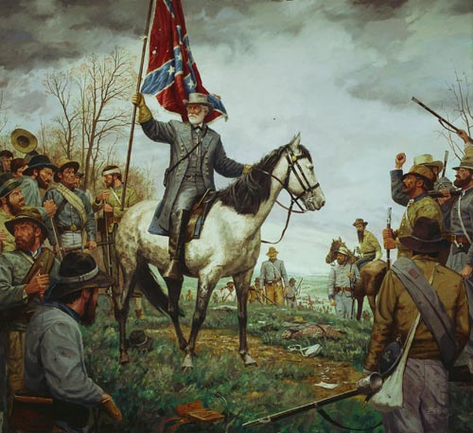 Heritage of Honor – Feature Article: Confederate General Robert E. Lee
Robert E. Lee is no doubt one of the most respected figures on the stage of human history. The love, admiration and respect given to this man were universal. He was loved by his soldiers, revered by his peers, respected by his enemies, and even his former slaves and servants cherished the time they were given to be with him. Posterity has placed Robert E. Lee in a unique position as one of the most respected men who ever lived.
After his death, a Northern newspaper wrote of him "We have long since ceased to look upon him as the Confederate leader, but have claimed him as one of ourselves; have cherished and felt proud of his military genius; have recounted and recorded his triumphs as our own; have extolled his virtue as reflecting upon us—for Robert Edward Lee was an American, and the great nation which gave him birth would be today unworthy of such a son if she regarded him lightly".

Robert E. Lee prayed for Revival -
When another minister, the Rev. Mr. Jones, delivered an earnest address at the "Concert of Prayer for Colleges," urging that all Christians should pray for the aid of the Holy Spirit in changing the hearts of the students, General Lee, after the meeting, approached the minister and said with great warmth: "I wish, sir, to thank you for your address. It was just what we needed. Our great want is a revival, which shall bring these young men to Christ." from Part 8, Chapter 19 of "A LIFE OF GEN. ROBERT E. LEE." BY JOHN ESTEN COOKE

Robert E. Lee showed love and prayed for his enemies –
"One day last autumn the writer saw General Lee standing at his gate, talking pleasantly to a humbly-clad man, who seemed very much pleased at the cordial courtesy of the great chieftain, and turned off, evidently delighted, as we came up. After exchanging salutations, the general said, pointing to the retreating form, 'That is one of our old soldiers, who is in necessitous circumstances.' I took it for granted that it was some veteran Confederate, when the noble-hearted chieftain quietly added, 'He fought on the other side, but we must not think of that.' I afterward ascertained--not from General Lee, for he never alluded to his charities--that he had not only spoken kindly to this 'old soldier' who had 'fought on the other side,' but had sent him on his way rejoicing in a liberal contribution to his necessities." from Part 8, Chapter 19 of "A LIFE OF GEN. ROBERT E. LEE." BY JOHN ESTEN COOKE

Robert E. Lee’s personal prayer –

"Help me to be, to think, to act what is right because it is right; make me truthful, honest, and honorable in all things; make me intellectually honest for the sake of right and honor and without thought of reward to me." From the Truman Library. This Robert E. Lee prayer was memorized by Harry Truman, and Used by Truman throughout his life.

Quotes of Robert E. Lee -

[T]here is no more dangerous experiment than that of undertaking to be one thing before a man's face and another behind his back.

You must study to be frank with the world: frankness is the child of honesty and courage. Say just what you mean to do on every occasion, and take it for granted that you mean to do right.

Never do a wrong thing to make a friend or to keep one.

Do your duty in all things. You cannot do more. You should never wish to do less.

I cannot trust a man to control others who cannot control himself.

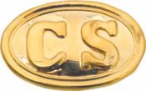Quotes from our Confederate Heroes

Surrender means that the history of this heroic struggle will be written by the enemy: that our youth will be trained by Northern school teachers: learn from Northern school books their version of the war: will be impressed by all the influences of history to regard our gallant dead as traitors, and our maimed veterans as fit subjects for derision...
~ General Patrick Cleburne

A nation which does not remember what it was yesterday does not know where it is today ... The reputation of an individual is of minor importance to the opinion posterity may form of the motives which governed the South in their late struggle for the maintenance of the principles of the Constitution. I hope therefore, a true history will be written, and justice will be done them.
~ General Robert E. Lee

I fought against the people of the North because they were seeking to wrest from the South its dearest rights. But I have never cherished toward them bitter or vindictive feelings, and I have never seen the day when I did not pray for them.
~ General Robert E. Lee

Nothing fills me with deeper sadness than to see a Southern man apologizing for the defence we made of our inheritance &amp; denying the great truths on which all our institutions were founded. To be crushed by superior force, to be robbed; insulted, were great misfortunes, but these could be borne while there still remained manhood to assert the truth, and a proud consciousness in the rectitude of our course.
~ President Jefferson F. Davis, CSA

"I would have our children's children to know not only that our cause was just, but to have them know that the men who sustained it were worthy of the cause for which they fought."
~ President Jefferson F. Davis, CSA

"It is our duty to keep the memory of our heroes green. We want our side of the war so fully and exactly stated, that the men who come after us may compare and do [us] justice."
~ President Jefferson Davis, CSA

"My chief concern is to try to be a humble, earnest Christian."
~ General Robert E. Lee

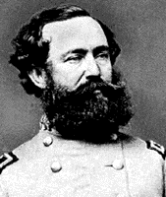 Feature Profile: Lt. General Wade Hampton
Wade Hampton was born in Charleston, South Carolina, on March 28, 1818. He graduated from South Carolina College in 1826 and studied law, but he did not practice. He made a financial success of his family's plantations in South Carolina and Mississippi. Hampton felt that the states of the South had the right to secede, but he questioned the institution of slavery and was concerned about the economic consequences of secession. When South Carolina seceded from the Union, Hampton raised a command of cavalry, which was known as the Hampton Legion. Wounded at the First Battle of Bull Run, Hampton fought in most of the Peninsula Campaign. He was commissioned a brigadier general on May 23, 1862, and was wounded again at the Battle of Seven Pines. Hampton fought in the Battle of Antietam, the Chambersburg raid, and the Battle of Gettysburg. Wounded a third time at Gettysburg, he was promoted to major general to date from August 3, 1863. After the Battle of the Wilderness, he became commander of the cavalry corps, and took part in the Petersburg Campaign. Hampton trained the cavalry troops to fight on foot when the Confederacy faced a shortage of horses. He was promoted to lieutenant general on February 15, 1865, one of only three Confederate lieutenant generals to reach that rank without formal military education. Hampton led troops to support Gen. Joseph E. Johnston's retreat through South Carolina. Since he and his troops were not actually under Johnston's command, Hampton did not have to surrender. After the Civil War, Hampton returned to his family's estates, which were ruined, and was able to restore them to their precious financial success. Politically, he strongly opposed the Radical Republicans, and was elected governor of South Carolina in 1876 and 1878. He was then elected to the Senate, in which he served until 1891. When the Populists defeated Hampton's "Old South" party, Hampton ended his political career. He died on April 11, 1902, in Columbia, South Carolina.
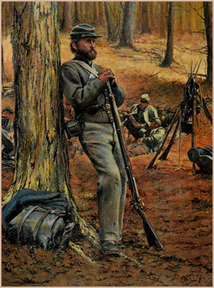 For the “Thought You Might Like This” file…
A Confederate soldier, brought before General Benjamin Butler to take the Oath of Allegiance at the end of the War Between the States, impudently remarked, "We sure gave you hell at Chickamauga, General!" The furious Butler warned him if he did not take the oath immediately, he would be shot. With some reluctance, the rebel duly took the oath. Then he looked Butler in the eye and said, "General, I suppose I am a good Yankee and citizen of the United States now?" The General replied benignly, "I hope so." "Well, General, the rebels did give us hell at Chickamauga, didn't they?"

