“A TRIAD OF AMERICAN PATRIOTS”

Initially, they came from Wales. Later, they migrated down from New England to North Carolina. They were in Duplin County when That First American Revolution “broke out.” Clifton Bowen was one of them. He was also a minuteman. Clifton was present at The Battle of Moore’s Creek Bridge. The Incident(s) at Moore’s Creek Bridge are relatively obscure to most students of American History. However, on February 27, 1776, near Wilmington, North Carolina, 1000 American Patriots handily defeated approximately 1500 Scottish Loyalists. In essence, this victory “ran The British out of the colony of North Carolina – for good!” It also sent King George III the powerful message that the Southern Colonies were equally intolerant of his unfair taxation and other tyrannical policies and practices. Like their New England Brethren, they were more than willing to fight for their freedom and independence. The Tories, Loyalists and other disciples of King George III often referred to Lieutenant Clifton Bowen – and many others of his kind -- as “Rebels.” There is little doubt that he perceived “This Royal Insult” as somewhat of a compliment. A couple of his eldest sons also fought against The English Crown in That War For American Independence. Clifton moved down to lands which would later become Bulloch County -- immediately following “King George’s War.” At some point during The War, this Ensign/Lieutenant in the North Carolina Militia suffered a pulmonary ailment of unknown origin. In 1781, he received an honorable discharge from his unit. Some say that the cause of his ailment may have been a British musket ball. In any event, he passed away in 1789. Unwritten stories tell us that he may have died with that enemy projectile still lodged in the alveolar tissues of his lungs. However, there are those who categorize this as “little more than sheer conjecture.”

Three generations later, many of his direct descendants would also be labeled as “Rebels.” Without a doubt, he would have been more than proud of them!

William M. Bowen was one of the great-grandsons of Old Clifton Bowen. Oddly enough, he was born almost exactly a century later than the old minuteman. Similarly, he would also be referred to by his enemies as “A Rebel.” Likewise, he, too, was proud to acquire such an honorable nickname!

William was married with an infant son when the pair of delegates from Old Bulloch voted in favor of secession from The Union. He had a trio of older brothers, and one, younger male sibling. All but one were known to have served in The Armies Of The Southland. William and his younger brother, John, joined shortly before the Christmas Of 1862. They enlisted in Company I of The 9th Georgia Volunteer Infantry. Right away, they would battle pneumonia and other diseases which purloined (away) more Confederate lives than did those detested soldiers clad in Union Blue!
During the annum which immediately preceded “Those Hostilities of ’61,” William resided in the Bulloch County Wilderness – as a member of the household of one of his older brothers. Both William and Brother Hezekiah, Jr. were married. Each possessed an infant child, as well. Hezekiah, Jr. was the namesake of their father. Old Hezekiah, Sr. was An Anti-Missionary Baptist Minister Of The Gospel. At the time of the 1860 Census and Slave Schedule, he also owned nine slaves. Hence, Old Hezekiah was perceived by many in the area as “somewhat of a small planter.” Additionally, he also attended monthly services and often preached at “That Church By the Lake.” History tells us that this is, by far, the oldest church located in present-day Candler County. Needless to say, non-written stories, passed down from ancestors-of-generations past, tell us that this old preacher was a serious, no-nonsense, type of guy. Furthermore, he was also well-known in these parts as a shrewd and astute businessman. As he was quite conservative, he made sure that all of his children were raised “not to waste.” As old-timers have often said, “times were indeed hard – back then!”

At least four of the five sons of Old Hezekiah Bowen and Fereby(sometimes listed as Pharby or Pharabee) Fitzpatrick Bowen donned “The Gray” and were active participants in “That Magnanimous Struggle For Southern Rights.” His youngest son, John, was the only one “to make it to Appomattox.” At over six feet in height, red-haired John was but one of the 28,000 ragged, shoeless, starved, and emaciated Rebels who “stuck with Marse Robert until the bitter end.” William was at home in Bulloch when The Army Of Northern Virginia finally yielded “to the seemingly - endless Armies of General Grant and Mister Lincoln.” He had been away from Company I of The Ninth Georgia since the summer of ’64. A Yankee Minie ball had taken him out of the fighting. It all happened at a place in faraway-Virginia called “The Wilderness.” The date was May 6, 1864. Stories from the past are quite descriptive and graphic. More than one of them leads us to believe that “his arm may have been practically ripped from its socket!” After several months in Confederate Hospitals in the Danville and Richmond area, he “furloughed home to Bulloch.” His physical condition, coupled with his geographical location, made it virtually impossible for him to return to The Army Of Northern Virginia. His compiled service records erroneously refer to him as “absent without leave!” After all, had he not sacrificed the use of one of his four limbs “for The Lost Cause?” It is interesting to note that both Hezekiah Bowen, Jr. and Malachi Bowen fought in Company K of The 54th Georgia. As they had recently moved south of The Mighty Altamaha, they belonged to this Appling County unit. Both lived to collect Confederate Pensions. John, their youngest male sibling, was also a deserving recipient of “a Bulloch County Old Soldiers’ Pension.” Just a trio of days past his 65th birthday, William passed away. The new century was in its second year of existence.

Similarly, another Old Civil War Soldier named William would also meet death in 1901. Approximately six weeks after the old, handicapped, Rebel Private was visited by The Grim Reaper, President William McKinley would be assassinated. Although McKinley had fought in an Ohio Unit in Lincoln’s Grand Army Of The Republic, he was not unpopular in the areas known as “The Former Confederate States Of America.” After he was shot, McKinley was carried in an ambulance to the hospital. This marked the first time that a U. S. President had ridden in “a motor car!”
Three generations later, Private William Bowen would beget a great-grandson who would also become a permanent casualty of war. Although this great-grandson was not his first, he was, perhaps, the one which he would have been the most proud of!

Walter Howard Daughtry was born on Independence Day of 1928. Symbolically, he would sacrifice his life for a form of American Independence. He became a casualty of “That War Against Communism.” On June 3, 1951, he was “taken out by a sniper from Red China.” He was 31 days shy of his 23rd birthday. It all happened in the vicinity of an obscure little village known as Kotan. Kotan lay just north of that infamous and perilous 38th Parallel. History tells us that Red China sent over one million soldiers down into North Korea to facilitate the flow of communism into that small, divided nation. One of them killed my uncle. Somewhere, tucked carefully away in some clandestine location, is his Purple Heart. In the front room of the old house where he once lived is an important and very official-looking document. It states that he died for his country. It is signed by President Truman. I pause to stare at it – on a daily basis. Although it is an honorable and impressive “piece of paper,” it is unfair and incomplete – to say the least. It tells virtually nothing of the real life and times of Walter Howard Daughtry. It merely speaks (rather generically) of his death.

Private William M. Bowen and Private Walter Howard Daughtry both lie “in eternal slumber” at Lake Church Cemetery. Less than ten yards from Howard is Corporal Jack Kimbrough, late of The United States Marine Corps. Jack and Howard were classmates and cousins. Young Kimbrough was a football star for the Old Metter Bulldogs. Jack was wounded a few weeks before Howard “met his demise.” Not unlike his cousin, Jack died shortly afterward. Neither left the hostile confines of North Korea alive. The numbers tell us that over 50,000 American males perished in Korea during the 37 months that “The Forgotten War Raged.” Two were native sons of Candler. Both were descended from “Confederate Stock.”

At the time of his untimely death, Private Daughtry had been in Korea less than a week. I know, because I have several of his letters. It seems that it rained each of the six days that he was there. At least one of his martial-correspondences arrived posthumously.

Although Lieutenant Clifton Bowen died in Old Bulloch, he is reportedly interred up in North Carolina. However, without a doubt, he would be more than proud of this pair of his direct descendants who are buried where one of his grandsons once preached “Hellfire And Damnation Sermons!” Both fought for the same reasons that he waged all-out war against the tyrannical British Crown. The dates and circumstances were different, but the principles were basically the same. William and Howard fought for the freedoms promised (to) them by their forefathers. Old Clifton Bowen just happened to be one of them.

Private William Bowen, his brothers, and the other approximately 750,000 men and boys “who became caught up in Mister Lincoln’s War,” had every right to take up arms against Yankee Oppression and Imperialism. From “The Southern Perspective,” Abraham Lincoln was an Americanized version of King George III! True students of American History know that many of the issues and causes of The War For Southern Independence were identical to those of The War For American Independence. It was that simple. Additionally, The Forces of the North were just as hostile and threatening as were The Forces of Communist China and North Korea – nine decades later.

William and Howard both fought in far-away lands – for principles which were near and dear to them. Both were willing to shed precious blood for these rights and freedoms. Neither fought in vain. Like their progenitor, Old Clifton Bowen, both were true, American Patriots.

I, for one, am proud of this triad of American Heroes. Since they are my biological relatives, I think of them each day “as their blood still thunders through my veins!”

Hu Daughtry

March 28, 2007

.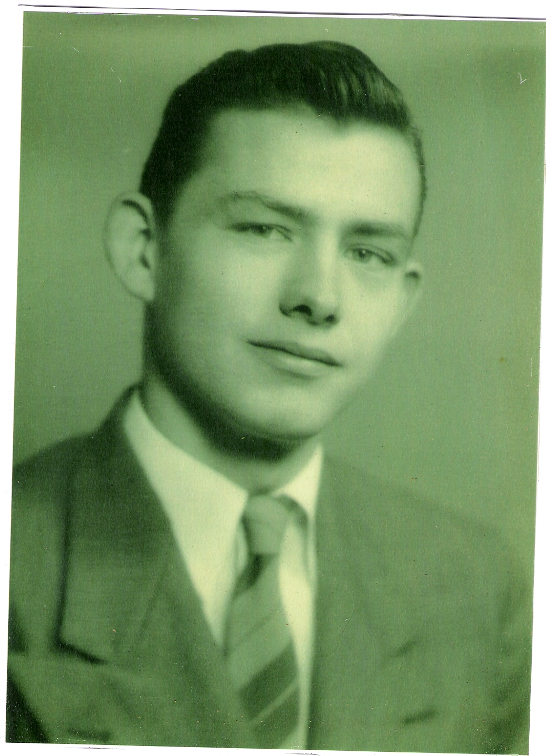

Walter Howard Daughtry; Late 1950.

