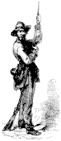

The Dispatch
The Official Publication of The Dixie Guards Camp # 1942
Sons of Confederate Veterans

Volume 4, 10th Edition
December 2004

________________________________________________________________________

Dixie Guards Camp # 1942
Sons of Confederate Veterans
P.O Box 761
Metter, Ga. 30439

Postmaster
Please Deliver To:

Visit Us Online at:
www.dixieguards.org

Commander's Comments

December during the war years of 1861-1865 must have been a very trying time. I can’t help but think about how awful it must have been for any soldier, Confederate or Federal to be away from their family during the Holy Season. Can you imagine what must have been going through their minds? How’s my family? Are they warm? Are they hungry? And, what about loved ones at home? They in many cases had it just as bad, if not worse. Is my husband alive or dead? Where’s my son? Is he hungry or cold? Oh, my God, what will become of him? It must have been awful. Next, I think of the wars since. WWI, WWII, Korea, Vietnam, Grenada, Desert Storm, Afghanistan and Iraq. When it comes down to it – the concerns are largely the same. But, dating from the minutemen that followed Elijah Clarke and George Washington – to those who followed Robert E. Lee, Ike, Patton, McArthur, Westmoreland, Swartzkopff and Franks, Southern men have always been there and could be counted upon. I know that it might not be very period oriented to discuss it here and you probably have your own opinions. You probably really don’t want mine, but as for me, I am really sick and tired of how the US media is portraying our soldiers in Iraq. The latest thing with the Marine shooting an “unarmed” Iraqi really gets my goat. Did anyone mention that this same Marine had been shot in the face the day before? What about the fact that one of his friends being blown up by a supposedly dead Iraqi earlier in that very building? Not to mention, that this battle has been going on nearly around the clock for almost 2 weeks. While we, and certainly the media reporters on TV, are safe here at home, these guys are sleeping sitting up propped up on each other – eating stuff out of a plastic bag that is flavored to taste like beef. Yet, this poor Marine has already been labeled a murderer by folks like Jennings and Rather.
The murderers are those sickening thugs who will cut a man’s head off or shoot a woman. Let’s not forget that they’ve killed their own for years and years. They simply don’t value human life. And what of the prison camps that we’ve mistreated them. I haven’t seen any heads rolling on the floor. I work with several folks that were involved with Desert Storm in the early 90’s. According to them, these people don’t respond to anything such as beatings, starvation or interrogation. To them, if they’re beheaded, they go straight to their reward, complete with 50 or 60 virgins. (Which I can’t help but wander why they say is OK) – Anyway, the only thing that they will respond to is embarrassment. That’s right, if you were to say – take a picture of one of them with women’s underwear on or with a bra on and promise them to publish the photos for the world to see – the threat of public humiliation is enough to make them give away military secrets. Some would say – Oh, they’ll just lie about the secrets – Nope, they know you still have the pictures! So, I say – Who cares about if they’ve been photographed all huddled up in a wad – they want 50 virgins anyway – Is one thing sicker than the other? If we’re wrong by saving American lives with a few photographs – then God forgive us for dropping atomic bombs on Japan! I don’t want to sound nasty, but better them than us! – As Forest Gump would say, “That’s all I have to say about that!”
Gentlemen, as I said at November’s meeting, the change in the dues deadline really cost us in members lost. We lost nearly 50% of our members. Hopefully, this was because of the change. I would like to urge everyone to contact us and make sure you’ve paid your dues for next year. You may think you have and you might not have. Maybe you know someone who hasn’t paid his yet. Please give them a call!
Our ancestors are under constant attack. Our teachers are taught that our ancestors were evil. It’s easy to see why they tell our kids this. This is all that most teachers know to be true. In most colleges, future teachers are taught that our ancestors were bad people, so it’s obvious that they would pass it along to our kids. With the attacks on our current military so prevalent in our newspapers today, is it so hard to see why our ancestors are such easy targets? Now more than ever, our ancestors need us to stand & stand tall. Without us, they will be lost to future generations. It doesn’t take a rocket scientist to see that! Please join me in earnest preservation of our Confederate Ancestors & earnest Prayer for our Troops everywhere. – They are all Americans & They deserve all the credit we can give them!

God Bless You and Your Families,
Randy

Adjutant's Report

Old Business: 1. The tabled motion relating to the Monument Foundation was tabled again. 2. Renewals were discussed and the need to renew those members lost to the deadline change. 3. The Tattnall Invincibles have asked us to help with the Battle of Manassas for 2005. Jay Clifton is the Camp Chairman for this effort. See Jay if you can help or need info.
New Business: 1. Elections were announced for the December Meeting. Ballots will be made from the nominations received by November 18^{th.} If you did not turn in your nomination form at the meeting, mail it to the Camp Post Office Box. 2. On December 3rd- 5th will be The Battle of Waynesborough reenactment near Waynesboro/Plant Vogtle. This is a change from the normal Battle of Buckhead Church because of the loss of the location with highway construction. Honorary Member Steve Burke is heading up this project and needs our support. Tell your friends and families. 3. The Ebenezer Rifles has asked for help with the Christmas Parade in Guyton on December 4th. If you can march, be at the school at 9:00 on Saturday the 4th.

Membership Goal
“Recruit 4 in 2004”

4 Names & Addresses for Potential Members every month

Camp Calendar

December 2 - Regular Meeting – Western Steer – 7 PM Meal – 7:30 Meeting
Guest Speaker: Hu Daughtry on his upcoming book & family research.

Will you honor him?

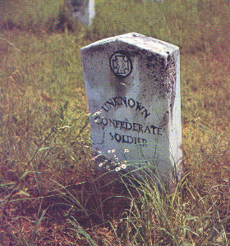
Remember
Bring a new member or guest with you to our meetings.

Bring the names & addresses of 4 Potential Members who you know are qualified for SCV membership. This is Easy!!

The Confederate Home Front Series
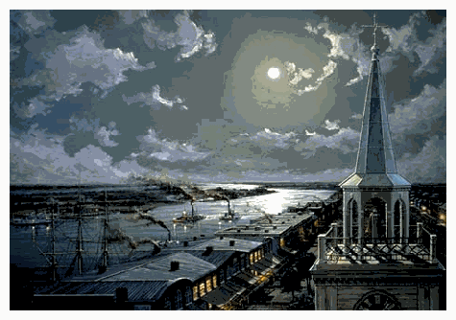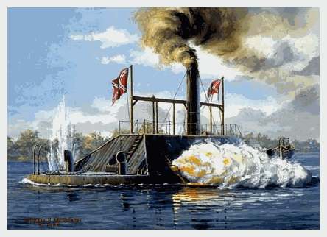
The Ladies Gunboat Association
Georgia seceded on January 19, 1861. However, in anticipation of secession or even in an attempt to persuade the vote to usher in secession, Georgia Governor Joseph E. Brown ordered the confiscation of Fort Pulaski in Savannah on January 2nd. Georgia militia troops under Colonel Lawton took control of the fort. These actions held onto the basis that Georgia’s coastal gem of Savannah were paramount to Georgia’s overall defense. Fear of Federal invasion way of Savannah is evident in thousands of letters and manuscripts from the war period. Most likely lost to most of today’s Georgians is the story of the Ladies Gunboat Association.
By early 1862, the concern for Savannah’s defense was the topic all across the state. The Federal blockade of southern ports was beginning to cause privations throughout the South. Georgia, and specifically Savannah, had a concern for items being able to get through the blockade and for the perceived threat of Federal invasion from the Union fleet already off the coast of Tybee.
All across Georgia women began to raise the needed funds to enable ship builders in Savannah to construct a new ironclad vessel to protect Savannah and Georgia’s coast. Women in all the larger cities were directly involved and the efforts of the groups in Athens, Milledgeville, Atlanta, Macon, and Columbus were chronicled in their local newspapers. Most of these newspapers were readily available in each of the larger towns, so women from one town to the next saw the fruits of the efforts, plus they were inspired to do more. Not to be outdone, the ladies from the towns began to try to out do each other in friendly competitions to raise money, where the results created a sense of patriotism, pride and of course, the money needed for construction.
The women of the Ladies Gunboat Association generated $115,000 towards the construction of the ironclad. Initially, christened The Ladies Gunboat, the ship was later named the CSS Georgia and was Savannah’s first ironclad warship and was commissioned to protect Savannah and the immediate area.
After the fall of Fort Pulaski, the CSS Georgia became even more important to the citizens of Savannah, because of the reputation the new ironclad type ships had already obtained from such battles as the one between the USS Monitor and the CSS Virginia. For the most part, Savannah never was really threatened from the sea, but the fear of such an invasion was written in countless diaries, letters and articles of the war. The CSS Georgia never really was effectively used or manned by the Confederacy, mainly because of all the other efforts to obstruct the harbor. Efforts to hamper any Federal attempt to gain access to Savannah from the mouth of the River, also prevented the CSS Georgia and other vessels from getting to the Federal ships out at sea.

