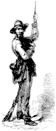

The Dispatch
The Official Publication of The Dixie Guards Camp # 1942
Sons of Confederate Veterans

Volume 4, 11th Edition
January 2005

________________________________________________________________________

Dixie Guards Camp # 1942
Sons of Confederate Veterans
P.O Box 761
Metter, Ga. 30439

Postmaster
Please Deliver To:

Visit Us Online at:
www.dixieguards.org
Commander's Comments

With the New Year come new challenges and new opportunities. Often, we find time to inspire ourselves with New Year’s resolutions. Sometimes we keep these pledges; many times we don’t. Like always, I wanted to come up with a Central Theme for the coming year. I believe that by setting a goal, we can reach new heights. Are New Year’s Resolutions applicable to civic groups or organizations such as ours? I for one think that they most definitely are. In fact, I believe that if a good goal is set and everyone strives to obtain the goal, the group will be rewarded with untold and uncommon success. For our members that are also members of other organizations, I bet you have a similar program. If not, try to initiate one. Our community will be the winner for it.
What about our Goals? First, I’d like to encourage each and every member to his own personal goal. Think – How can I support my Ancestor more? Not – How can I help my Camp more? The Camp will receive the benefit for your efforts for you kinfolk. I for one did not join to support a Camp or group. I joined to honor my forefathers. The work I do, I do in their remembrance and in their names. The Camp & The SCV receives the benefit. Never do anything for the benefit of the Camp – you will most assuredly come up short, because it won’t have the same sense of urgency. That makes perfect sense too! You can never have as much love and respect for a club as you do for your kin – At least I hope not!
With that in mind, here is my Central Theme for the coming year. In Recruitment, the Theme will be “If my Ancestor was alive, how many would he ask me to recruit in 2005?” In Community Support, the Central Goals are: 1.To get involved with our local Historical Society to help them get their Museum Project off to a successful pathway. 2. To help establish our ladies with the OREL (Order of Robert E. Lee) so that we can have a good Ladies Auxiliary, which can only further our Public Relations and aid or Cause. 3.To become involved with the Altamaha River Museum group because so many of our Ancestors will be honored within the museum.
In Retention – 100%, I’m really serious. I know that folks join clubs and quit all the time, but I refuse to believe that ours is not a more noble cause. Do you every hope to forget your father? I hope the answer is no and I hope that he felt the same way. I also hope that every male heir in your birth line has felt the same way, but you know, our numbers just don’t reflect this. Honor your father, his father, his father and so on. It is your Duty and Responsibility! If you don’t and won’t – Then who will? Men that won’t pay homage to their own families must have a couple of problems – They either have a terrible lineage and are trying to make a new life for themselves or they don’t deserve the name that their father gave them. That may sound like hard words, but you know what…tough! I won’t apologize for being a little sad for the Confederate Soldiers who lived and toiled right here in this area that aren’t remembered by their heirs. It is more than just sad; it is disgusting. You and I have members of our families that fall into this category. We’re all busy, so that’s no excuse. Membership doesn’t obligate someone to camping in the snow like the Soldiers did. Remind you friends and neighbors of this and challenge them to uphold their family name. Ask your kinfolk to join and refuse to accept excuses without challenging their commitment to family. Our Ancestors were freezing and dying in January 1861-1865 and on up until nearly 1870. Would you have them to continue to suffer?

God Bless You and Your Families,
Randy

Adjutant's Report

Old Business: 1. The tabled motion relating to the Monument Foundation was tabled again. 2. Renewals were discussed and the need to renew those members lost to the deadline change. 3. The Tattnall Invincibles have asked us to help with the Battle of Manassas for 2005. Jay Clifton is the Camp Chairman for this effort. See Jay if you can help or need info. The Camp will receive 40% of the profits from the sale of Program Ads. 4. Camp Elections were held for the coming year. 5. The Camp was reminded about the Battle of Waynesborough reenactment near Plant Vogtle and encouraged to attend to help make it a success. 6. The Camp was reminded of the Christmas Parade in Guyton to support the Ebenezer Rifles.
New Business: 1. The Camp set Saturday, February 5th for the date of the General’s Banquet. As of this time, the details regarding a speaker have not been finalized. The event will be a covered dish supper at the Metter Community House. The time will be 7 PM. 2. The Ogeechee Rifles are having a Confederate Riverboat Trip Raffle to be given away this upcoming summer. For details see Commander Crooms or Brigade Commander Mike Mull.

Membership Goal – Retention &Recruitment

If My Ancestor Were Alive

How Many Would He Ask Me To Recruit In 2005?

Camp Calendar

January 6 - Regular Meeting – Western Steer – 7 PM Meal – 7:30 Meeting
Guest Speaker: TBA
February 5 – General’s Banquet – Metter Community Center – 7 PM
**This will be our banquet & regular meeting for February.

Will you honor him?

Camp Officers for 2005

Commander – Randy Crooms
1st Lt. Commander – Jason West
2nd Lt. Commander – Jackie Wallace
Adjutant – Tony Thompson
Chaplain – Grady Franklin
Color Sgt – Ben Franklin
Historian – Ted Lewis

Surgeon – Jay Clifton

Quartermaster – Marcus Coursey
Judge Advocate – Hu Daughtry

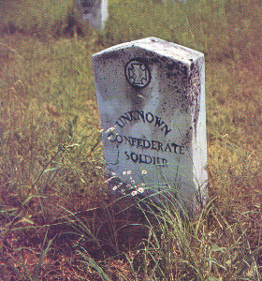
The Confederate Home Front Series
Nancy Hill Morgan &The Nancy Harts Militia
In his Inaugural Address of 1863, Georgia Governor Joseph E. Brown attempted to compare the women of the American Revolution to those of the ongoing War. In his speech, Governor Brown used political savvy to try and influence the women of Georgia to hold strong with their war support and do their part to maintain a good spirit that would filter over into the government and military efforts. His hopes did not necessarily spread across the entire state, but it did at least in the West Georgia town of LaGrange. Here are the words from Governor Brown’s speech and the story of Nancy Hill Morgan and the Nancy Harts Militia.
“Without their energetic efforts and moral support of wives, mothers, sisters and daughters of the Confederate States, our liberties would before this time have been lost.”

“With their continued effort and God’s blessing upon it, women will avenge the blood of their slain relatives.”
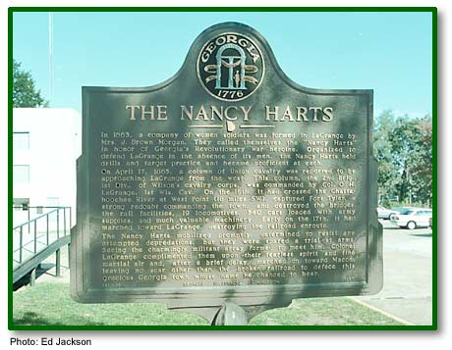
- Governor Joseph E. Brown
*From the Road Marker
In 1863, a company of women soldiers was formed in LaGrange by Mrs. J. Brown Morgan. They called themselves the "Nancy Harts" in honor of Georgia's Revolutionary War heroine. Organized to defend LaGrange in the absence of its men, the Nancy Harts held drills and target practice and became proficient at each.
On April 17, 1865, a column of Union cavalry was reported to be approaching LaGrange from the west. This column, the 2nd Brig., 1st Div., of Wilson's cavalry corps, was commanded by Col. O.H. LaGrange, 1st Wis. Cav. On the 16th, it had crossed the Chattahoochee River at West Point (18 miles SW), captured fort Tyler, a strong redoubt commanding the town, and destroyed the bridges, the rail facilities, 19 locomotives, 340 cars loaded with army supplies, and much valuable machinery. Early on the 17th, it had marched toward LaGrange, destroying the railroad enroute.
The Nancy Harts mobilized promptly, determined to resist any attempted depredations, but they were spared a trial at arms. Seeing the charmingly militant array formed to meet him, Colonel LaGrange complimented them upon their fearless spirit and fine martial air and, after a brief delay, marched on toward Macon, leaving no scar other than the broken railroad to deface this gracious Georgia town whose name he chanced to bear.
141-13 GEORGIA HISTORICAL COMMISSION 1957
© Carl Vinson Institute of Government, The University of Georgia

Right – Roadside Marker in LaGrange, Georgia honoring the Nancy Harts Militia

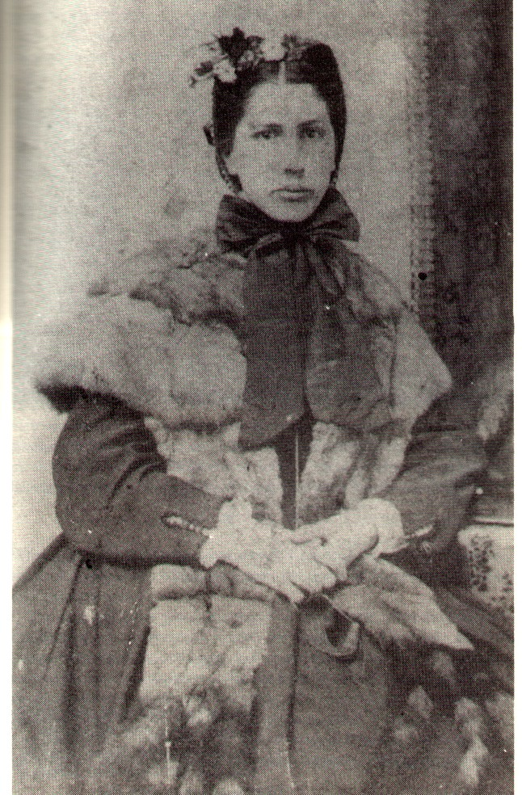
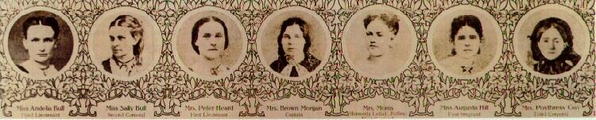
Left - Cpt. Nancy Hill Morgan
Organizer of the Nancy Harts Militia
Below Right – The Officers of the Nancy Harts Militia
During the American Revolution, Georgia women named Nancy Hart became a famous heroine. She was a spy for the Georgia Patriots in territory controlled by British Loyalist Tories. Since women weren’t held in high regard, she was able to overhear and pass along much valuable information to the patriots. She once held a log and drifted along the banks of the Savannah River in the dead of winter to gain information. Perhaps her most famous exploits were when a group of Tories entered her home and demanded to know the whereabouts of her husband. He was a known patriot and they aimed to capture him. When they did not discover him, they demanded she cook for them. She fed them & got them drunk. She sent her daughter to notify her husband of the situation and remained behind alone with the Tories. She threw their muskets out a window of the cabin but was caught in the act by the drunken Tories. She shot and killed 2 of the 5 men and held the others captive until her husband and his minutemen could arrive. Upon arrival, the 3 surviving Tories were hanged in the front yard of Hart’s home at her request.
This story was the inspiration for Nancy Hill Morgan organizing the Nancy Harts Militia in 1863. Once Sherman and his troops appeared to be on the southward march from Atlanta, all of Georgia became afraid that he would come their way. LaGrange stood in the direct pathway of the Columbus Naval Yards and the citizens were at the mercy of the invaders. The Nancy Harts were the only thing that stood in the way of the invaders to protect LaGrange, as well as the approach to the Naval Yards. Some of their exploits may be legend, but it is a fact that these women in defense of their homes armed themselves to protect all that they held dear.

